Table of contents
Introduction 6
What is ProjectDox? 6
Overview 7
What is a workflow? 7
What is a step? 8
What is a task? 8
Setting up workstation 9
Configure workstation 9
User credentials 9
Troubleshooting 9
Getting started 10
Initial log in 10
Part 1 – email notification 10
Part 2 – verification code 11
Part 3 – create password 11
Part 4 – logging in 11
Part 5 – personal information 12
Part 6 – dashboard 13
Subsequent log ins 13
Part 1 – logging in 13
Part 2 – dashboard 14
Navigating dashboard and homepage 14
Part 1: dashboard 14
Part 2: homepage 15
Resetting password 16
Part 1: forgot password 16
Part 2: request code 17
Part 3: request sent 17
Part 4: check email 17
Part 5: verification code 18
Part 6: create password 18
Part 7: logging in 19
Submission guidelines 20
Required documents 20
Folder structure 20
File requirements 20
Drawing sizes 20
Stamp location 21
Naming standards 21
Applicant upload task 22
Part 1: email notifications 22
Part 1.1: email notification about project invitation 22
Part 1.2: email notification about task assignment 23
Part 2: logging in 24
Part 3: accepting task 25
Part 4: e-form pop-up window 26
Part 5: uploading project files from the e-form window 26
Part 5.1: uploading files to the drawings folder 27
Part 5.1.1: selecting the drawings folder 27
Part 5.1.2: e-form’s folder pop-up window 28
Part 5.1.3: computer’s file explorer dialog 29
Part 5.1.4: upload files 30
Part 5.1.5: uploaded files 31
Part 5.2: uploading files to the hydraulic calculations folder 32
Part 5.2.1: selecting the hydraulic calculations folder 32
Part 5.2.2: e-form’s folder pop-up window 33
Part 5.2.3: computer’s file explorer dialog 34
Part 5.2.4: upload files 35
Part 5.2.5: uploaded files 36
Part 5.3: uploading files to the documents folder 37
Part 5.3.1: selecting the documents folder 37
Part 5.3.2: e-form’s folder pop-up window 38
Part 5.3.3: computer’s file explorer dialog 39
Part 5.3.4: upload files 40
Part 5.3.5: uploaded files 41
Part 6: completing task 42
Part 7: dashboard 43
Part 8: logging out 43
Part 9: email notification about upload completed 44
Part 10: next step 45
Applicant prescreen corrections task 47
Part 1: email notification about task assignment 47
Part 2: logging in 48
Part 3: accepting task 49
Part 4: e-form pop-up window 50
Part 5: reviewing comments and uploading missing project file from the e-form window 50
Part 5.1: review comments 51
Part 5.1.1: reviewing comments 51
Part 5.1.2: e-form’s comment pop-up window 52
Part 5.2: uploading missing file to the documents folder 53
Part 5.2.1: selecting the documents folder 53
Part 5.2.2: e-form’s folder pop-up window 54
Part 5.2.3: computer’s file explorer dialog 55
Part 5.2.4: upload file 56
Part 5.2.5: uploaded file 57
Part 6: completing task 58
Part 7: dashboard 59
Part 8: logging out 59
Part 9: email notification about upload completed 60
Part 10: next step 61
Applicant resubmit task 63
Part 1: email notification about task assignment 63
Part 2: logging in 64
Part 3: accepting task 65
Part 4: e-form pop-up window 66
Part 5: reviewing comments and uploading revised project files from the e-form window 66
Part 5.1: review comments 67
Part 5.1.1: reviewing comments 67
Part 5.1.2: e-form’s comment pop-up window 68
Part 5.2: uploading corrected file to the drawings folder 69
Part 5.2.1: selecting the drawings folder 69
Part 5.2.2: e-form’s folder pop-up window 70
Part 5.2.3: computer’s file explorer dialog 71
Part 5.2.4: upload file 72
Part 5.2.5: uploaded file 73
Part 5.3: uploading corrected file to the hydraulic calculations folder 74
Part 5.3.1: selecting the hydraulic calculations folder 74
Part 5.3.2: e-form’s folder pop-up window 75
Part 5.3.3: computer’s file explorer dialog 76
Part 5.3.4: upload file 77
Part 5.3.5: uploaded file 78
Part 6: completing task 79
Part 7: dashboard 80
Part 8: logging out 80
Part 9: email notification about upload completed 81
Part 10: next step 82
Applicant download task 84
Part 1: email notification about download ready 84
Part 2: logging in 85
Part 3: opening project 86
Part 4: downloading results 87
Part 4.1: downloading stamped drawings 87
Part 4.1.1: selecting files 87
Part 4.1.2: download files 88
Part 4.1.3: downloaded file 89
Part 4.1.4: computer’s file explorer 90
Part 4.1.5: extracting archive files 91
Part 4.1.6: extracted archive files 92
Part 4.1.7: viewing stamped drawings 93
Part 4.2: downloading permit letter 94
Part 4.2.1: selecting file 94
Part 4.2.2: downloaded file 95
Part 4.2.3: computer’s file explorer 95
Part 4.2.4: moved permit letter 96
Part 4.2.5: viewing permit letter 97
Part 4.3: downloading review comments 98
Part 4.3.1: project reports 98
Part 4.3.2: pop-up window 99
Part 4.3.3: computer’s file explorer 100
Part 4.3.4: moved reports 101
Part 4.3.5: viewing report 102
Part 5: logging out 103

Introduction
Reading and following the instructions in this user guide will make the electronic plan submission and review process more efficient for all participants. While there is a learning curve with every new system, we hope your experience is a good one.

What is ProjectDox?
ProjectDox is an electronic plan review (ePlan) product from Avolve Software, which is a web-based workflow and collaboration system that allows everyone to communicate electronically throughout the plan review process. This provides an alternative to printing and mailing paper documents.

Unlike the paper-based system, ePlans provides the following benefits:
- Upload documents from the convenience of your office – 24 hours a day, 7 days a week.
- Resubmission of corrected documents from the convenience of your office.
- View plan reviewer markups as an overlay over the electronic plans to provide better direction and clarity when plan corrections are required.
- Once the review is complete, receive immediate notification and access to your reviewed and stamped plans.

Overview
The electronic plan review process replaces the paper-based plan review process with tools that enable electronic collaboration between the applicant and the plan reviewer. The information within the permit application is used to create a new project in ProjectDox. After a new project is created, an invitation email is sent to the applicant. There is no need to set up an account ahead of time. If the applicant is new, an account will be created and then a welcome email will be sent to the applicant.

What is a workflow?
The electronic plan review process within ProjectDox is managed by a “workflow,” which is the behind-the-scenes process that automatically moves the project from one step to another.

The picture below illustrates the workflow at a high level.

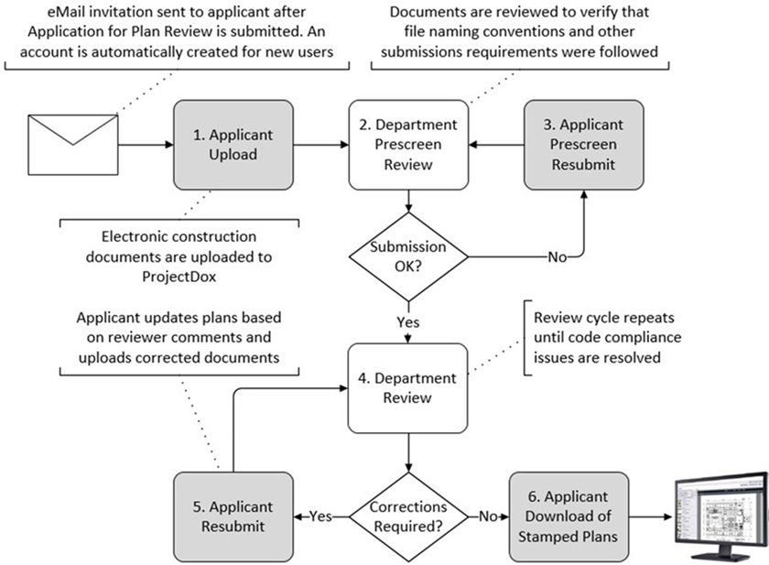

The major workflow tasks outlined in the picture above are:
- The applicant will upload all required sprinkler documents.
- The department coordinator will check the uploaded sprinkler documents to ensure they adhere to naming convention, sheet size, orientation, missing documents, etc.
- If any issues are found during the check process, the applicant must fix and then upload any corrections or missing documents.
- The department coordinator will assign the project to a department plan reviewer who will review all drawings, hydraulic calculations, and data sheets for code compliance.
- If any issues are found during the plan review process, the applicant must fix any code violations and then upload all required corrections.
- Once the plan review process is done and meets code requirements, the applicant can retrieve the permit and stamped drawings.
NOTE: The stamped set of drawings is a copy of the original drawings. The original set of drawings is not altered or embellished in any way.

What is a step?
Each activity within the workflow is referred to as a “step.” Each step must be completed before the next one can begin. Each step is automatically set up to be completed by a specific group. The three groups are as follows:
- SFMD Applicant – this is the applicant who should be you.
- SFMD Plan Reviewer – this is a sprinkler plan reviewer/inspector employed at the Minnesota Department of Public Safety State Fire Marshal division.
- SFMD Project Coordinator – this is a support staff employed at the Minnesota Department of Public Safety State Fire Marshal division.

What is a task?
Each time a step completes, it becomes a “task,” and an email notification is sent to the next group. This user guide provides instructions to complete the four applicant tasks listed below:
- Applicant Upload Task – this is the first step in the workflow where the applicant must upload sprinkler documents before a plan review can begin.
- Applicant Prescreen Corrections Task – this is the second step in the workflow if the sprinkler documents do not meet the submission guidelines section of this user guide.
- Applicant Resubmit Task – this is the third step in the workflow if the sprinkler documents failed to meet code requirements during a plan review.
- Applicant Download Task – this is the last step in the workflow once the plan review is completed and no code violations were found during the plan review.

Setting up workstation

Configure workstation
- Since ProjectDox is an electronic plan review product that is web-based, there is not much set up needed. ProjectDox supports any HTML 5 web browser, such as Microsoft Edge, Google Chrome, or Mozilla Firefox.
- ProjectDox uses pop-up windows. If your web browser blocks pop-up windows, make sure to add the URL listed below to your web browser’s allowed pop-up list:
https://mn-us.avolvecloud.com/projectdox/
- To ensure that you receive email notifications, make sure to add the email address listed below to your email client’s safe senders list:
noreply.DLI@avolvecloud.com

User credentials
If you are new to ProjectDox, you cannot create a user account ahead of time. A user account is created when your first project is created. You will receive a welcoming email from the system to finish setting up your user account. Follow the steps in the initial log in subsection of the getting started section.

Troubleshooting
If ProjectDox does not appear nor behave as described in any of the task sections of this user guide, it could be related to your web browser’s pop-up blocker preventing the system from opening a new window.

Getting started

Initial log in
If the applicant is new to ProjectDox, they will receive an email notification inviting them to finish setting up their user account. Below illustrates the steps needed to complete this.

Part 1 – email notification
The applicant will receive a welcoming email notification the very first time they are invited to join like shown in the picture below. Note the verification code listed and then click on the “Login” link within the email.

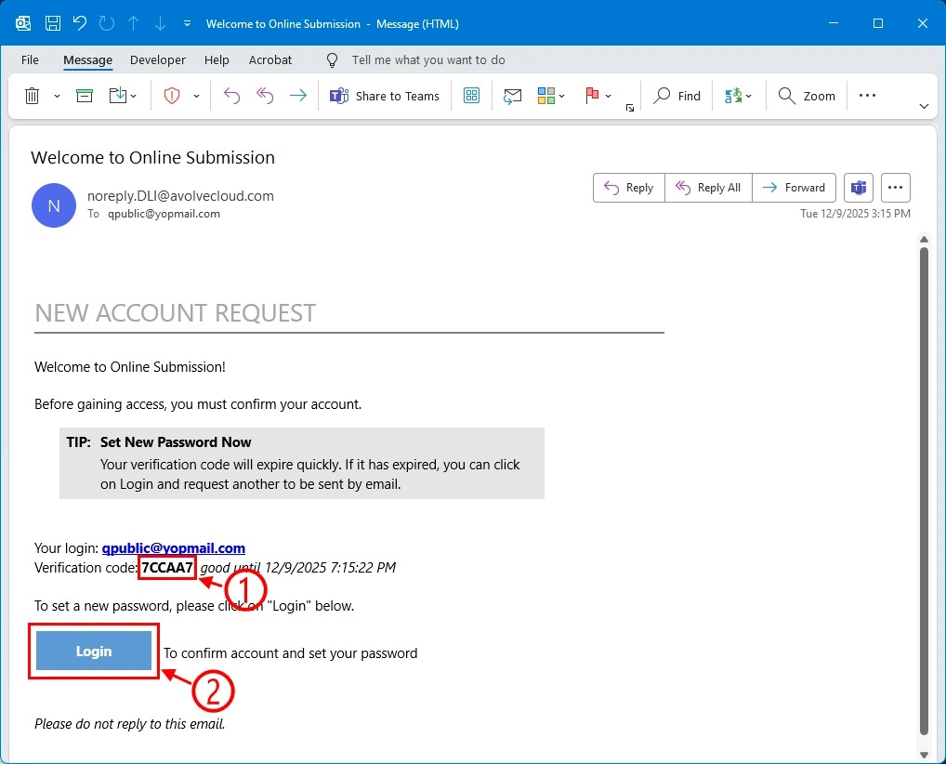

Part 2 – verification code
Take the verification code form the email and enter it into the textbox by either copying and pasting it or typing it in and then click on the “Continue” button as shown in the picture below.

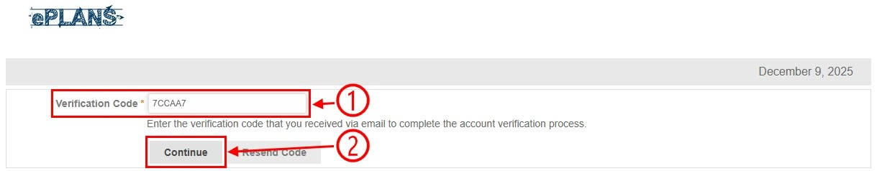

Part 3 – create password
Create a password by entering it into the two boxes before clicking on the “Update” button as shown in the picture below.

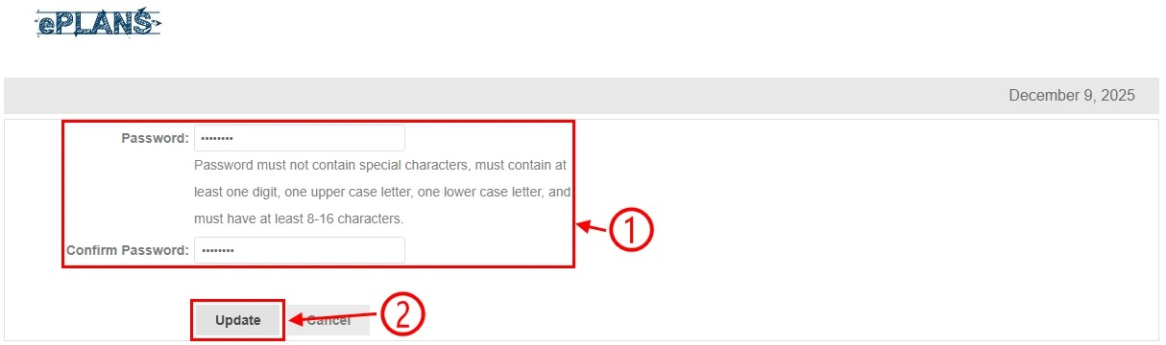

Part 4 – logging in
Enter your email address and then newly created password before clicking on the “Login” button as shown in the picture below.

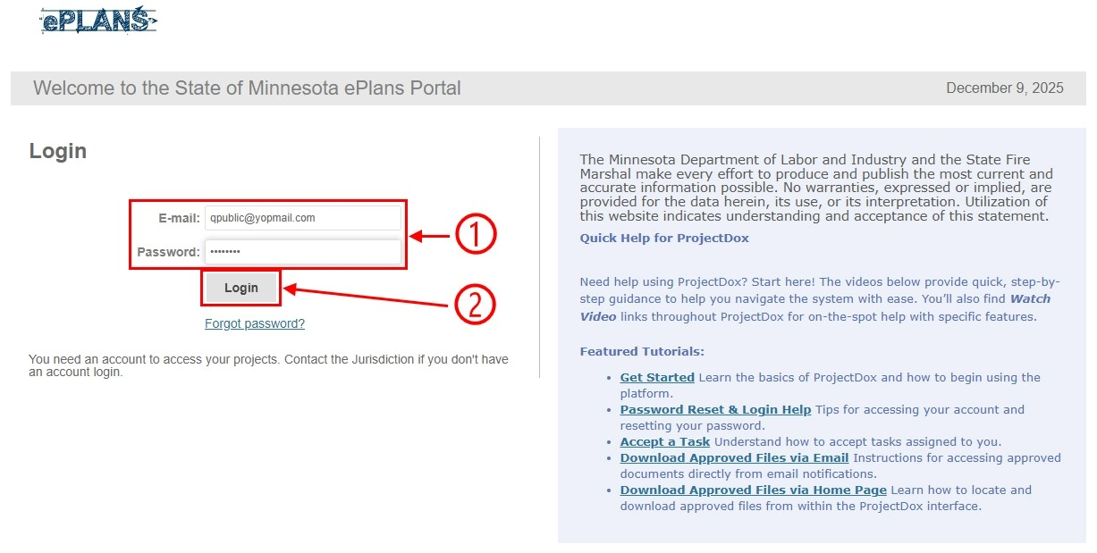

Part 5 – personal information
Fill out all the boxes marked with the red asterisks, enter your current password, and then click on the “Save” button as shown in the picture below.

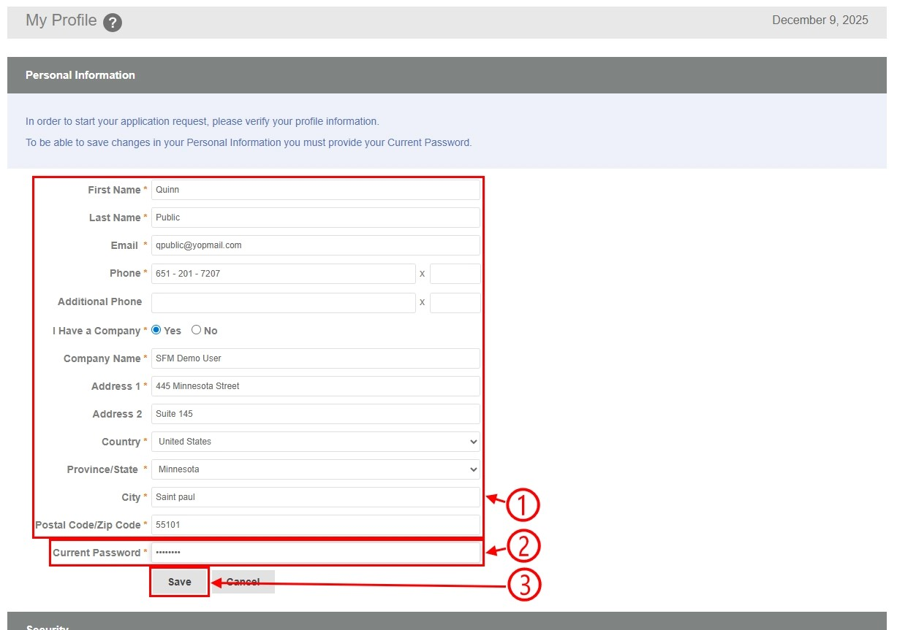

Part 6 – dashboard
Go to the navigating dashboard and homepage section below.

Subsequent log ins
If the applicant is not new to ProjectDox, they can log back into their user account at any time.

Part 1 – logging in
Enter your email address and password before clicking on the “Login” button as shown in the picture below.

Part 2 – dashboard
Go to the navigating dashboard and homepage section below.

Navigating dashboard and homepage

Part 1: dashboard
In the picture below, this is the default ProjectDox dashboard you will see after logging in. The numbered list below relates to the numbers in the picture:
- Clicking on that image will bring you back to this ProjectDox dashboard.
- Clicking on that image will allow you to manage your profile and/or update your password.
- Clicking on that link will log you out of ProjectDox.
- Clicking on that icon will refresh the projects list.
- Clicking on that link will open the project.
- Clicking on that column or any other column will sort the list.
- Clicking on that button will accept and/or open the task.
- Clicking on that button will view all your projects from a different view; refer to part two below.

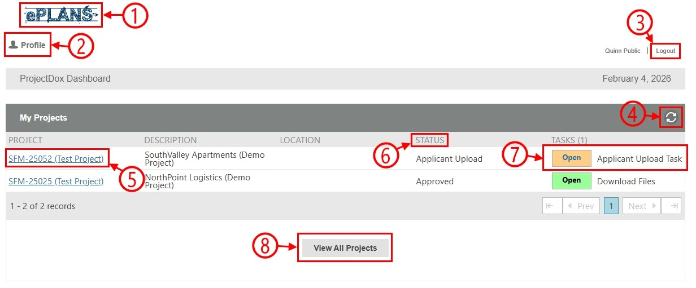

Part 2: homepage
In the picture below, this is the ProjectDox homepage you will see after clicking on the “View All Projects” button from the ProjectDox dashboard. The numbered list below relates to the numbers in the picture:
- Clicking on that image will bring you to the ProjectDox dashboard; refer to part one above.
- Clicking on that button will bring you back to this ProjectDox homepage.
- Clicking on that button will display all your tasks from a new pop-up window. You can also refer to the sixth item within this list.
- Clicking on that button will allow you to manage your profile and/or update your password.
- Clicking on that button will log you out of ProjectDox.
- Clicking on that tab will display all your tasks.
- Clicking on that tab will display all your projects.
- Clicking on any of those icons will open the project directly to that tab.
- Clicking on that link will open the project.
- Clicking on that column or any other column will sort the list. Clicking on the gear icon will customize the list like hiding a column, sorting by multiple columns, or reordering the columns.
- Clicking on the icon will change the filtering type. Typing in the textbox will filter the list down.
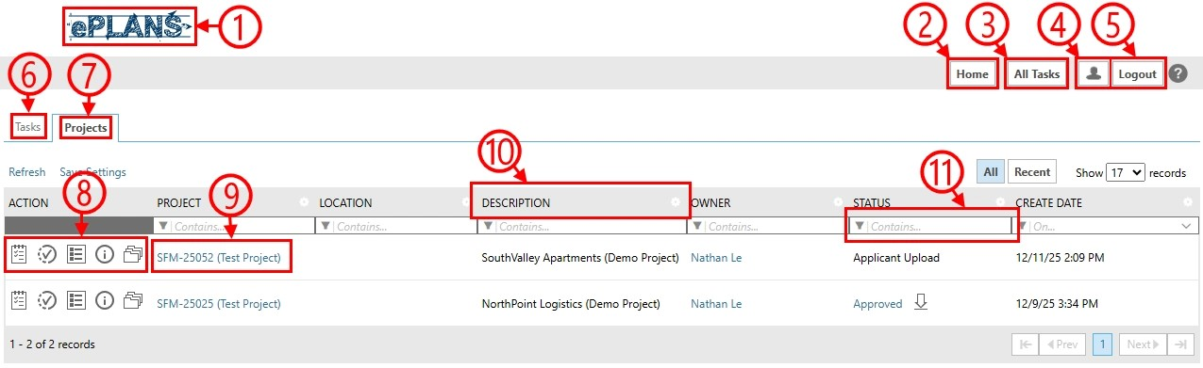

Resetting password
On the “Login” page, click on the “Forgot password?” link. On the “Password Reset Code” page, enter your email address, click on the “Go” button, check your email, click on the link, copy the code, enter a password, done.

Part 1: forgot password
On the “Login” page, click on the “Forgot password?” link as shown in the picture below.

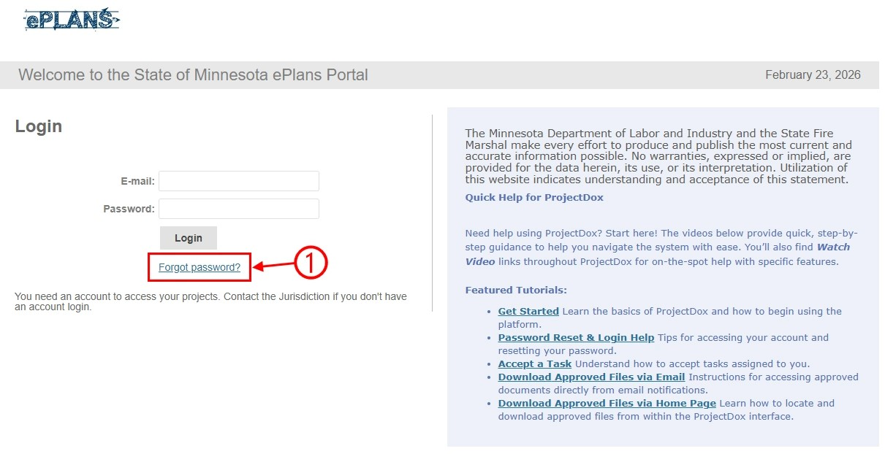

Part 2: request code
Enter your user account’s email address in the textbox and then click on the “Go” button as shown in the picture below.

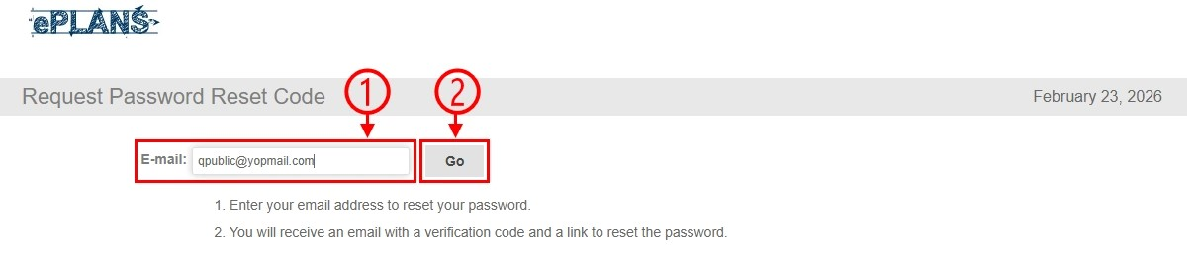

Part 3: request sent
Go to your emails as stated in the picture below.

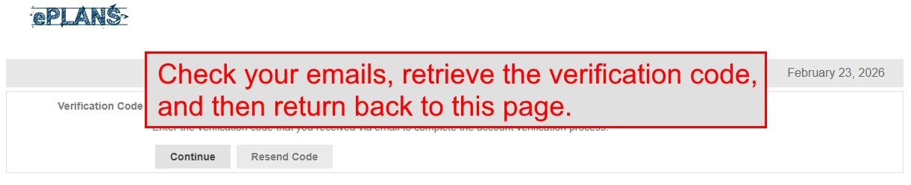

Part 4: check email
Note the verification code listed within the email like shown in the picture below.

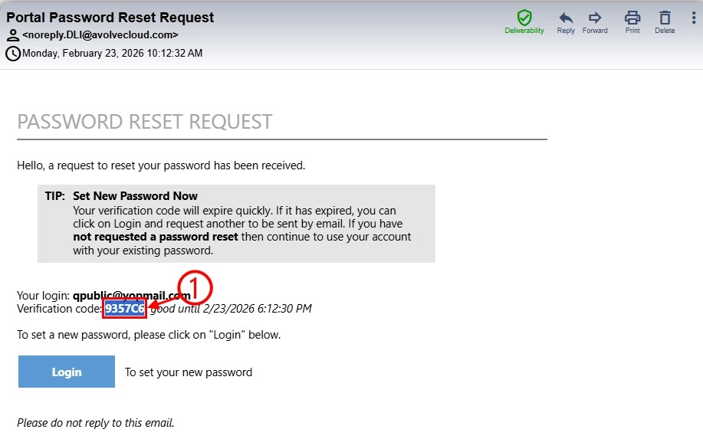

Part 5: verification code
Take the verification code form the email and enter it into the textbox by either copying and pasting it or typing it in and then click on the “Continue” button as shown in the picture below.

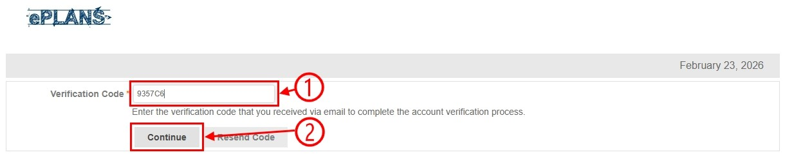

Part 6: create password
Create a password by entering it into the two boxes before clicking on the “Update” button as shown in the picture below.

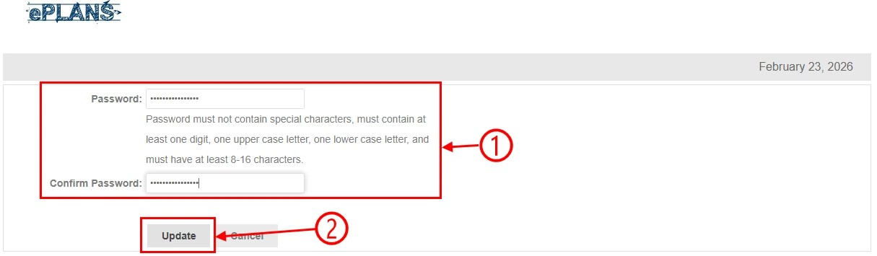

Part 7: logging in
Go to the subsequent login section above.

Submission guidelines

Required documents
There is a section about what a submittal should include listed within our division policy called sprinkler protection plan review | Minnesota Department of Public Safety. The electronic submittal should include one set as multiple sets will not be needed.

Folder structure
These are the five folders within a project:
- The “Drawings” folder will show up right away in the workflow since you must upload all drawing files to this folder.
- The “Documents” folder will show up right away in the workflow since you must upload any non-drawing and any non-hydraulic calculation files to this folder.
- The “Hydraulic Calculations” folder will show up right away in the workflow since you must upload all hydraulic calculation files to this folder.
- The “SFMD Permit Documents” folder will show up later in the workflow since this folder will hold a copy of the permit letter once the review is completed.
- The “SFMD Reviewed Drawings” folder will show up later in the workflow since this folder will hold a copy of the drawings from the “Drawings” folder with a stamp affixed to them.

File requirements
All file types must be in a PDF format.

For the file requirements:
- Drawing files must be a single sheet in landscape orientation.
- Hydraulic calculation files must be separated by remote area.

Drawing sizes
The following sheet sizes are acceptable for drawings:
- 48-inch wide by 36-inch high (48” x 36”).
- 42-inch wide by 30-inch high (42” x 30”).
- 36-inch wide by 24-inch high (36” x 24”).
- 17-inch wide by 11-inch high (17” x 11”).

When providing drawings for sprinkler-head for sprinkler-head or pipe-size for pipe-size replacements, the drawings do not have to be to scale; however, they should illustrate your intentions.

Stamp location
The SFMD plan reviewer will electronically stamp the drawings at the conclusion of the review.
- The standard stamp location is in the lower right-hand corner.
- The stamp size is 4-inch wide by 2.25-inch high (4” x 2.25”).
- The stamp is designed to accommodate a 2.5-inch horizontal title block along the bottom with a 1-inch border.

Naming standards
The file name for drawings should include a discipline identifier, sheet number, and a brief name.
- The discipline identifier can be SFM (for State Fire Marshal) or SP (for Fire Sprinkler).
- The sheet number can range from 001 to 999.
- The brief name should be meaningful to its contents.
For example:
- SFM_001_COVER-SHEET
- SFM_002_FIRST-FLOOR
- SP_001_COVER-SHEET
- SP_002_FIRST-FLOOR
Note:
- The file name should not exceed 60 characters in length.

Applicant upload task
After a new project is created, the applicant upload task is the first step in the workflow. To complete this task, the applicant must upload all necessary project files, such as drawings, data sheets, hydraulic calculations.

After the applicant completes this task, it will move to the prescreen task, which is completed by the SFM coordinator, to ensure the files meet the submission guidelines section of this user guide.

The 10 parts below illustrate how to complete this task.

Part 1: email notifications
You will receive two email notifications – one for the project invitation and one for the task assignment.

Part 1.1: email notification about project invitation
When you are added to a new or existing project, you will be notified through email as shown in the picture below. No action is needed until you receive the email notification about task assignment.

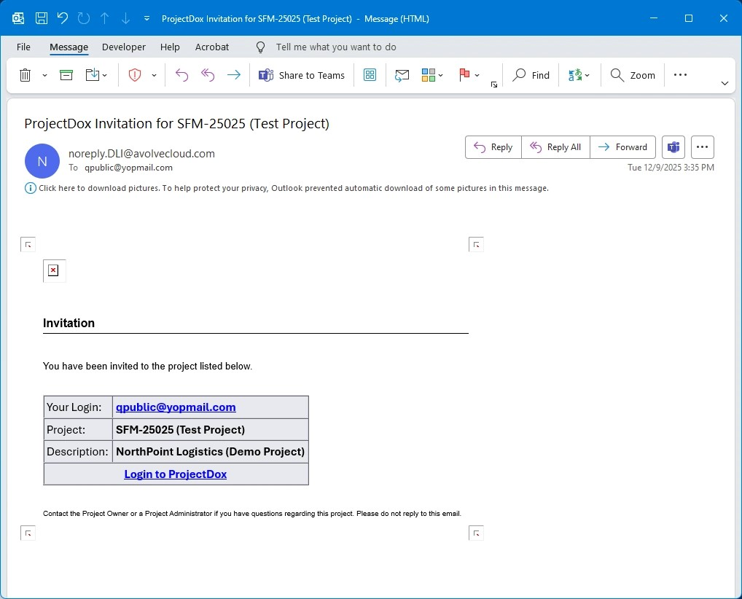

Part 1.2: email notification about task assignment
After the project is started and project files are ready to be uploaded, you will be notified through email as shown in the picture below. Action is needed to upload project files.

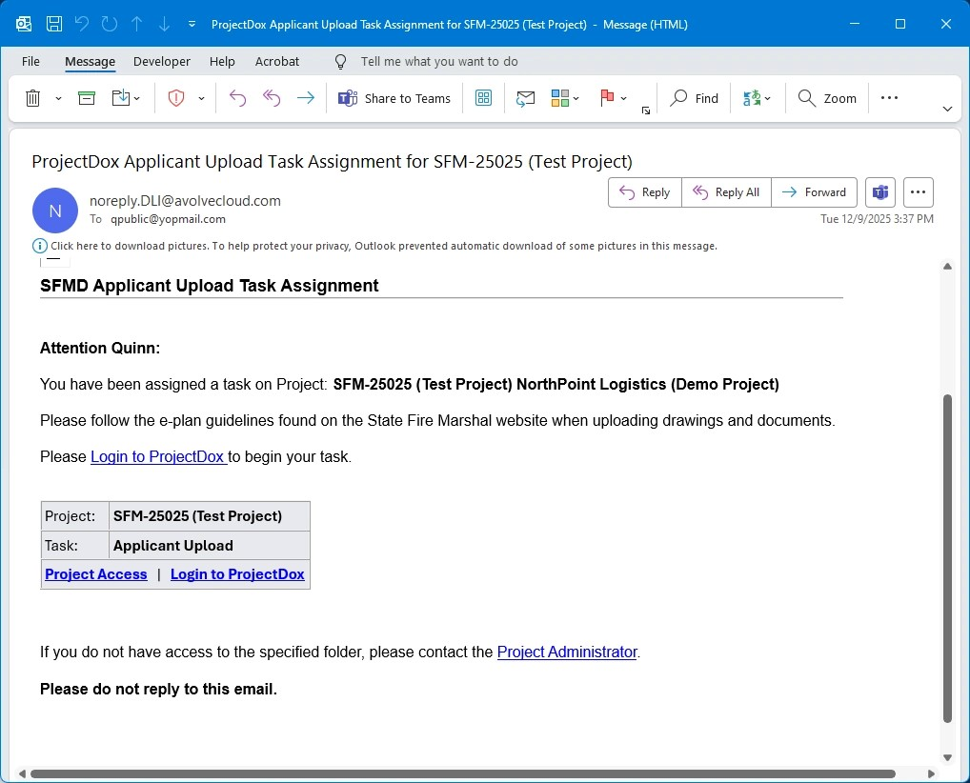

Part 2: logging in
If you are not currently signed into your ProjectDox user account when receiving the task assignment email notification, go to the log in page as shown in the picture below and then:
- Enter your email address and password.
- Click on the “Login” button.

Part 3: accepting task
On the dashboard, click on the “Open” button under the “Tasks” column to accept and begin the task as shown in the picture below.

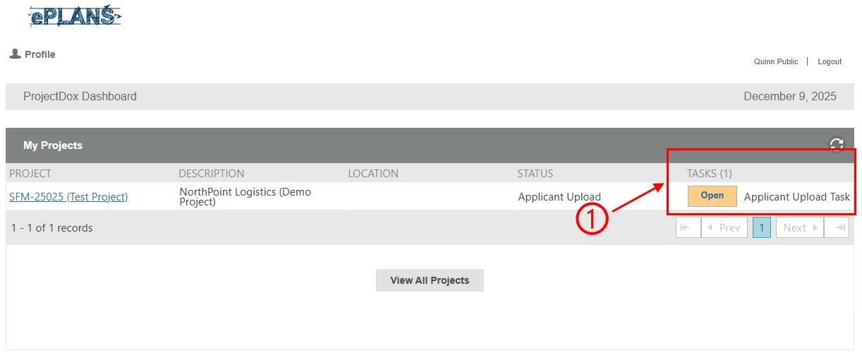

Part 4: e-form pop-up window
A new pop-up window will appear as shown in the picture below. This window is called the e-form. The e-form includes steps on how to complete the task.

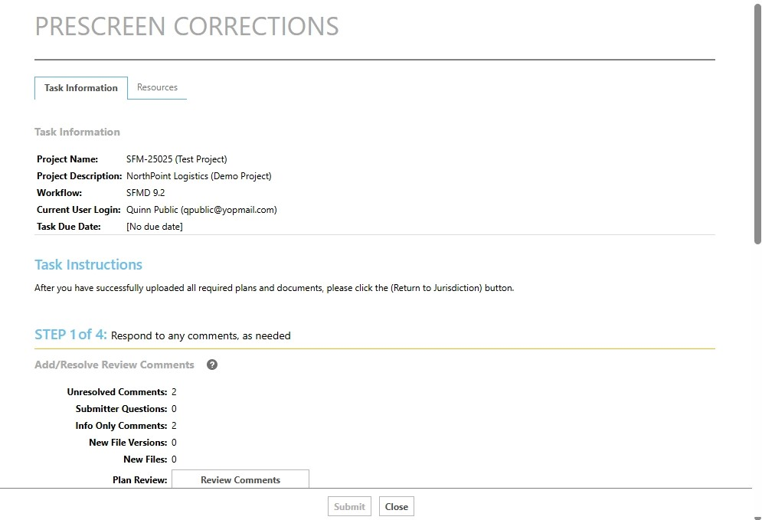

Part 5: uploading project files from the e-form window
You must upload all required project files into the three predefined folders as outlined in the picture below. There are three subparts below – one for drawings, one for hydraulic calculations, and one for documents. The three subparts below are similar but require different files.

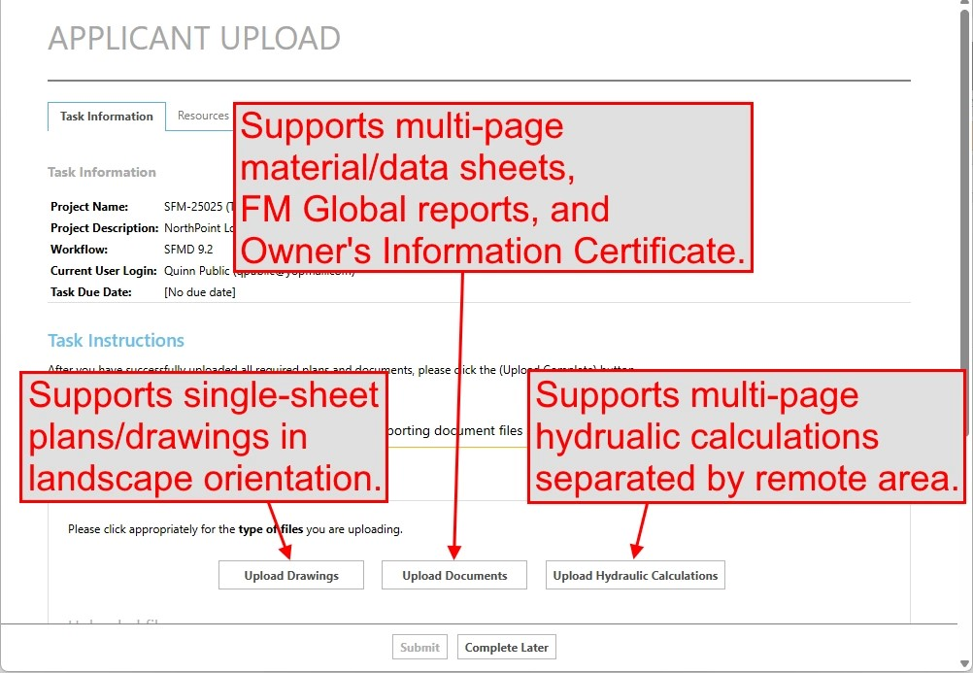

Part 5.1: uploading files to the drawings folder
Any drawing related files must be uploaded to the drawings folder.
- For hydraulic calculations, go to part 5.2 below.
- For documents, go to part 5.3 below.

Part 5.1.1: selecting the drawings folder
To upload drawing files to the drawings folder, click on the “Upload Drawings” button as shown in the picture below.

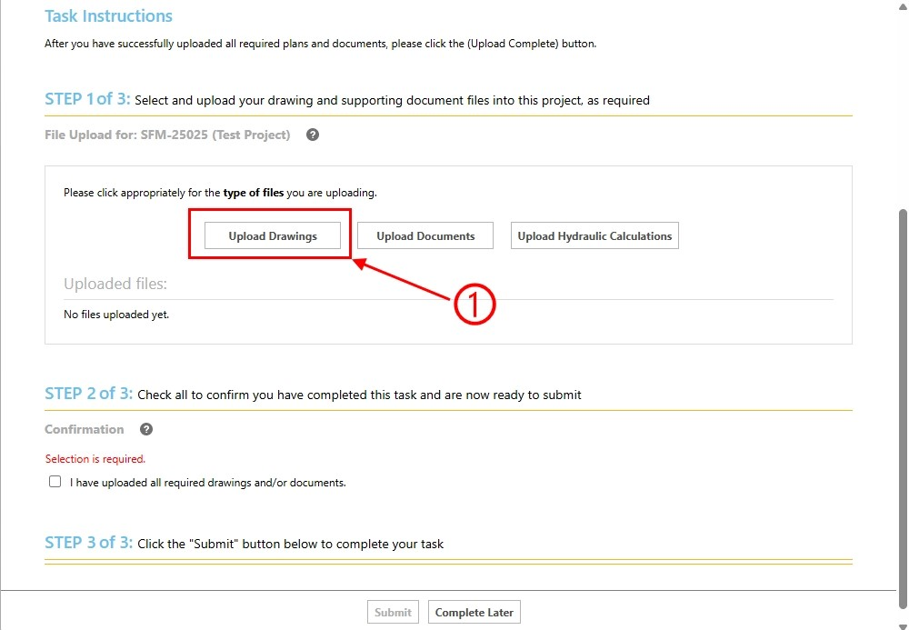

Part 5.1.2: e-form’s folder pop-up window
A new pop-up window will appear as shown in the picture below. We will call this the e-form’s folder pop-up window. You can either drag and drop the drawing files from your file explorer window or use the “Browse For Files” button.

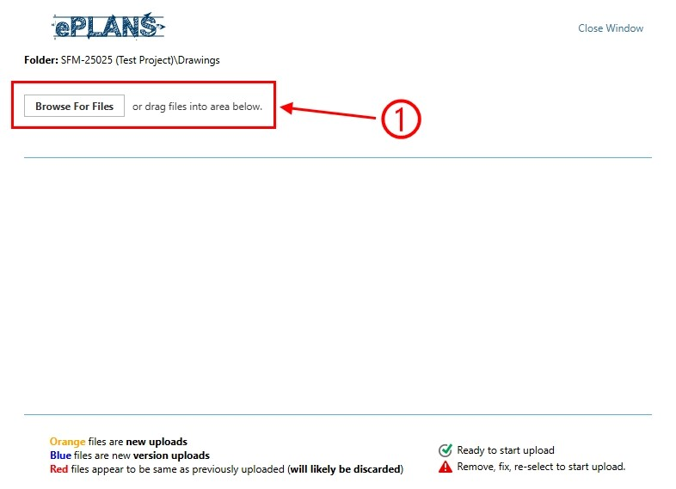

Part 5.1.3: computer’s file explorer dialog
There are two methods to add drawing files to the e-form’s folder pop-up window:
- You can drag and drop them, or
- You can click on the “Browse For Files” button.
Since both methods are similar, we will demonstrate using the second method as shown in the picture below. Once the file explorer is visible:
- Navigate to the location where the drawing files are on your computer.
- Select all applicable drawing files.
- Click on the “Open” button to select them.

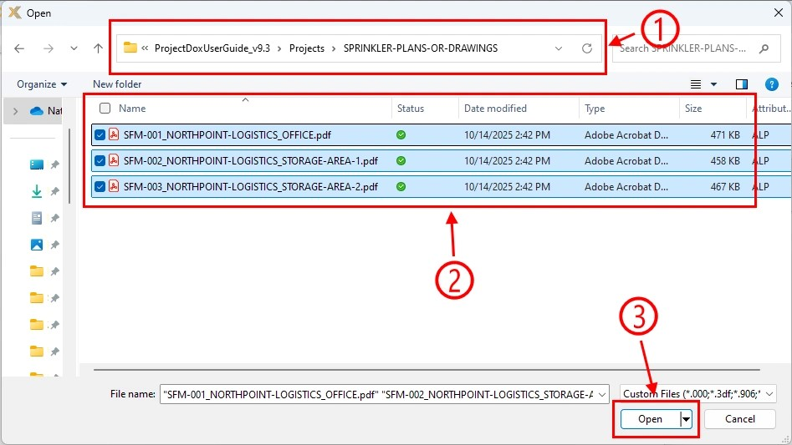

Part 5.1.4: upload files
After adding all applicable drawing files to the e-form’s folder pop-up window, make sure to click on the “Start Upload” button to upload them as shown in the picture below.

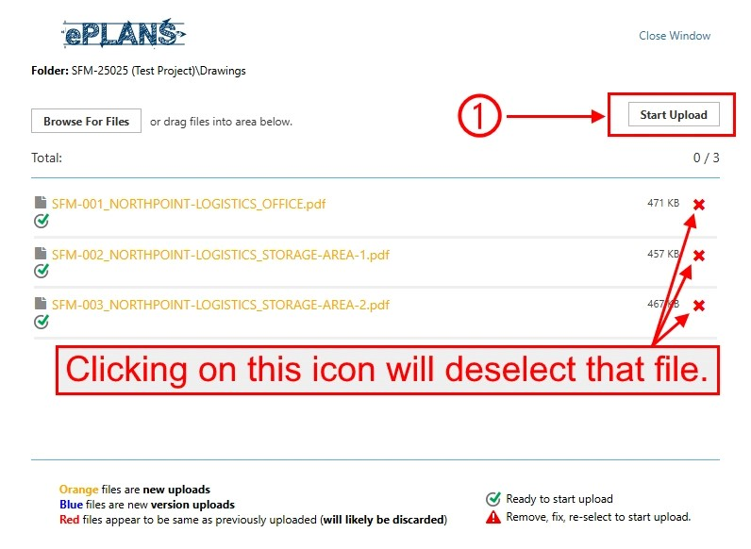

Part 5.1.5: uploaded files
Once the drawing files finish uploading, the e-form’s folder pop-up window will automatically close. If you need to add additional drawing files, go to part 5.1.1 above. Back in the e-form, you can view all files uploaded to the drawings folder as shown in the picture below. You can also remove any uploaded file added in error.

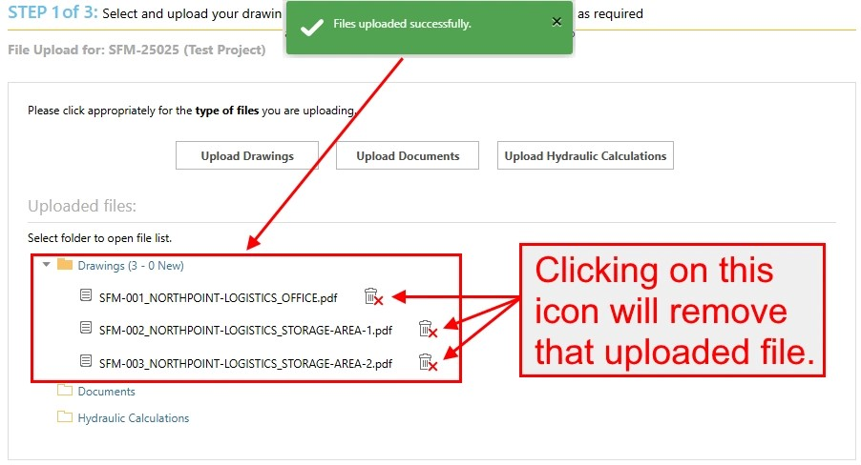

Part 5.2: uploading files to the hydraulic calculations folder
Any hydraulic calculation related files must be uploaded to the hydraulic calculations folder.
- For drawings, go to part 5.1 above.
- For documents, go to part 5.3 below.

Part 5.2.1: selecting the hydraulic calculations folder
To upload hydraulic calculation files to the hydraulic calculations folder, click on the “Upload Hydraulic Calculations” button as shown in the picture below.

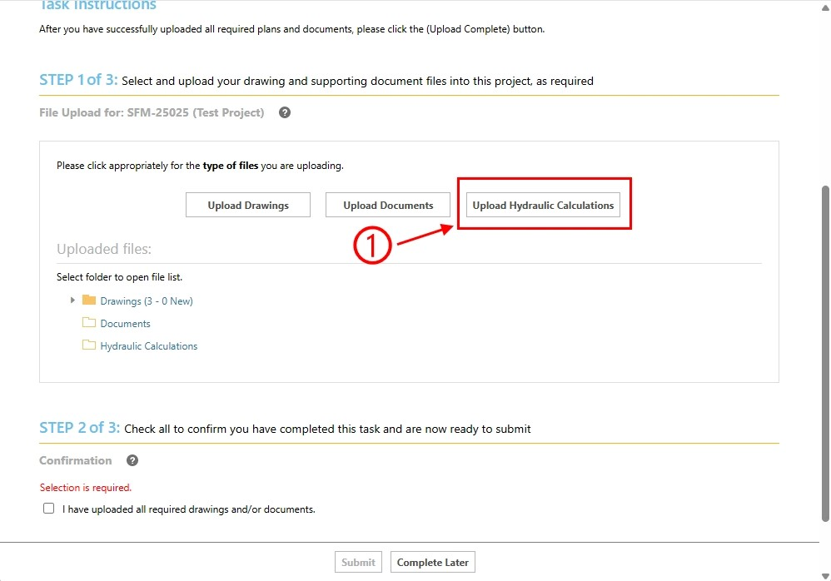

Part 5.2.2: e-form’s folder pop-up window
A new pop-up window will appear as shown in the picture below. We will call this the e-form’s folder pop-up window. You can either drag and drop the hydraulic calculation files from your file explorer window or use the “Browse For Files” button.

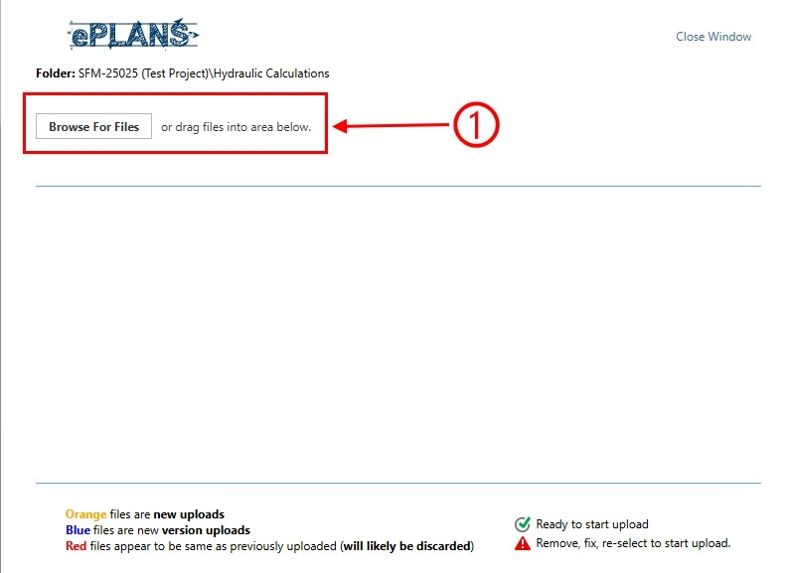

Part 5.2.3: computer’s file explorer dialog
There are two methods to add hydraulic calculation files to the e-form’s folder pop-up window:
- You can drag and drop them, or
- You can click on the “Browse For Files” button.
Since both methods are similar, we will demonstrate using the second method as shown in the picture below. Once the file explorer is visible:
- Navigate to the location where the hydraulic calculation files are on your computer.
- Select all applicable hydraulic calculation files.
- Click on the “Open” button to select them.

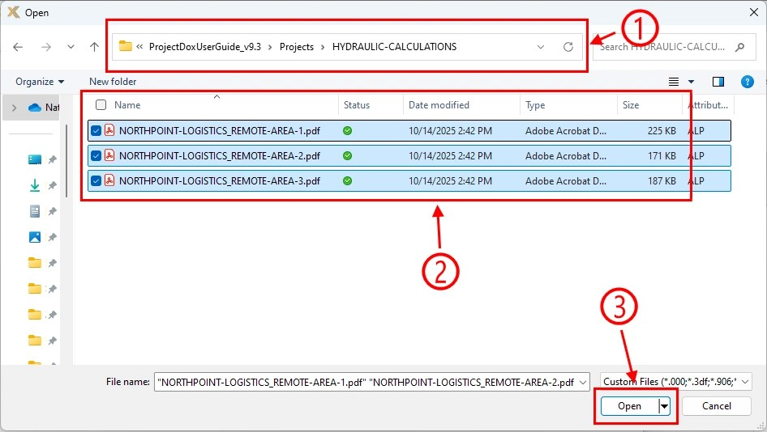

Part 5.2.4: upload files
After adding all applicable hydraulic calculation files to the e-form’s folder pop-up window, make sure to click on the “Start Upload” button to upload them as shown in the picture below.

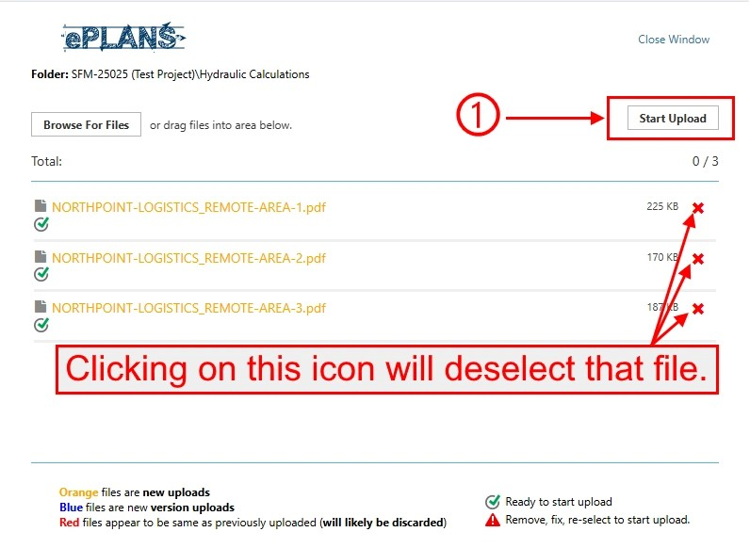

Part 5.2.5: uploaded files
Once the hydraulic calculation files finish uploading, the e-form’s folder pop-up window will automatically close. If you need to add additional hydraulic calculation files, go to part 5.2.1 above. Back in the e-form, you can view all files uploaded to the hydraulic calculations folder as shown in the picture below. You can also remove any uploaded file added in error.

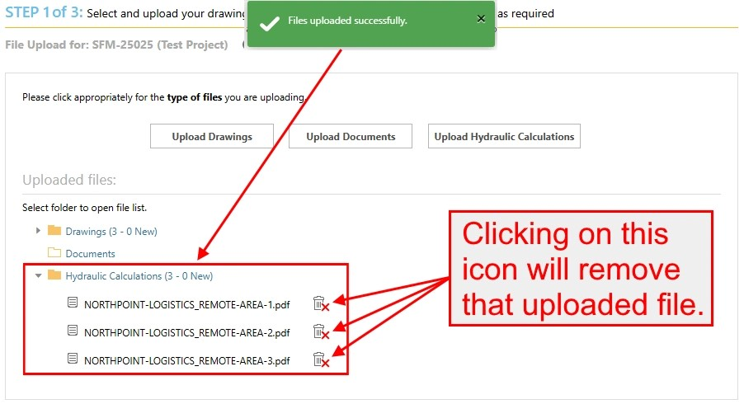

Part 5.3: uploading files to the documents folder
Any file that does not go into the drawings folder and the hydraulic calculations folder must be uploaded to the documents folder, such as data sheets, FM Global report, and owner’s information certificate.
- For drawings, go to part 5.1 above.
- For hydraulic calculations, go to part 5.2 above.

Part 5.3.1: selecting the documents folder
To upload miscellaneous files (i.e., data sheets, FM Global report, owner’s information certificate) to the documents folder, click on the “Upload Documents” button as shown in the picture below.

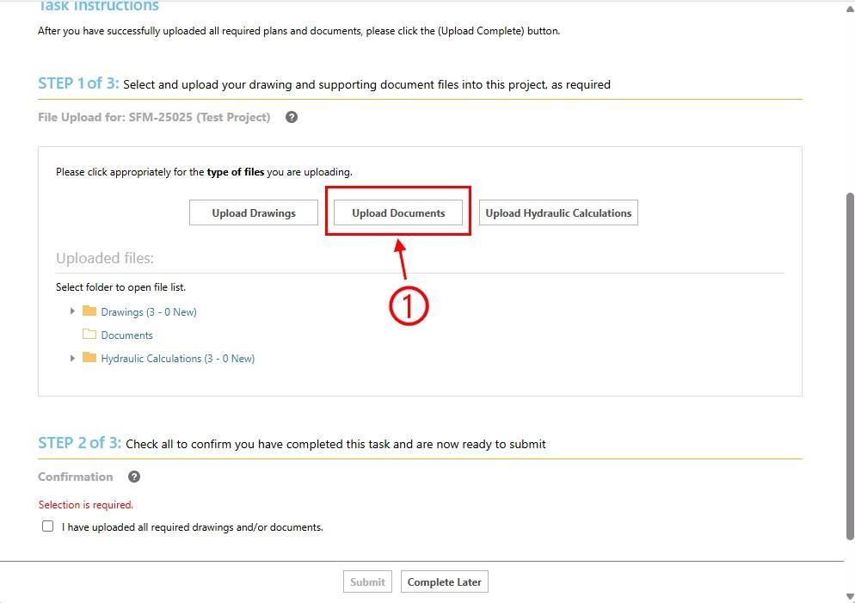

Part 5.3.2: e-form’s folder pop-up window
A new pop-up window will appear as shown in the picture below. We will call this the e-form’s folder pop-up window. You can either drag and drop the miscellaneous files from your file explorer window or use the “Browse For Files” button.

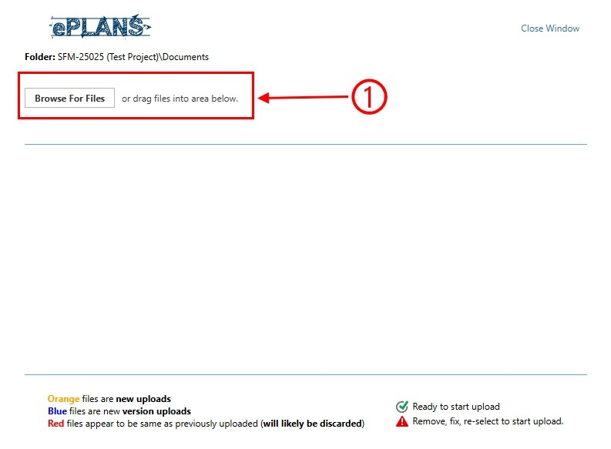

Part 5.3.3: computer’s file explorer dialog
There are two methods to add miscellaneous files to the e-form’s folder pop-up window:
- You can drag and drop them, or
- You can click on the “Browse For Files” button.
Since both methods are similar, we will demonstrate using the second method as shown in the picture below. Once the file explorer is visible:
- Navigate to the location where the miscellaneous files are on your computer.
- Select all applicable miscellaneous files.
- Click on the “Open” button to select them.

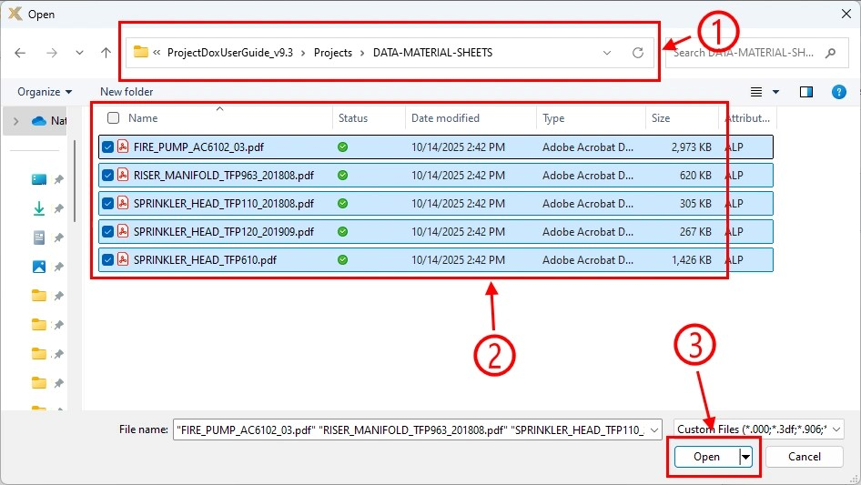

Part 5.3.4: upload files
After adding all applicable miscellaneous files to the e-form’s folder pop-up window, make sure to click on the “Start Upload” button to upload them as shown in the picture below.

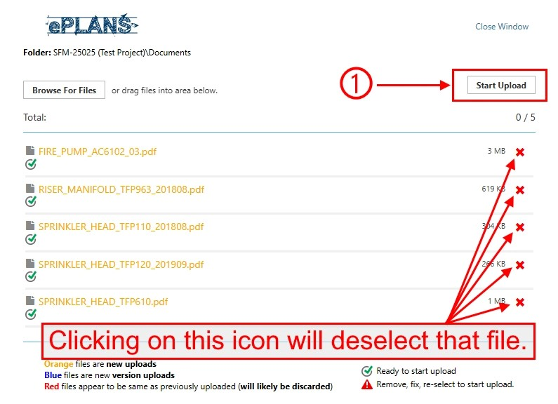

Part 5.3.5: uploaded files
Once the miscellaneous files finish uploading, the e-form’s folder pop-up window will automatically close. If you need to add additional files, go to part 5.3.1 above. Back in the e-form, you can view all files uploaded to the documents folder as shown in the picture below. You can also remove any uploaded file added in error.

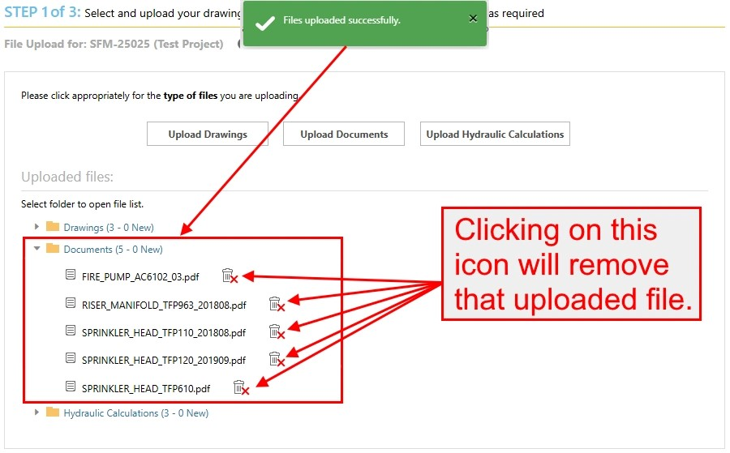

Part 6: completing task
After all project files are uploaded, you must complete the task to move it to the next step. As shown in the picture below:
- Read and then check the checkbox.
- Click on the “Submit” button.

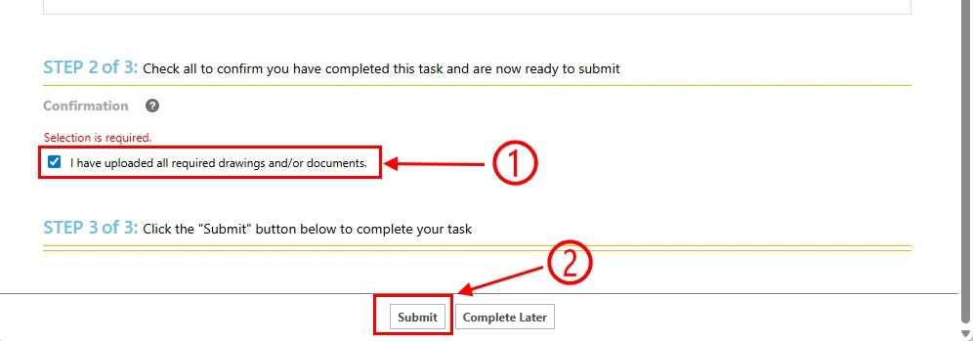

Part 7: dashboard
From the dashboard, the task is completed and will disappear from your “Tasks” column as shown in the picture below.

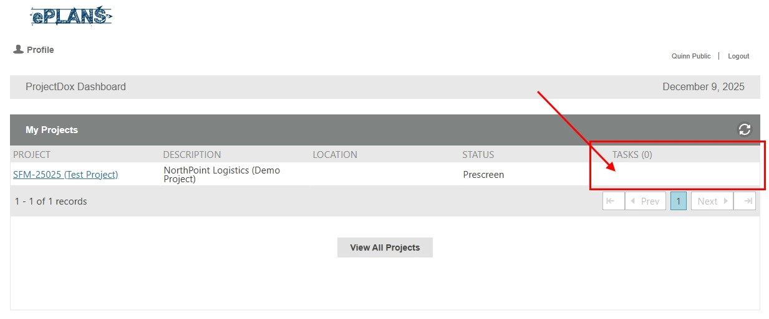

Part 8: logging out
If you do not need to complete any other tasks, you can log out by clicking on the “Logout” button as shown in the picture below.

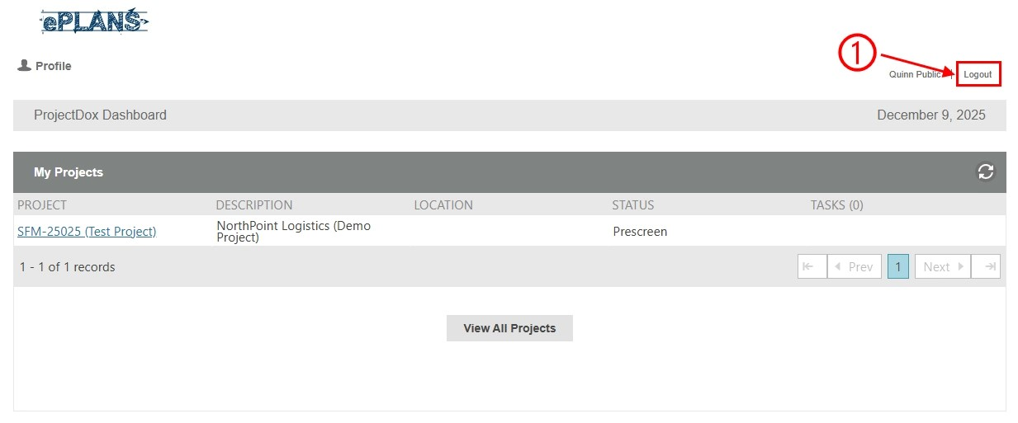

Part 9: email notification about upload completed
After the task is completed, you will receive an email notification as shown in the picture below of all the uploaded files.

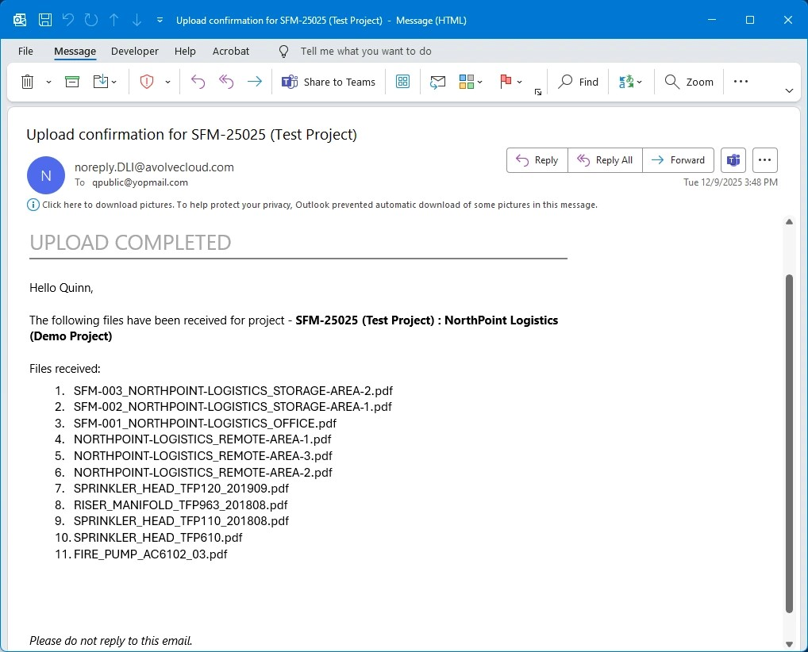

Part 10: next step
The SFM coordinator will begin the prescreen review process to determine if the files meet the submission guidelines section of this user guide.
- If the files do not meet the requirements of that section, the applicant must fix any issues identified by the SFM coordinator. An example is demonstrated in the applicant prescreen corrections task section.
- If the files meet the requirements of that section, the project will move to the plan review process. An SFM plan reviewer will be assigned to the project, and it will be reviewed for code compliance in the order it was received. You will be notified through email when this happens as shown in the picture below.

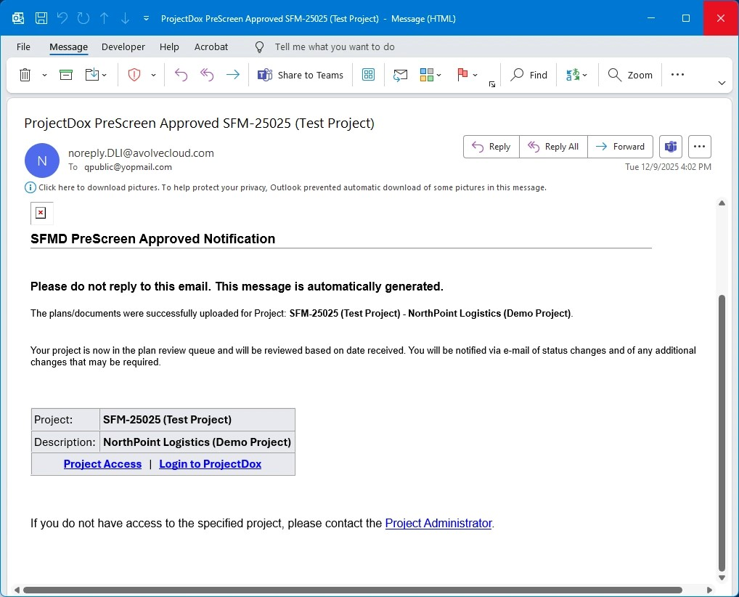

Applicant prescreen corrections task
If any issues were found during the prescreen review process, then the applicant prescreen corrections task is the second step in the workflow. To complete this task, the applicant must correct any issues identified by the SFM coordinator. The most common issues will be related to file naming convention or missing files.

After the applicant completes this task, it will move to another cycle of the prescreen task, which is completed by the SFM coordinator, to ensure the files meet the submission guidelines of this user guide.

The 10 parts below illustrate how to complete this task.

Part 1: email notification about task assignment
After a cycle of the prescreen review process is completed with issues found, you will be notified through email as shown in the picture below. Action is needed to fix the issues.

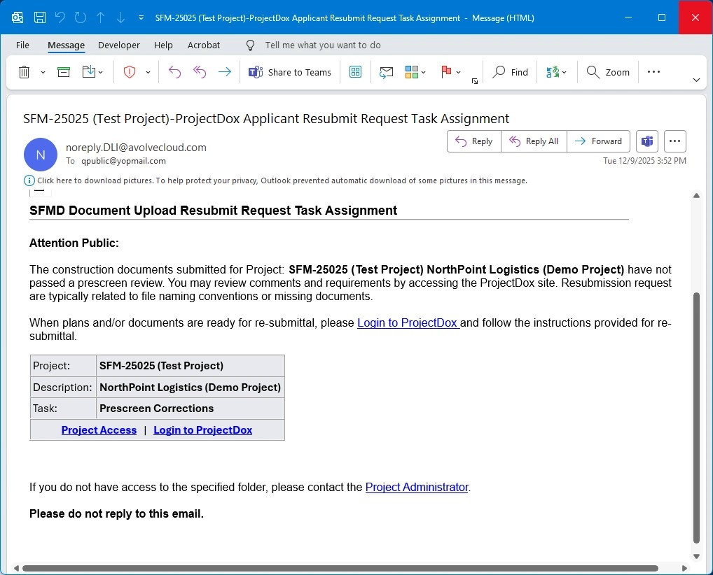

Part 2: logging in
If you are not currently signed into your ProjectDox user account when receiving the task assignment email notification, go to the log in page as shown in the picture below and then:
- Enter your email address and password.
- Click on the “Login” button.

Part 3: accepting task
On the dashboard, click on the “Open” button under the “Tasks” column to accept and begin the task as shown in the picture below.

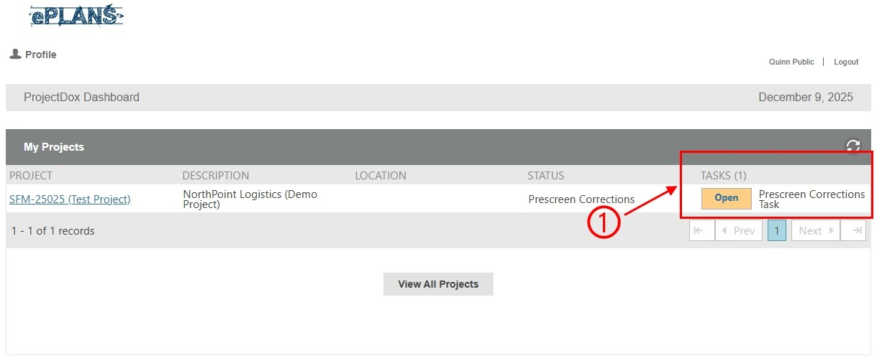

Part 4: e-form pop-up window
A new pop-up window, which is called the e-form, will appear as shown in the picture below. The e-form includes steps on how to complete the task.

Part 5: reviewing comments and uploading missing project file from the e-form window
You should review the comments made by the SFM coordinator to determine what issues must be fixed. Since this task could have several reasons why it failed the prescreen review, we will give an example of a missing file as stated in the picture below.

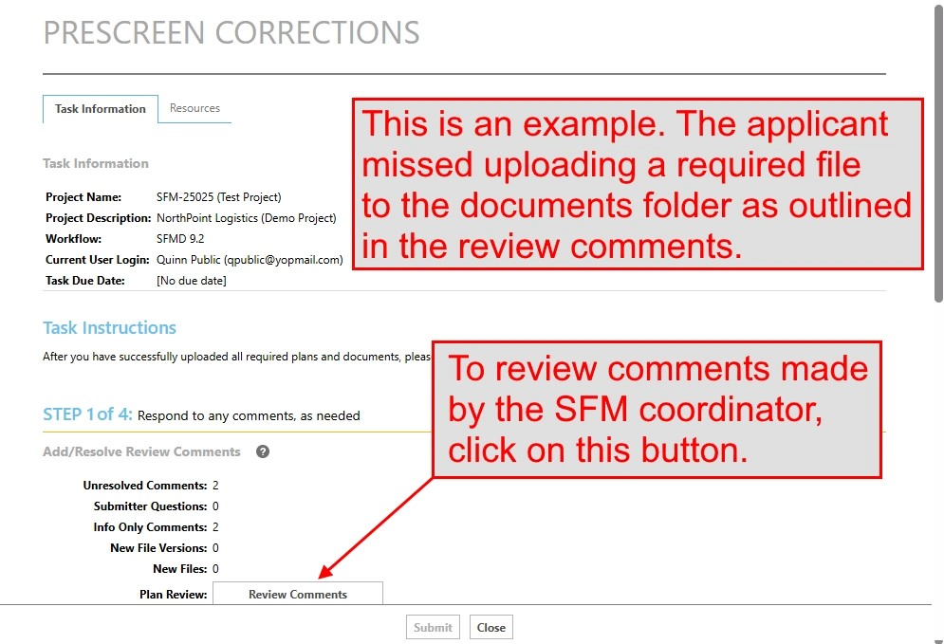

Part 5.1: review comments
Any issues found during the prescreen review process will show up in the review comments.

Part 5.1.1: reviewing comments
To view the review comments, click on the “Review Comments” button as shown in the picture below.

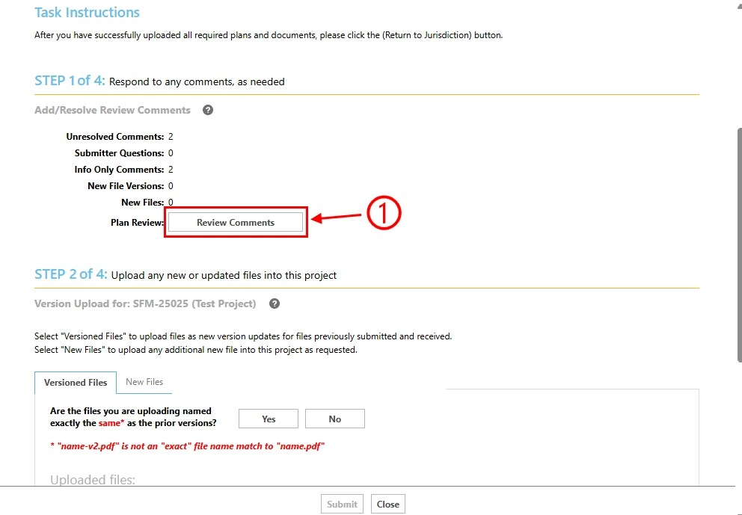

Part 5.1.2: e-form’s comment pop-up window
A new pop-up window will appear as shown in the picture below. Within that window:
- Read all comments.
- If a response is needed, add one.
- Once done, click on the “Close Window” link.

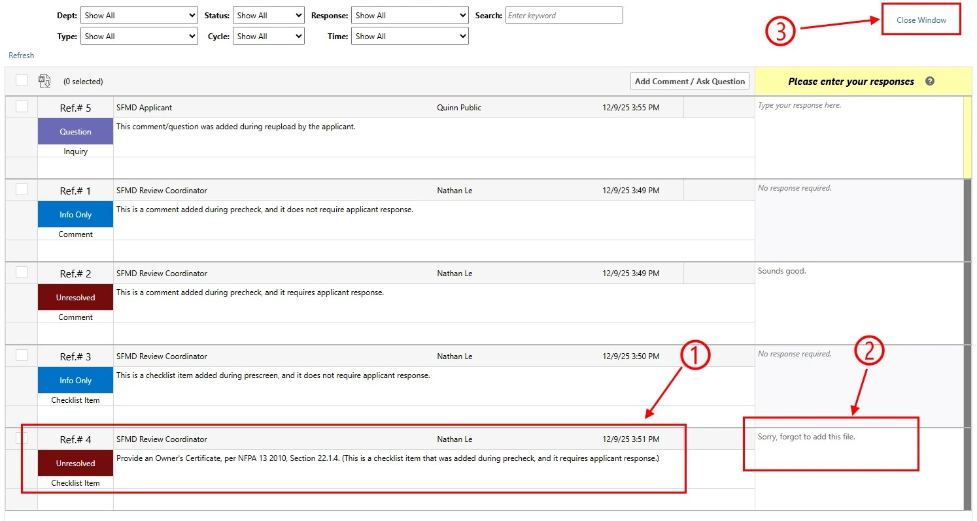

Part 5.2: uploading missing file to the documents folder
This example requires the applicant to upload a file to the documents folder that was missing during the initial upload.

Part 5.2.1: selecting the documents folder
To upload the missing file to the documents folder for this example as shown in the picture below:
- Make sure to select the “New Files” tab.
- Click on the “Upload Documents” button.

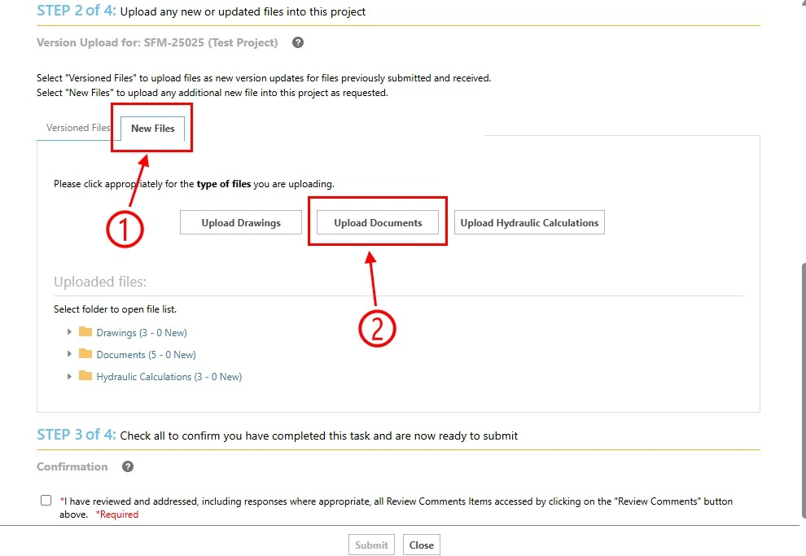

Part 5.2.2: e-form’s folder pop-up window
A new pop-up window will appear as shown in the picture below. We will call this the e-form’s folder pop-up window. You can either drag and drop the files from your file explorer window or use the “Browse For Files” button.

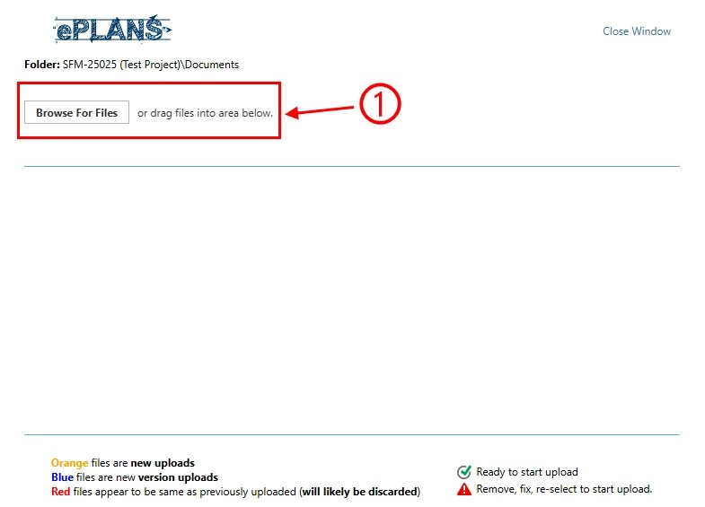

Part 5.2.3: computer’s file explorer dialog
There are two methods to add files to the e-form’s folder pop-up window:
- You can drag and drop them, or
- You can click on the “Browse For Files” button.
Since both methods are similar, we will demonstrate using the second method as shown in the picture below. Once the file explorer is visible:
- Navigate to the location where the files are on your computer.
- Select all applicable files.
- Click on the “Open” button to select them.

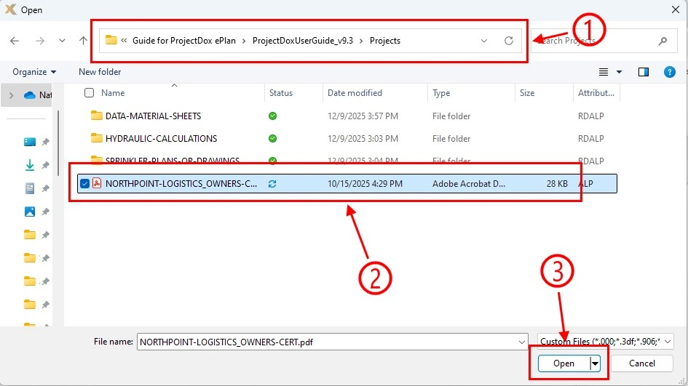

Part 5.2.4: upload file
After adding all applicable files to the e-form’s folder pop-up window, make sure to click on the “Start Upload” button to upload them as shown in the picture below.

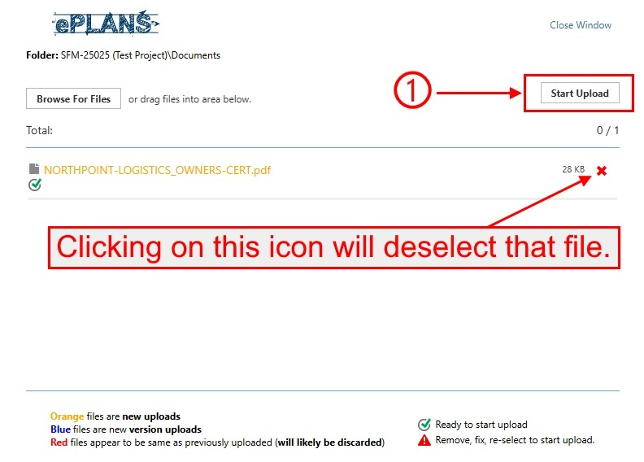

Part 5.2.5: uploaded file
Once the files finish uploading, the e-form’s folder pop-up window will automatically close. If you need to add additional, go to part 5.2.1 above. Back in the e-form, you can view all files uploaded to the hydraulic calculations folder as shown in the picture below. You can also remove any uploaded file added in error.

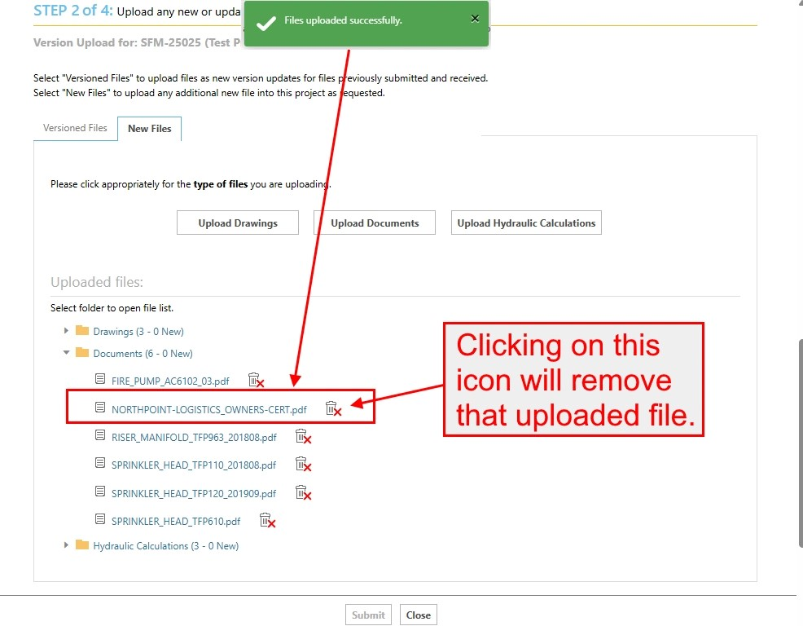

Part 6: completing task
After fixing all issues noted by the SFM coordinator, you must complete the task to move it to the next step. As shown in the picture below:
- Read and then check the checkbox.
- Click on the “Submit” button.

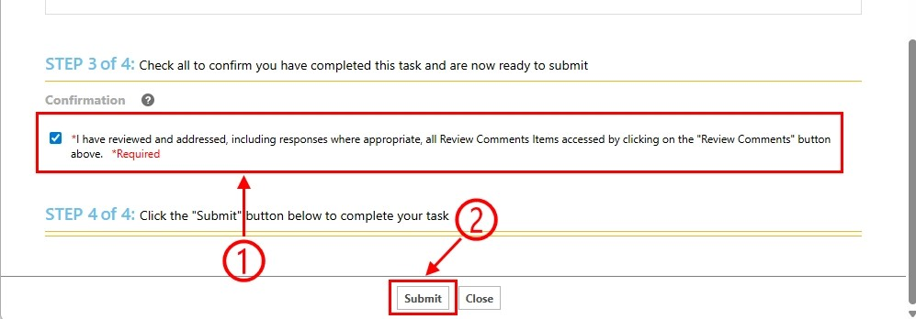

Part 7: dashboard
From the dashboard, the task is completed and will disappear from your “Tasks” column as shown in the picture below.

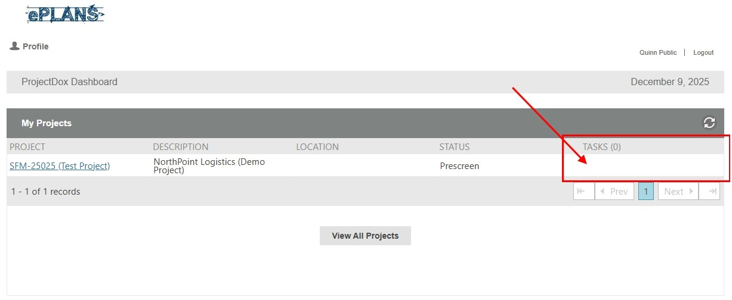

Part 8: logging out
If you do not need to complete any other tasks, you can log out by clicking on the “Logout” button as shown in the picture below.

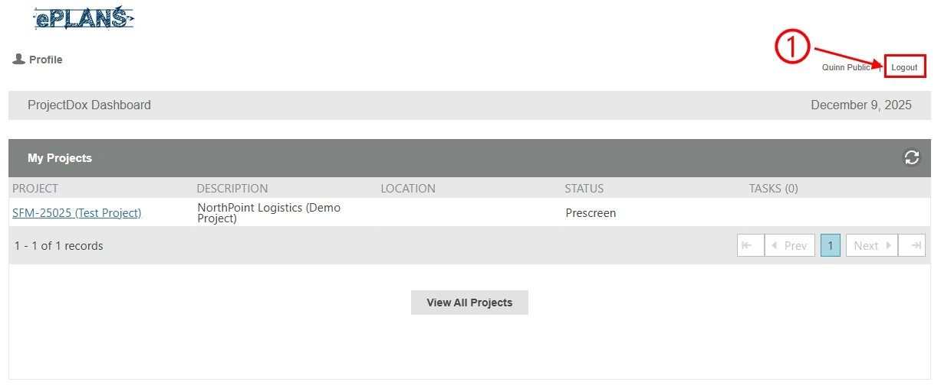

Part 9: email notification about upload completed
After the task is completed, you will receive an email notification as shown in the picture below of all the uploaded files.

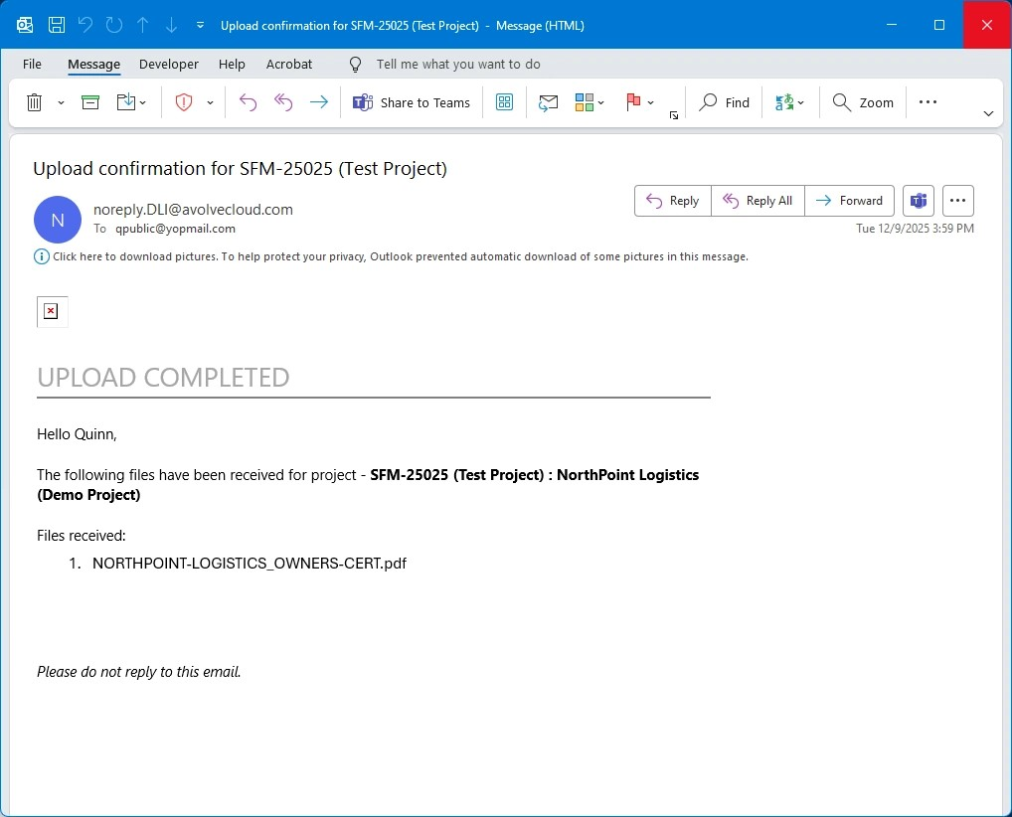

Part 10: next step
The SFM coordinator will begin another cycle of the prescreen review process to determine if the files meet the submission guidelines section of this user guide.
- If the files do not meet the requirements of that section, the applicant must fix any issues identified by the SFM coordinator. An example is demonstrated in this section.
- If the files meet the requirements of that section, the project will move to the plan review process. An SFM plan reviewer will be assigned to the project, and it will be reviewed for code compliance in the order it was received. You will be notified through email when this happens as shown in the picture below.

Applicant resubmit task
If any code violations were found during the plan review process, then the applicant resubmit task is the third step in the workflow. To complete this task, the applicant must correct all code violations identified by the SFM plan reviewer.

After the applicant completes this task, it will move to the prescreen task, which is completed by the SFM coordinator, to ensure the files meet the submission guidelines section of this user guide. After a quick look, it will move to another cycle of the SFMD fire plan reviewer department review task, which is completed by the assigned SFM plan reviewer, to ensure the project complies with applicable fire safety and fire protection laws, rules, and standards.

The 10 parts below illustrate how to complete this task.

Part 1: email notification about task assignment
After a cycle of the plan review process is completed with code violations found, you will be notified through email as shown in the picture below. Action is needed to fix the code violations.

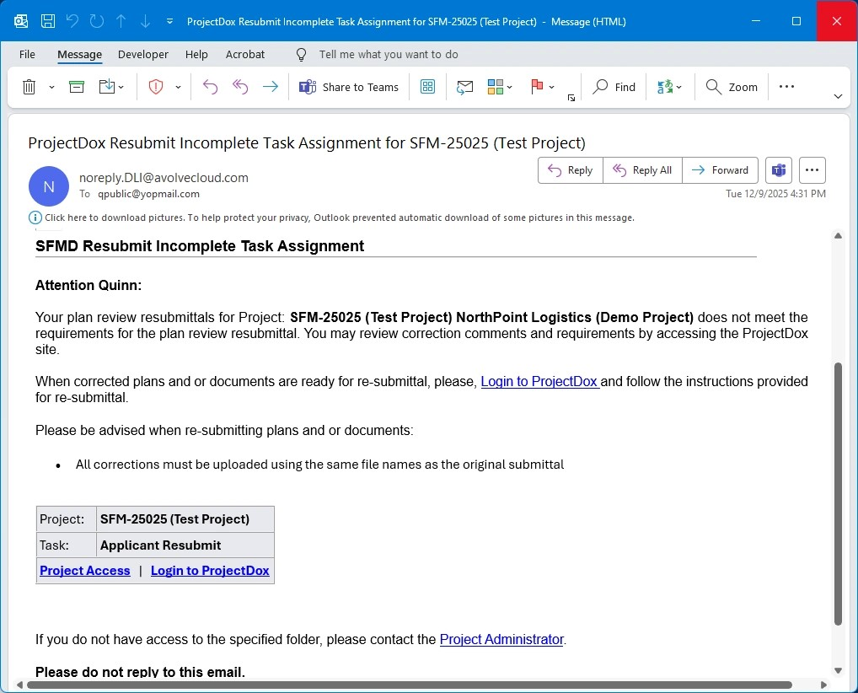

Part 2: logging in
If you are not currently signed into your ProjectDox user account when receiving the task assignment email notification, go to the log in page as shown in the picture below and then:
- Enter your email address and password.
- Click on the “Login” button.

Part 3: accepting task
On the dashboard, click on the “Open” button under the “Tasks” column to accept and begin the task as shown in the picture below.

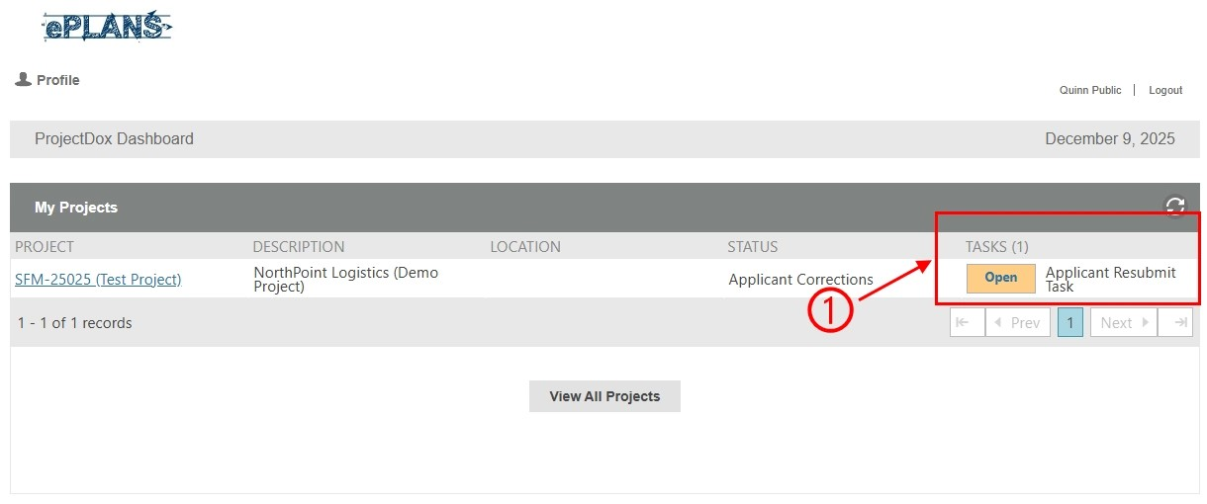

Part 4: e-form pop-up window
A new pop-up window, which is called the e-form, will appear as shown in the picture below. The e-form includes steps on how to complete the task.

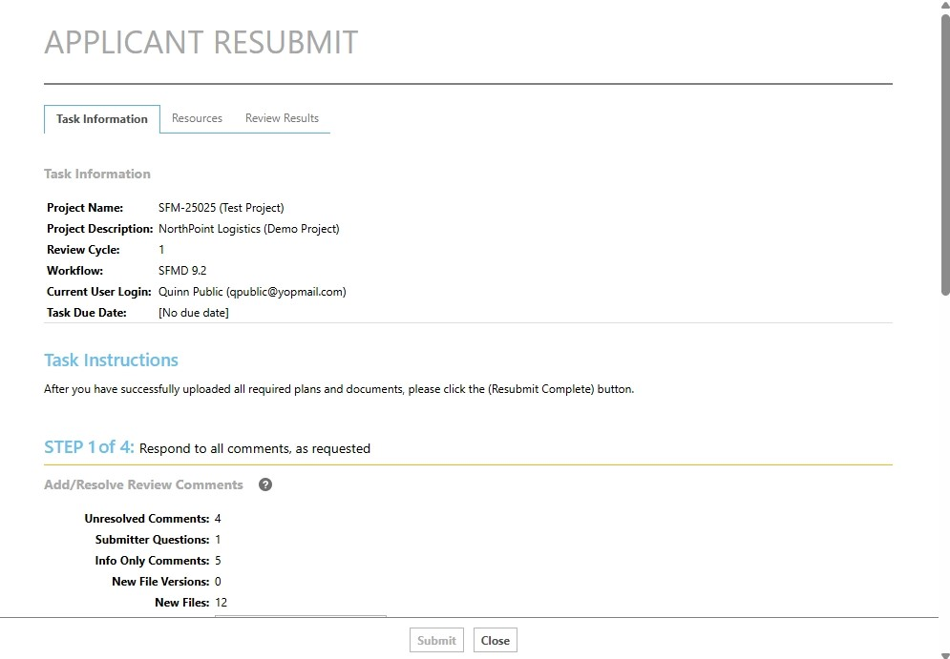

Part 5: reviewing comments and uploading revised project files from the e-form window
You should review the comments made by the SFM plan reviewer to determine what code violations must be fixed. Since this task could have several reasons why it failed the plan review, we will give an example of uploading revisions for one drawing file and one hydraulic calculation file that was marked up by the SFM plan reviewer as stated in the picture below.

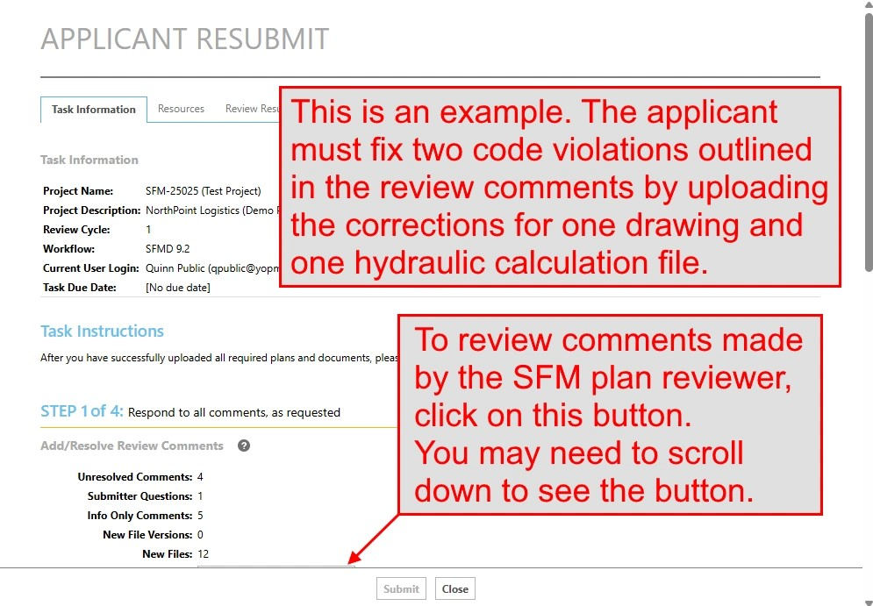

Part 5.1: review comments
Any code violations found during the plan review process will show up in the review comments.

Part 5.1.1: reviewing comments
To view the review comments, click on the “Review Comments” button as shown in the picture below.

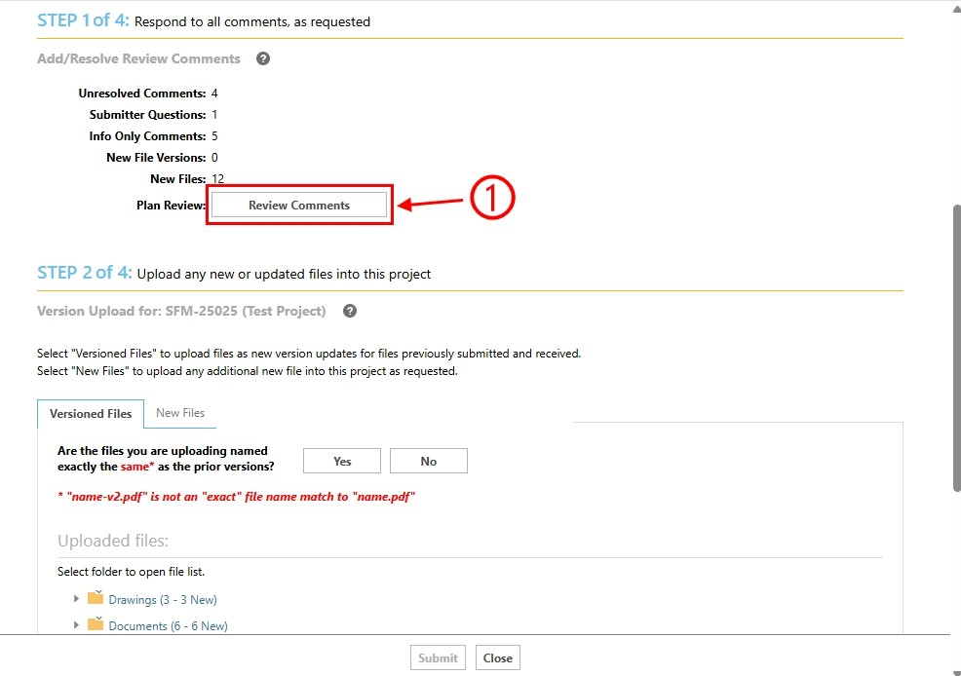

Part 5.1.2: e-form’s comment pop-up window
A new pop-up window will appear as shown in the picture below. Within that window:
- Read all comments.
- If a response is needed, add one.
- Once done, click on the “Close Window” link.

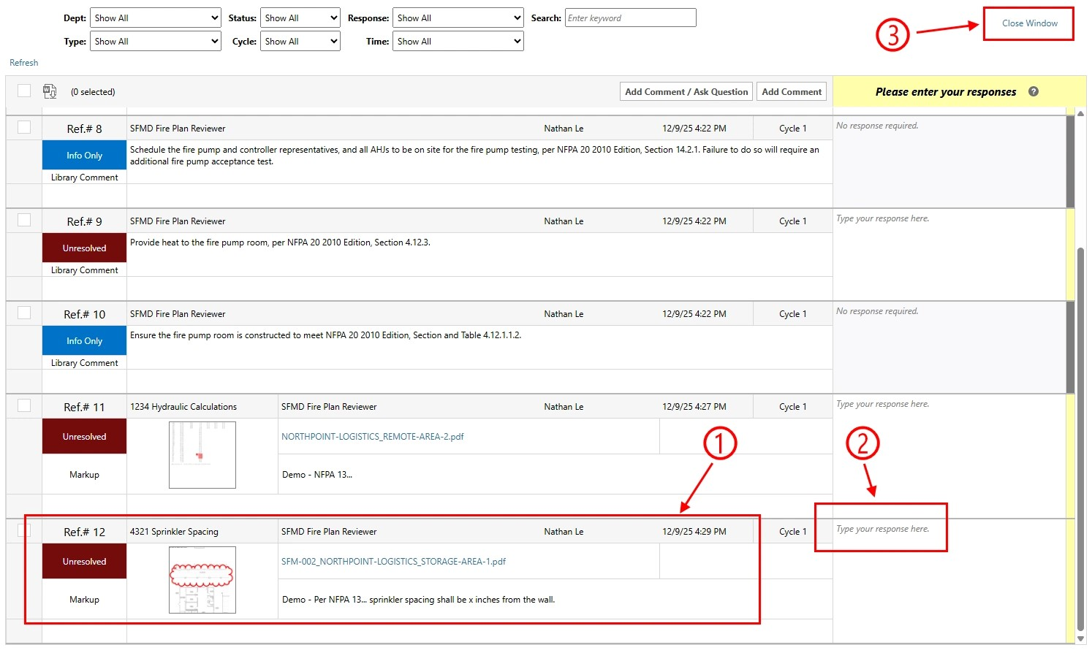

Part 5.2: uploading corrected file to the drawings folder
This example requires the applicant to upload a revised drawing file to the drawings folder after fixing the code violation.

Part 5.2.1: selecting the drawings folder
In this example, a revised file must be uploaded to the drawings folder; therefore, in the picture below:
- Make sure to select the “Versioned Files” tab.
- Either click on the “Yes” or “No” buttons depending on the situation. In this example, the file name is the same, so we will click on the “Yes” button. If the file name is different, we would click on the “No” button, which would then display another pop-up window where you can select the file from the project files before picking the new file from your computer.
- Click on the “Upload Drawings” button.

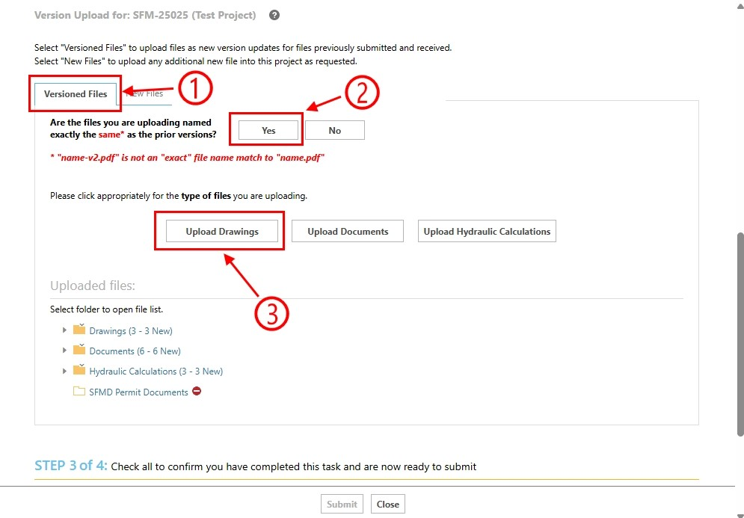

Part 5.2.2: e-form’s folder pop-up window
A new pop-up window will appear as shown in the picture below. We will call this the e-form’s folder pop-up window. You can either drag and drop the files from your file explorer window or use the “Browse For Files” button.

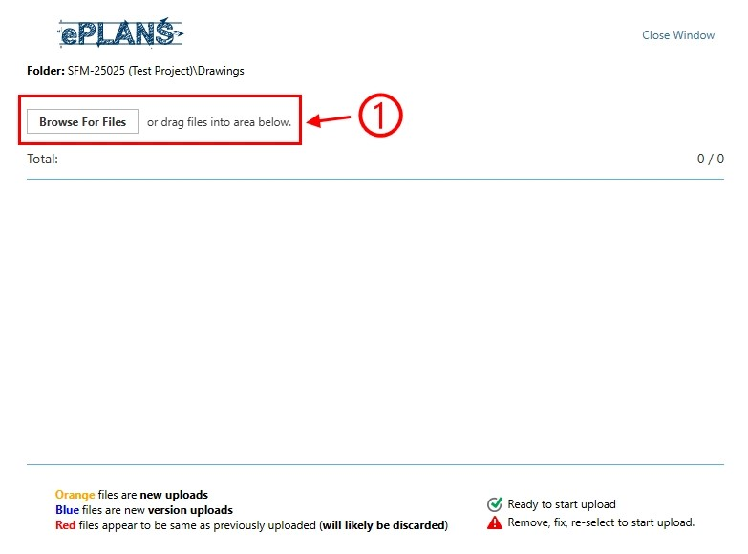

Part 5.2.3: computer’s file explorer dialog
There are two methods to add files to the e-form’s folder pop-up window:
- You can drag and drop them, or
- You can click on the “Browse For Files” button.
Since both methods are similar, we will demonstrate using the second method as shown in the picture below. Once the file explorer is visible:
- Navigate to the location where the drawing files are on your computer.
- Select all applicable drawing files.
- Click on the “Open” button to select them.

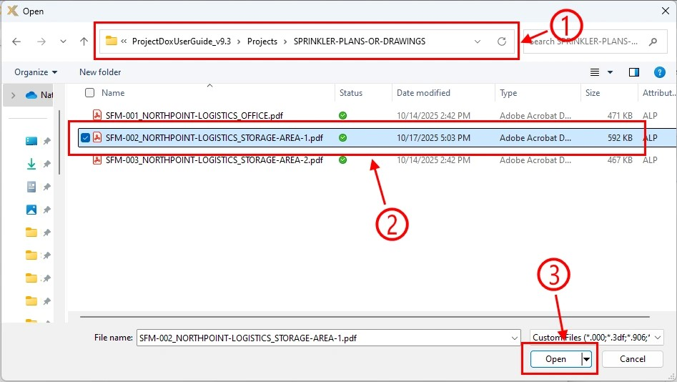

Part 5.2.4: upload file
After adding all applicable drawing files to the e-form’s folder pop-up window, make sure to click on the “Start Upload” button to upload them as shown in the picture below.

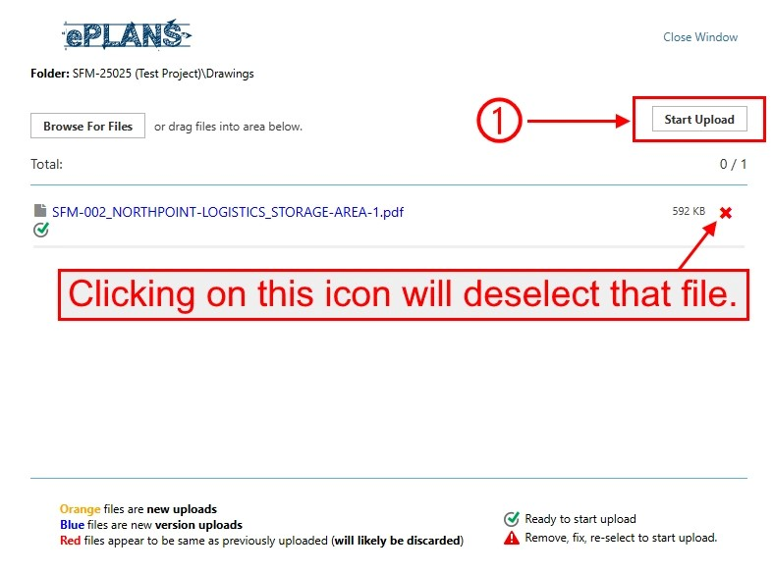

Part 5.2.5: uploaded file
Once the drawing files finish uploading, the e-form’s folder pop-up window will automatically close. If you need to add additional drawing files, go to part 5.2.1 above. Back in the e-form, you can view all revised files uploaded to the drawings folder as shown in the picture below.

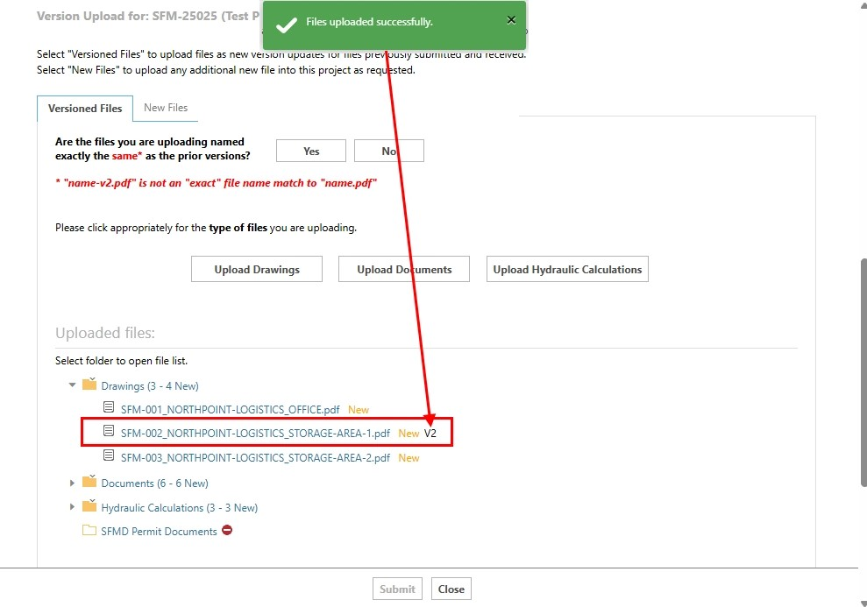

Part 5.3: uploading corrected file to the hydraulic calculations folder
This example requires the applicant to upload a revised hydraulic calculation file to the hydraulic calculations folder after fixing the code violation.

Part 5.3.1: selecting the hydraulic calculations folder
In this example, a revised file must be uploaded to the hydraulic calculations folder; therefore, in the picture below:
- Make sure to select the “Versioned Files” tab.
- Either click on the “Yes” or “No” buttons depending on the situation. For this example, the file name is the same, so we will click on the “Yes” button. If the file name is different, we would click on the “No” button, which would then display another pop-up window where you can select the file from the project files before picking the new file from your computer.
- Click on the “Upload Hydraulic Calculations” button.

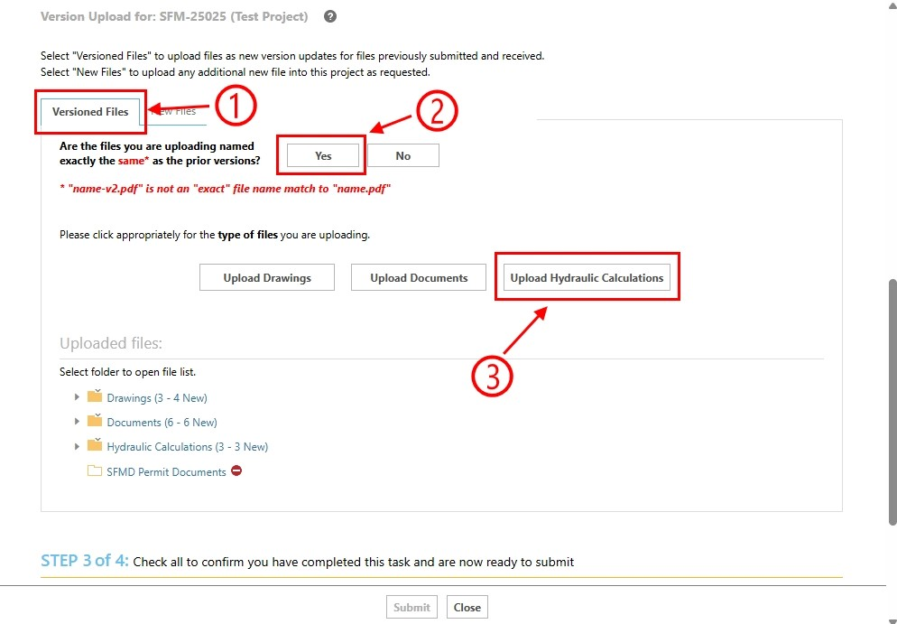

Part 5.3.2: e-form’s folder pop-up window
A new pop-up window will appear as shown in the picture below. We will call this the e-form’s folder pop-up window. You can either drag and drop the files from your file explorer window or use the “Browse For Files” button.

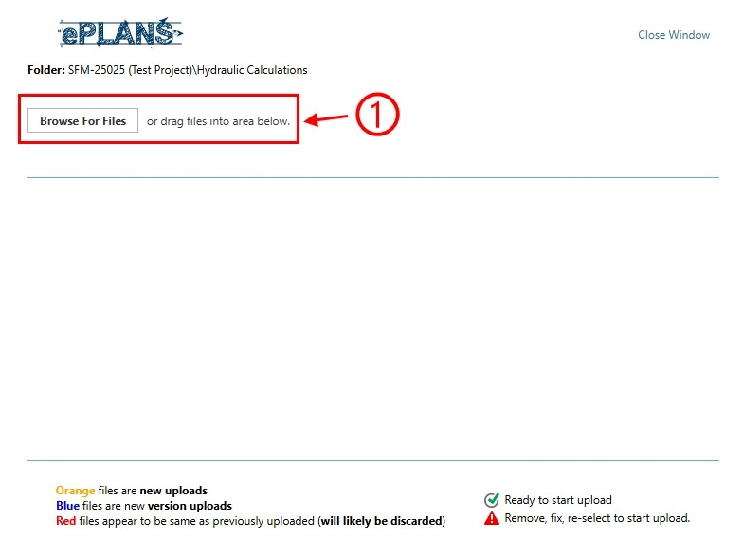

Part 5.3.3: computer’s file explorer dialog
There are two methods to add files to the e-form’s folder pop-up window:
- You can drag and drop them, or
- You can click on the “Browse For Files” button.
Since both methods are similar, we will demonstrate using the second method as shown in the picture below. Once the file explorer is visible:
- Navigate to the location where the hydraulic calculation files are on your computer.
- Select all applicable hydraulic calculation files.
- Click on the “Open” button to select them.

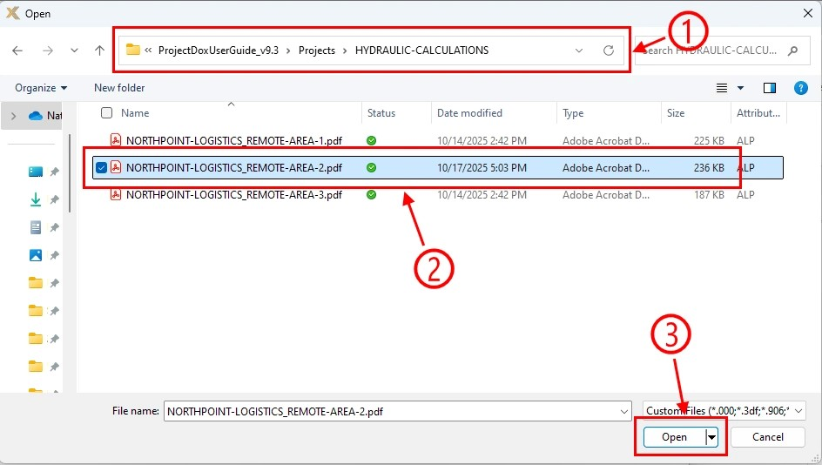

Part 5.3.4: upload file
After adding all applicable hydraulic calculation files to the e-form’s folder pop-up window, make sure to click on the “Start Upload” button to upload them as shown in the picture below.

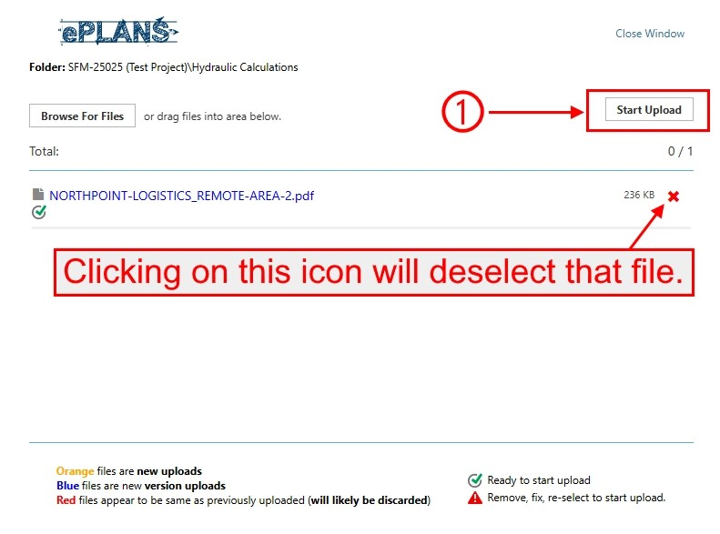

Part 5.3.5: uploaded file
Once the hydraulic calculation files finish uploading, the e-form’s folder pop-up window will automatically close. If you need to add additional hydraulic calculation files, go to part 5.3.1 above. Back in the e-form, you can view all revised files uploaded to the hydraulic calculations folder as shown in the picture below.

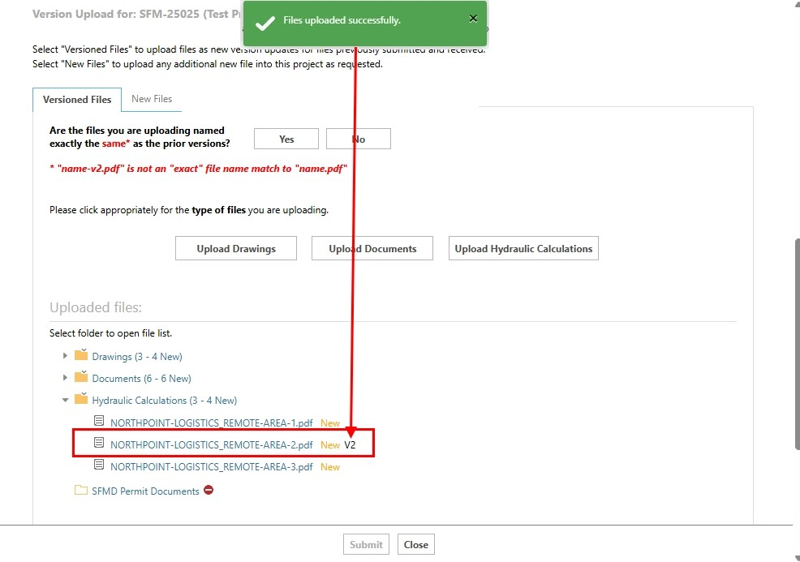

Part 6: completing task
After fixing all code violations identified by the SFM plan reviewer, you must complete the task to move it to the next step. As shown in the picture below:
- Read each checkbox and then check them.
- Click on the “Submit” button.

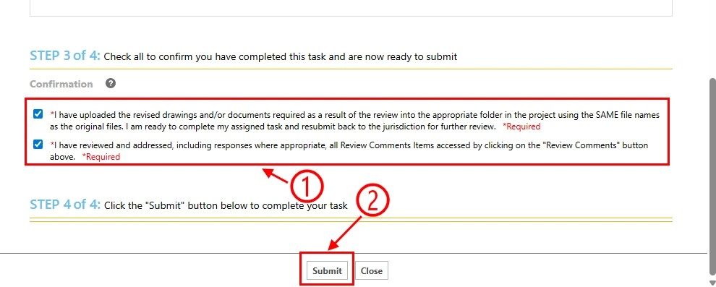

Part 7: dashboard
From the dashboard, the task is completed and will disappear from your “Tasks” column as shown in the picture below.

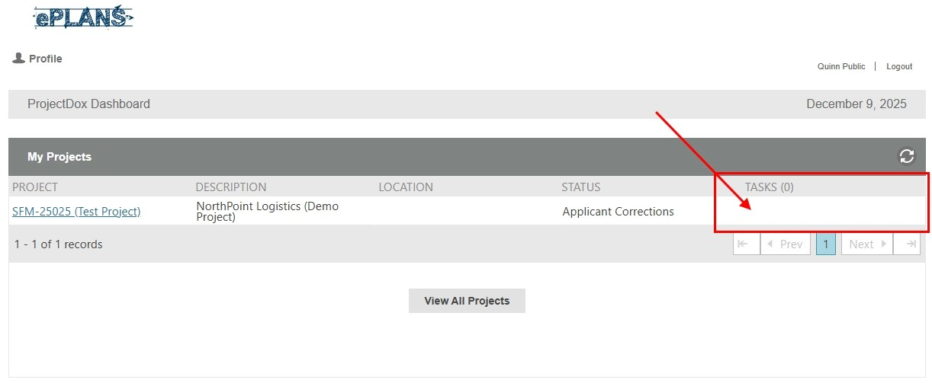

Part 8: logging out
If you do not need to complete any other tasks, you can log out by clicking on the “Logout” button as shown in the picture below.

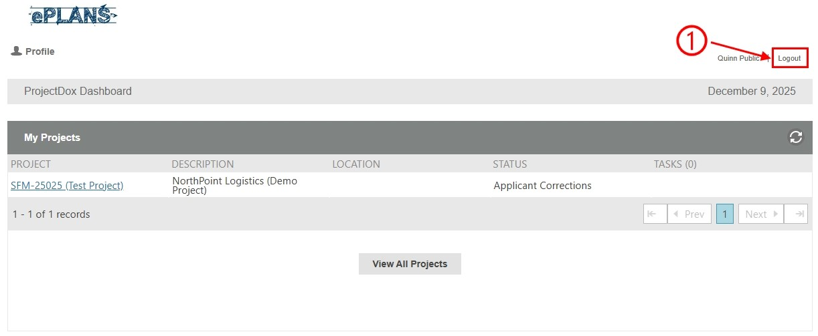

Part 9: email notification about upload completed
After the task is completed, you will receive an email notification as shown in the picture below of all the uploaded files.

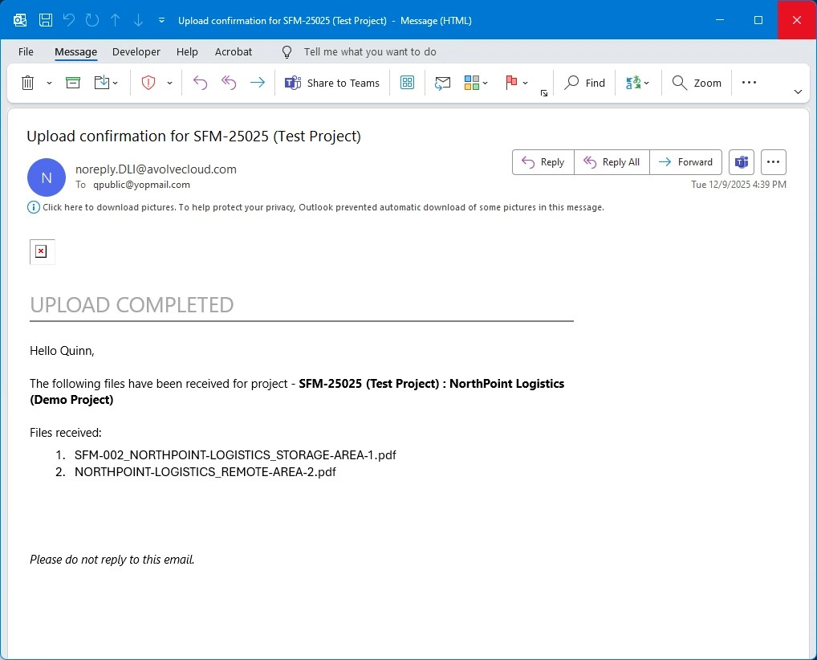

Part 10: next step
The SFM coordinator will begin another cycle of the prescreen review process to determine if the files meet the submission guidelines section of this user guide.
- If the files do not meet the requirements of that section, the applicant must fix any issues identified by the SFM coordinator. An example is demonstrated in the applicant prescreen corrections task section.
- If the files meet the requirements of that section, the project will move to another cycle of the plan review process where the assigned SFM plan reviewer will review the submittal for code compliance. You will be notified through email when this happens as shown in the picture below.

Applicant download task
After the plan review is completed and no mandatory code violations are found, this applicant download task is the last step in the workflow. No action is needed to accept it; however, you will need to download the stamped drawings and permit whenever you have time. This task allows access to the project files to download those stamped drawings and permit.

IMPORTANT NOTE: The State Fire Marshal (SFM) is a division under the Department of Public Safety (DPS); therefore, due to our retention policy, the project files can only be accessed for a period of seven years before they are removed.

The five parts below illustrate how to complete this task. You can repeat parts two through five anytime you need to re-download the stamped drawings and permit within the seven-year period.

Part 1: email notification about download ready
If you are added to an existing project, you will see an email like the one shown in part 1.1 of the applicant upload task section; go ahead and proceed with the next part below.

Once the project is completed and no mandatory discrepancies are found, the stamped drawings and permit can be downloaded. You will be notified through email as shown in the picture below.
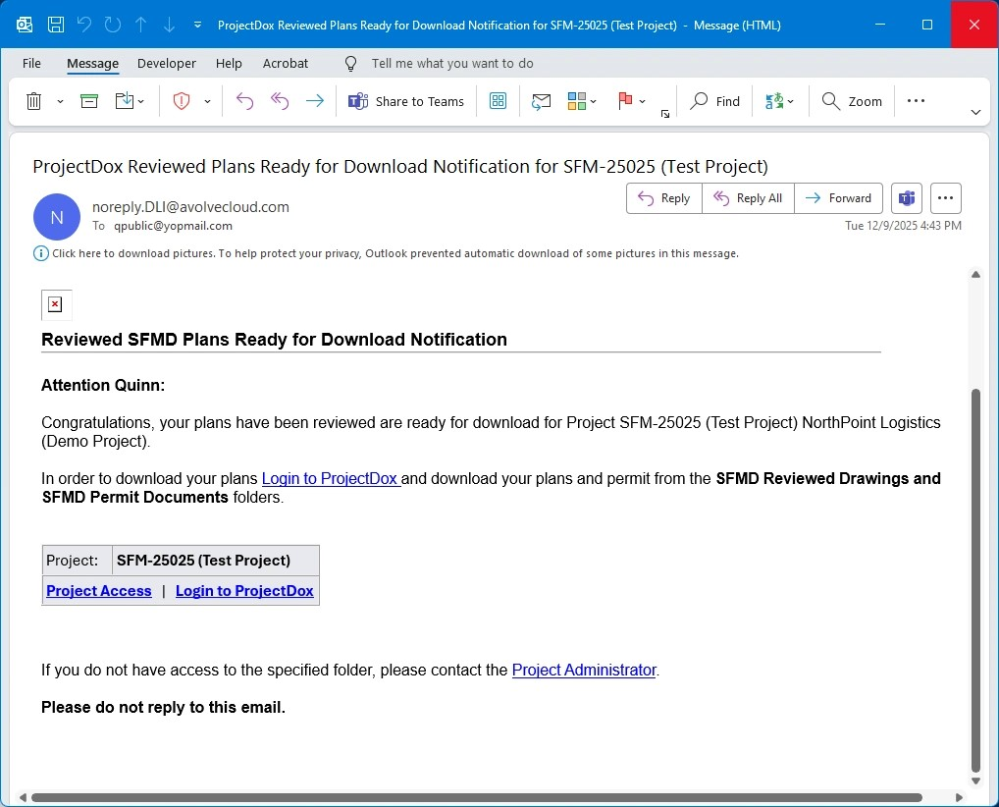

Part 2: logging in
If you are not currently signed into your ProjectDox user account when receiving the task assignment email notification, go to the log in page as shown in the picture below and then:
- Enter your email address and password.
- Click on the “Login” button.

Part 3: opening project
On the dashboard, you have three options:
- Click on the project name link under the “Project” column. After clicking on the link, the project will open in the “Status” tab. You can now proceed to the next part below.
- Click on the “Open” button under the “Tasks” column. After clicking on the button, a new pop-up window will appear. You must click on the “Access Project Files” button before proceeding to the next part below.
- Click on the “View All Projects” button. After clicking on the button, you will see a different view from the dashboard’s view, but it will still look similar. You can either click on the project name link or any of the icons under the “Action” column to open the project before proceeding to the next part below.

We will illustrate using the first option as shown in the picture below.

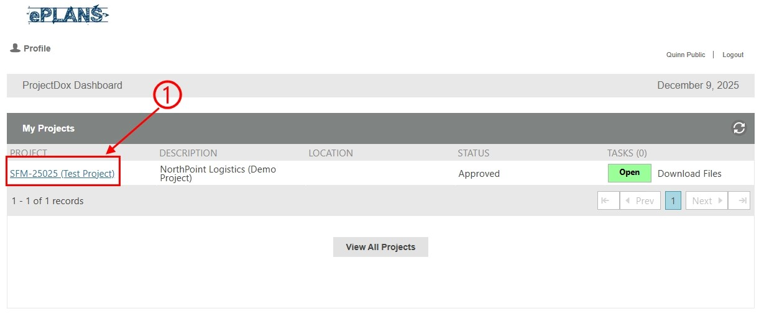

Part 4: downloading results
There are three subparts below – one for the stamped drawings, one for the permit letter, and one for the review comments. The process for both the stamped drawings and permit letter are similar, but the stamped drawings involve downloading multiple files while the permit letter involves downloading one file.

Part 4.1: downloading stamped drawings
This demonstrates downloading two or more files from the “SFMD Reviewed Drawings” folder; however, it can be applied to any of the other folders when downloading multiple files. See part 4.2 below for a demonstration of downloading one file.

Part 4.1.1: selecting files
As shown in the picture below, follow these directions:
- Click on the “Files” tab.
- Click on the “SFMD Reviewed Drawings” folder.
- Click the select all checkbox to select all files.
- Click the download icon.
- A pop-up message will appear notifying you that the files are being packaged.

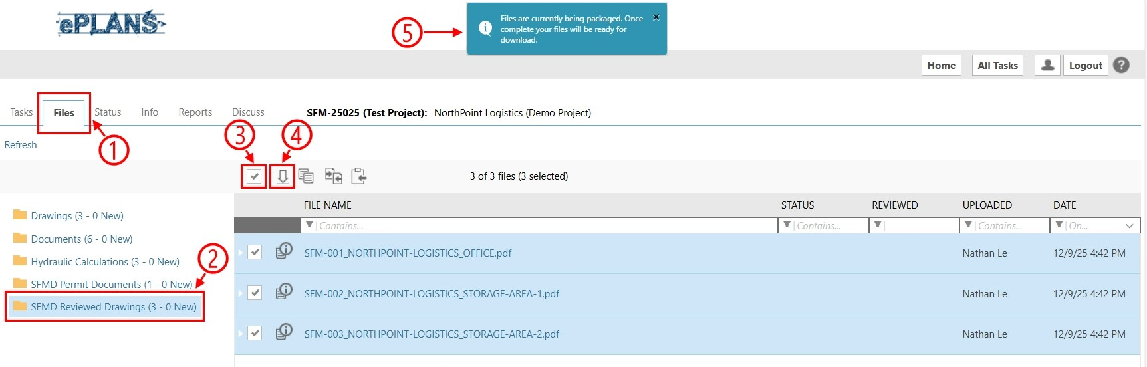

Part 4.1.2: download files
Once the files are packaged, a pop-up dialog will appear as shown in the picture below. Click on the “Download ZIP” button to begin the download.

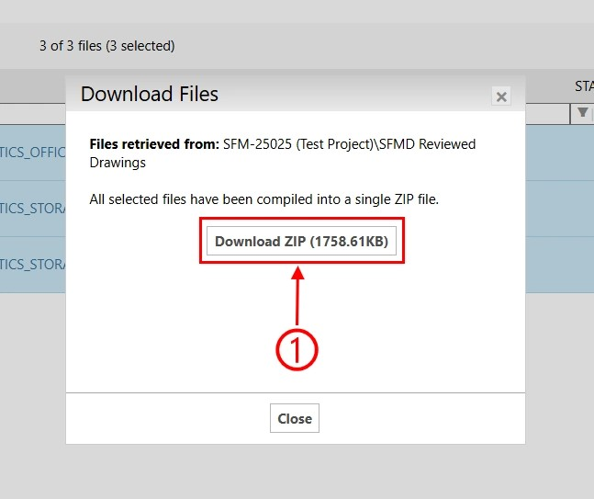

Part 4.1.3: downloaded file
The file will appear in your browser’s download history as shown in the picture below. Once the file has been downloaded:
- Click on the web browser’s download icon.
- Click on the folder icon to open the location where the file was saved on your computer.

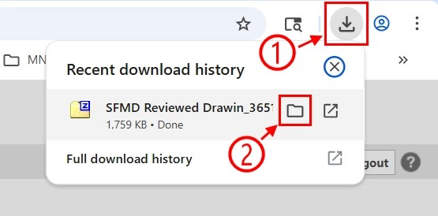

Part 4.1.4: computer’s file explorer
If you skipped the last part above, navigate to the location where the file was downloaded to as shown in the picture below. Next, we need to extract the contents of the ZIP file by doing the following:
- Click on the ZIP file to select it.
- Click on the “Extract all” button.

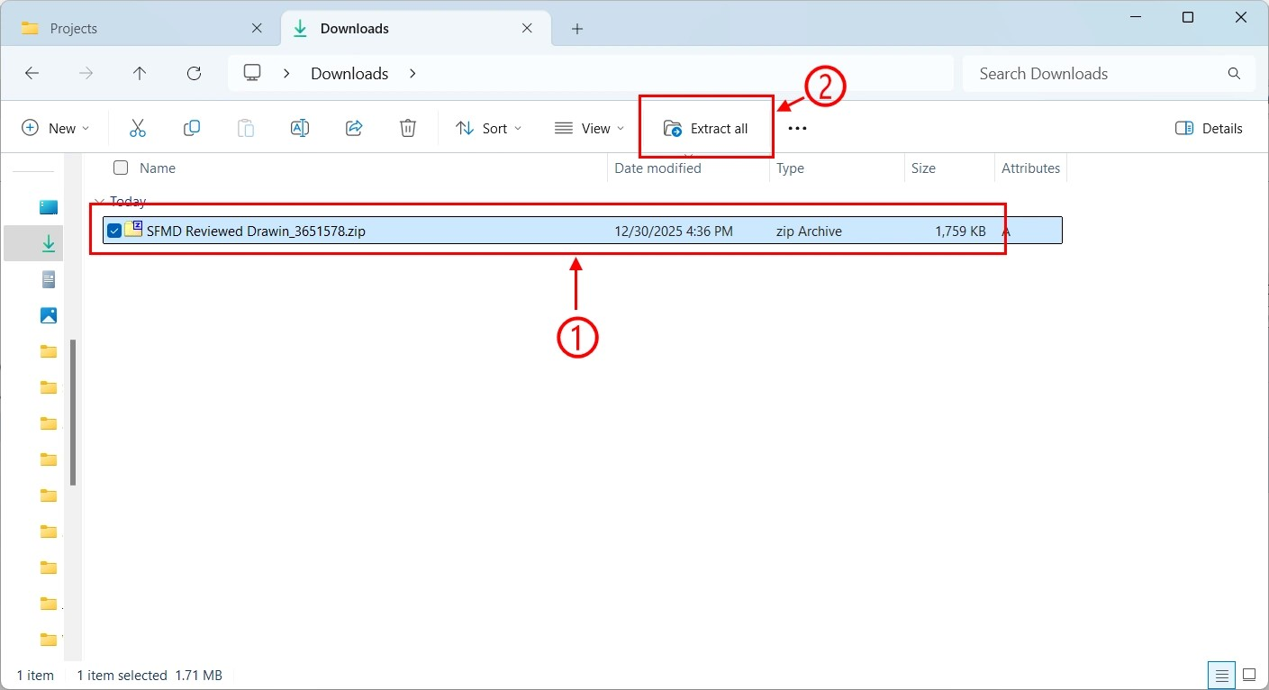

Part 4.1.5: extracting archive files
A dialog window will appear as shown in the picture below:
- Enter the folder path where you want the files within the archive to be extracted to.
- Click on the “Extract” button.
You can also click on the “Show extracted files when complete” checkbox, which will open a file explorer window to that location; otherwise, you can navigate there yourself.

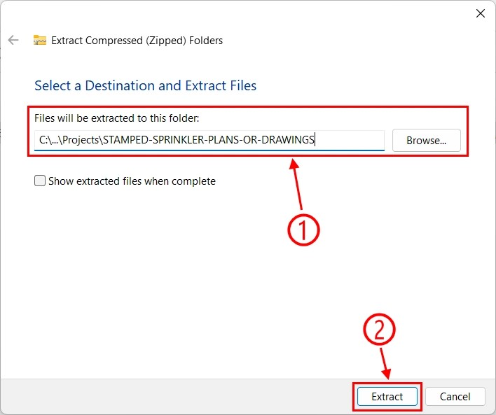

Part 4.1.6: extracted archive files
As shown in the picture below, the files were extracted.

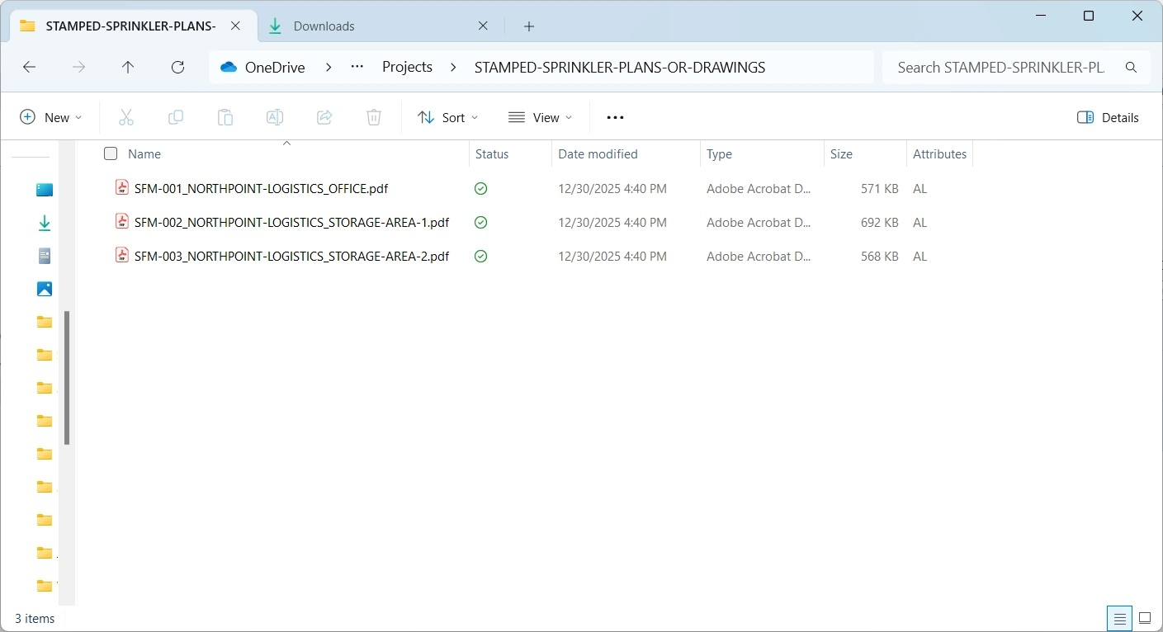

Part 4.1.7: viewing stamped drawings
Since all the drawing files were stamped, we will only open one of them to view the stamp. As shown in the picture below, the drawing was stamped.

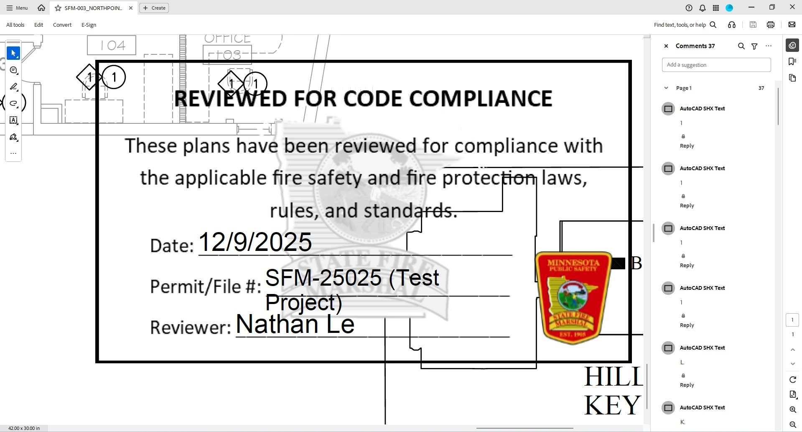

IMPORTANT NOTE: As of January 2026, the logo shown in the picture above is outdated since our logo recently changed and we are in the process of updating that stamp.

Part 4.2: downloading permit letter
This demonstrates downloading one file from the “SFMD Permit Documents” folder; however, it can be applied to any of the other folders when downloading one file. See part 4.1 above for a demonstration of downloading multiple files.

Part 4.2.1: selecting file
As shown in the picture below, follow these directions:
- Click on the “Files” tab.
- Click on the “SFMD Permit Documents” folder.
- Click the checkbox next to the file to select it.
- Click on the download icon.
- A pop-up message will appear notifying you that the file is being packaged. That message is not applicable in this scenario since files are packaged into an archive when two or more files are selected.

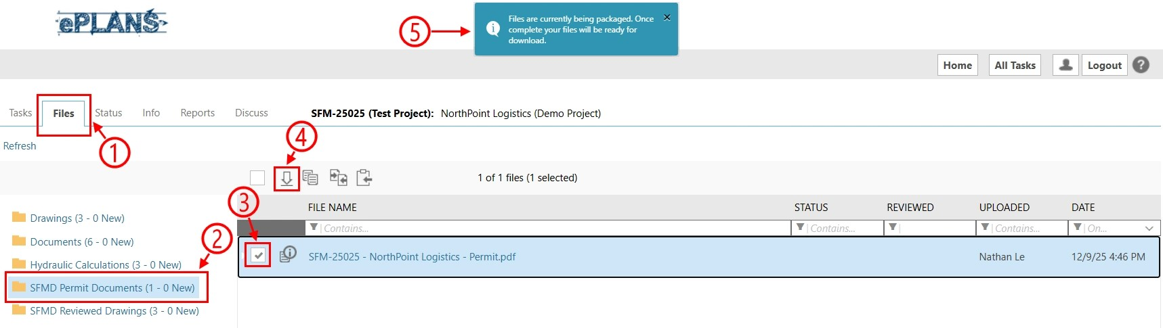

Part 4.2.2: downloaded file

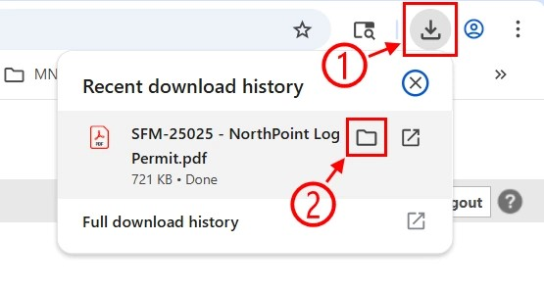

Part 4.2.3: computer’s file explorer

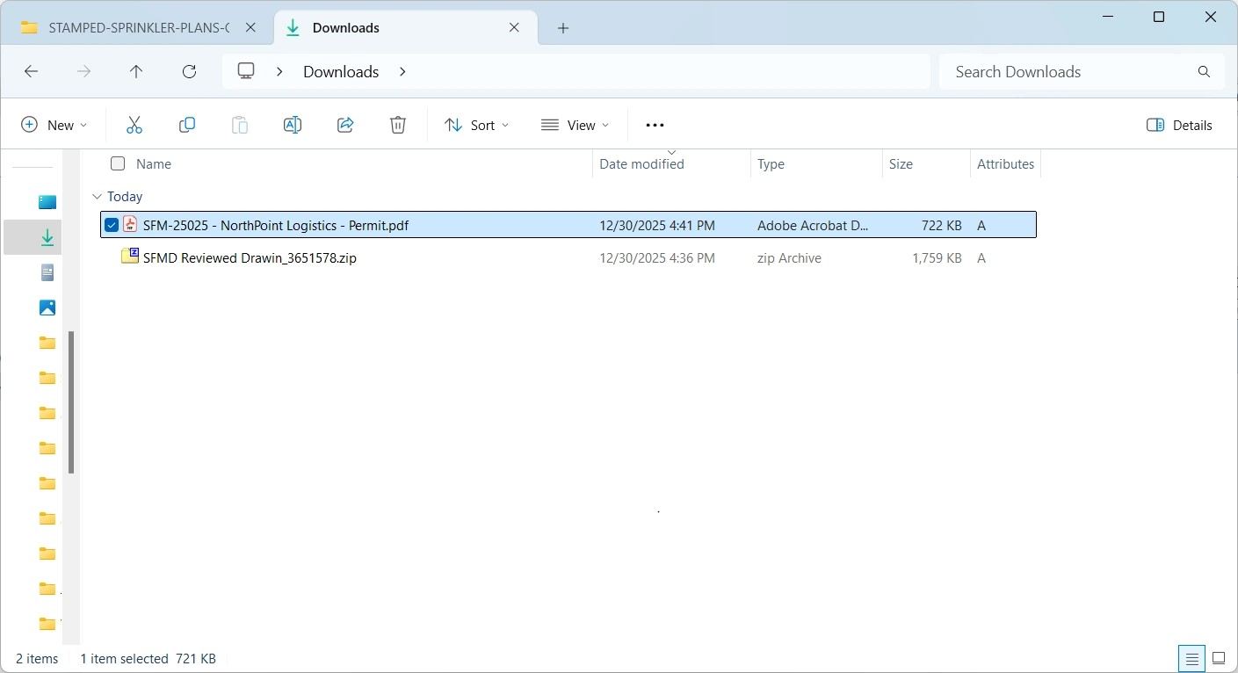

Part 4.2.4: moved permit letter
If needed, you can move the permit letter to the location where you have your project files as shown in the picture below.

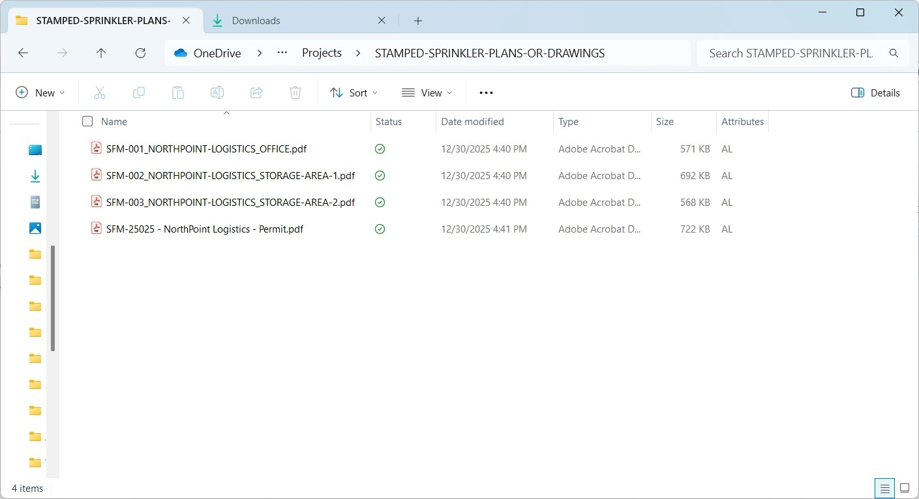

Part 4.2.5: viewing permit letter
Since there is only one permit letter, we will open that file as shown in the picture below.

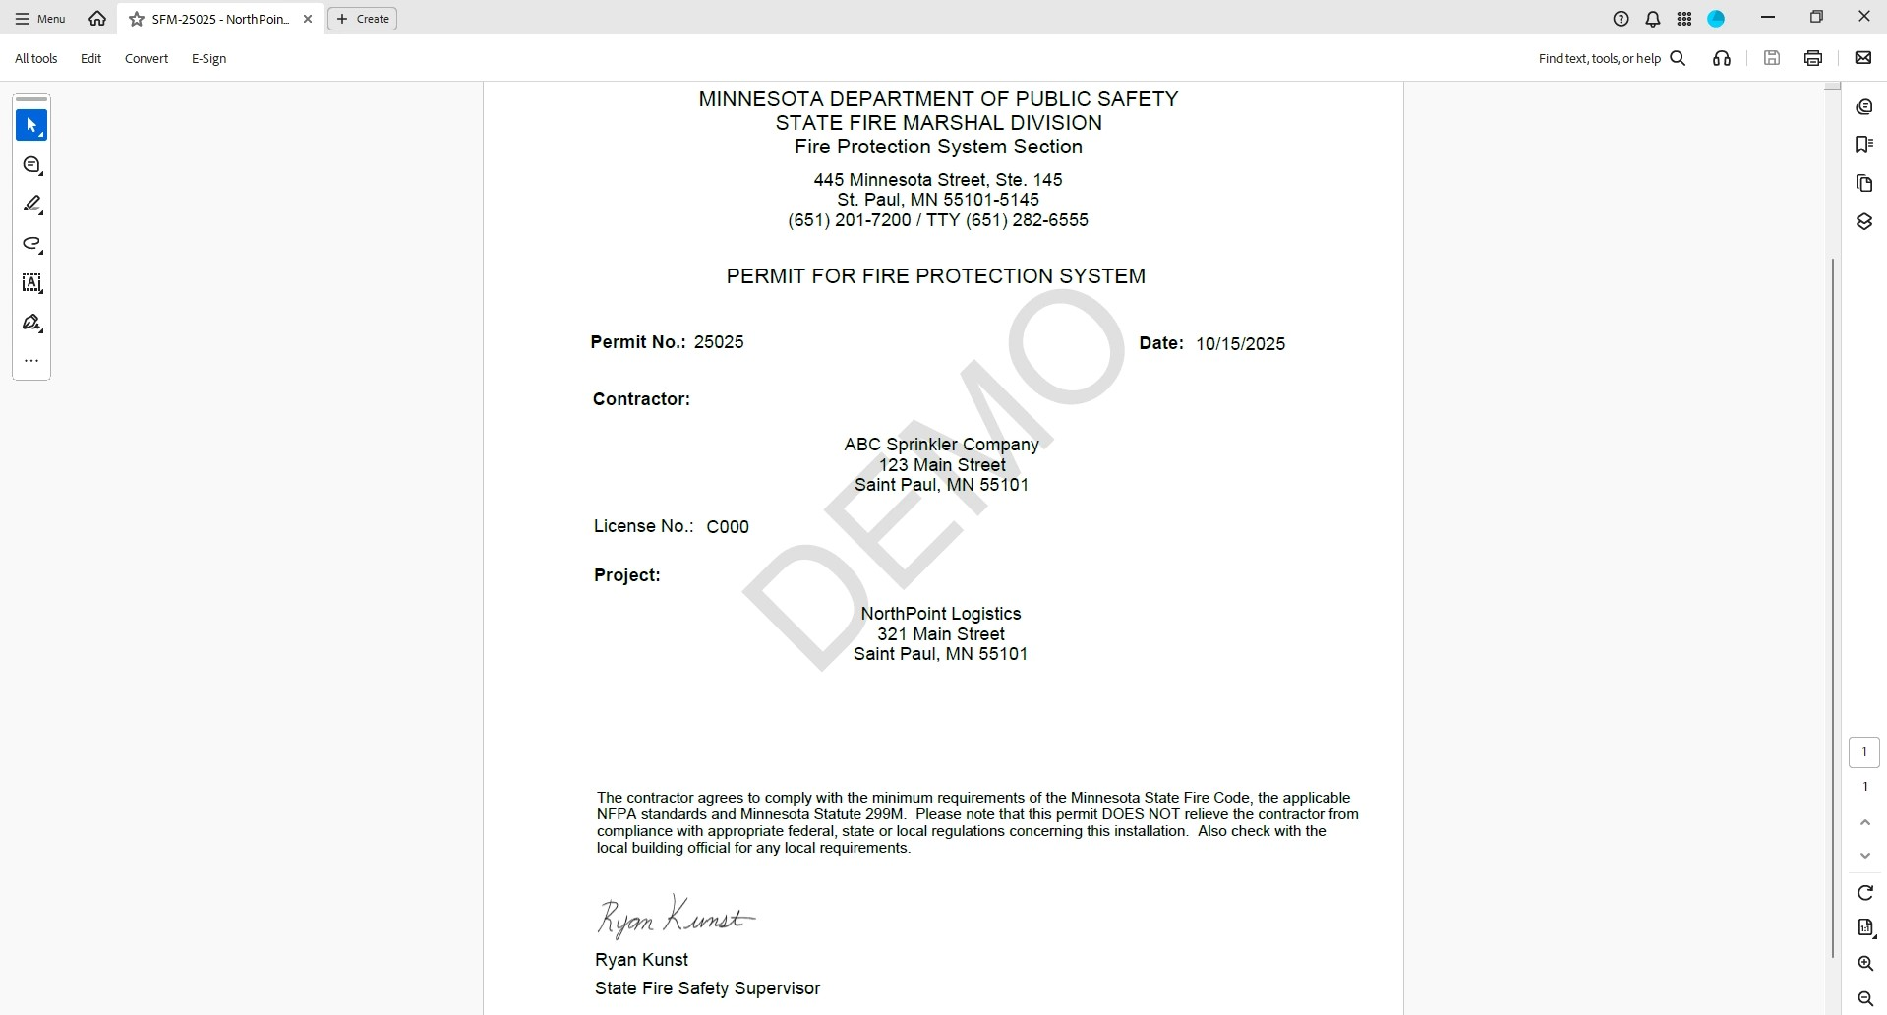

IMPORTANT NOTE: The permit letter shown in the picture above could change designs.

Part 4.3: downloading review comments
This demonstrates retrieving the review comments report.

Part 4.3.1: project reports
As shown in the picture below, follow these directions:
- Click on the “Reports” tab.
- Click on the “Plan Review - Review Comments” link.

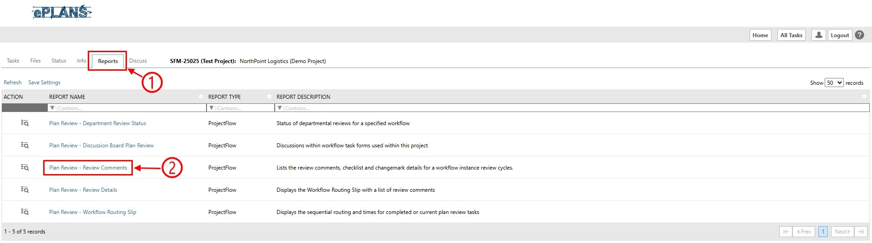

Part 4.3.2: pop-up window
A new pop-up window will appear as shown in the picture below. Next:
- Click on the save icon drop-down menu.
- Click on one of the options in the drop-down list to save the report as that file type.
- Repeat the two directions above for each of the other file types you want to download.

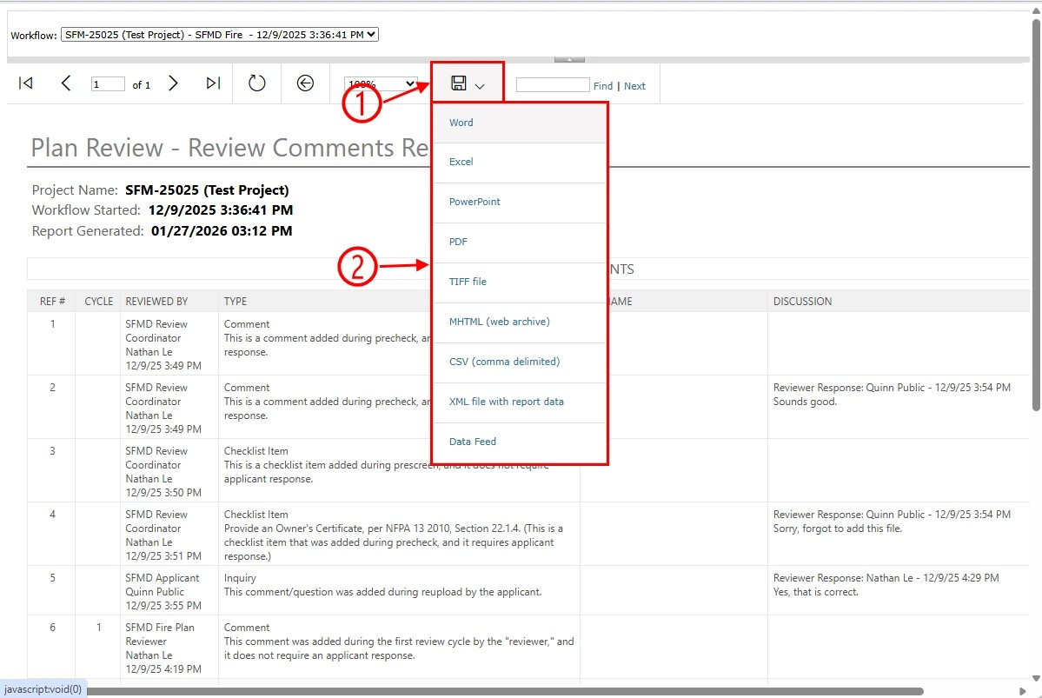

Part 4.3.3: computer’s file explorer

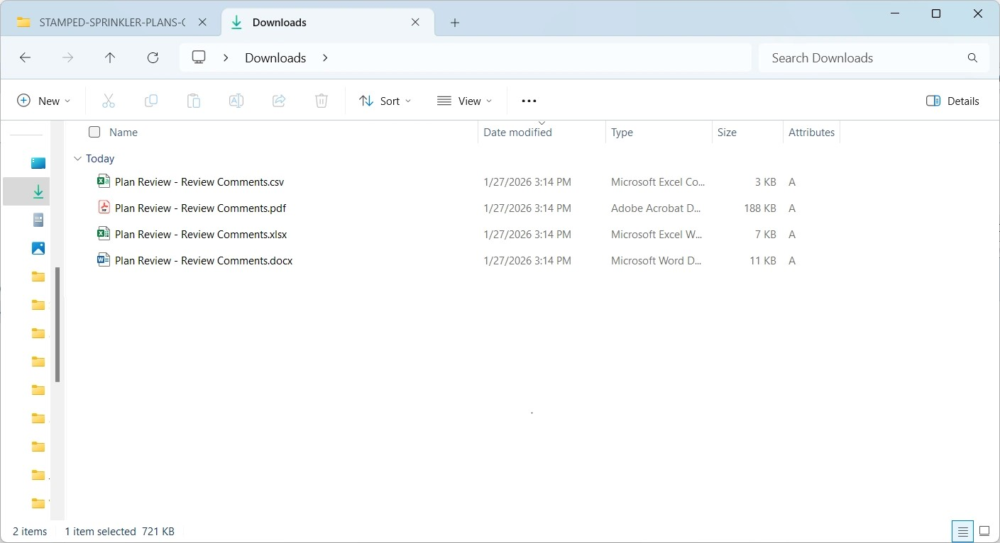

Part 4.3.4: moved reports

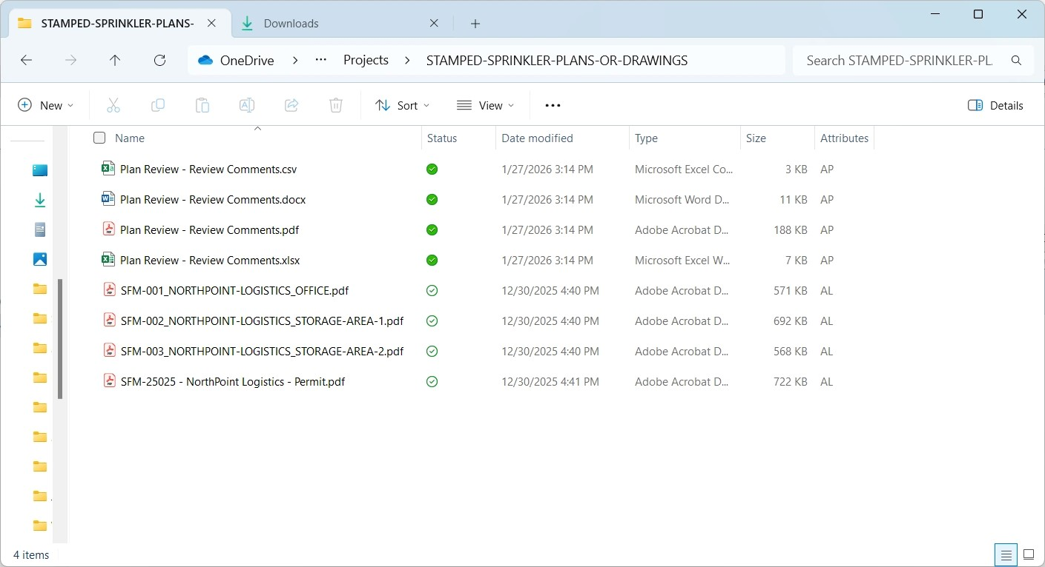

Part 4.3.5: viewing report

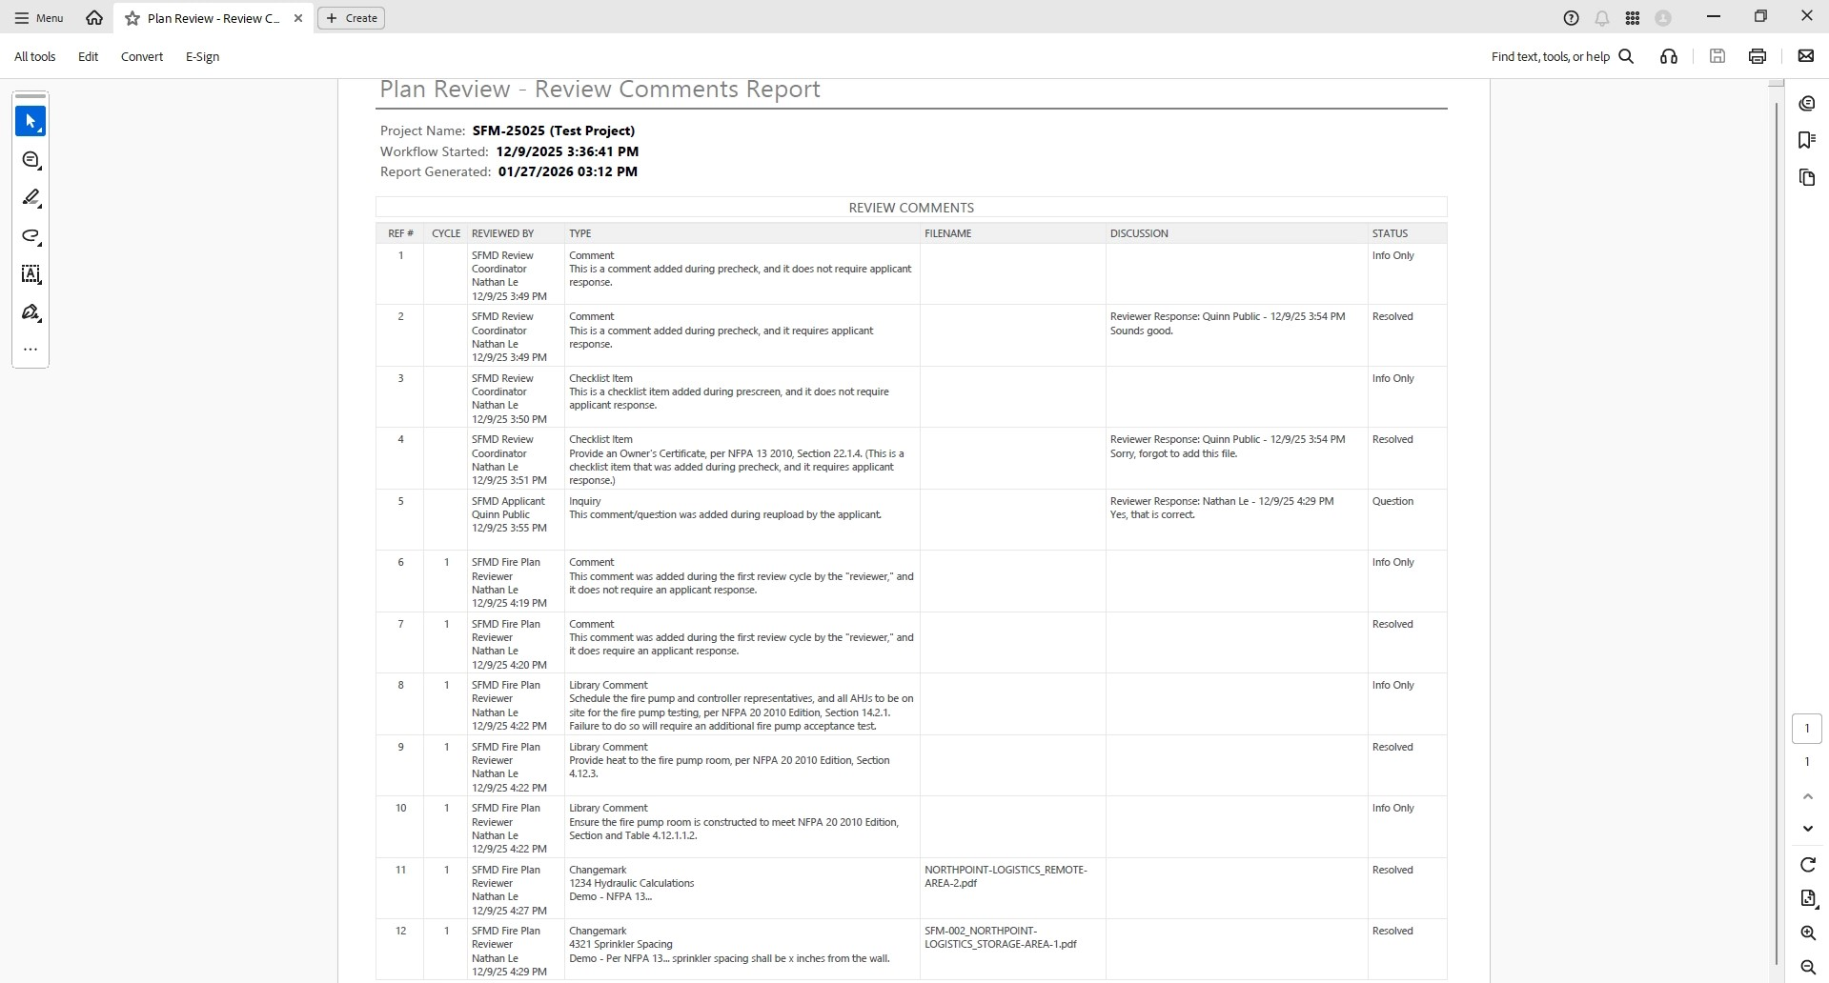

Part 5: logging out
If you do not need to complete any other tasks, you can log out by clicking on the “Logout” button as shown in the picture below.

