MN BCA FSS Internship Interest Form

Name: |  | Date:

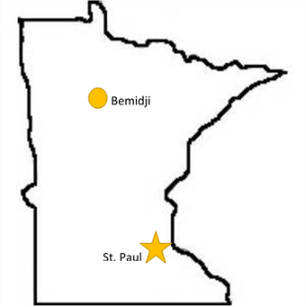
Check all locations and sections of interest:

☐ Testing – Bemidji
☐ Biology
☐ Drug Chemistry
☐ Firearms & Toolmarks
☐ Latent Prints

☐ Calibration – St. Paul

☐ Testing – St. Paul
☐ Biology
☐ Drug Chemistry
☐ Evidence Intake & Processing
☐ Firearm and Toolmarks
☐ Latent Prints
☐ Toxicology
☐ Trace Evidence

University/College Currently Attending:
Major/Program:
Anticipated Graduation Date:
Current GPA:
Date able to start internship:
Hours per week:

Relevant courses taken/in progress:  Choose all that apply | ☐ Molecular Biology ☐ Genetics ☐ Biochemistry  ☐ Organic Chemistry ☐ Statistics ☐ Instrumental Analysis
Other relevant courses/skills:
Laboratory experience:
Laboratory instrumentation experience:

Why are you interested in forensic science?

Please write a brief statement about your ideal internship experience, how it fits into your future goals, how it will enhance your academic and professional career, and what qualifies you for that internship.

