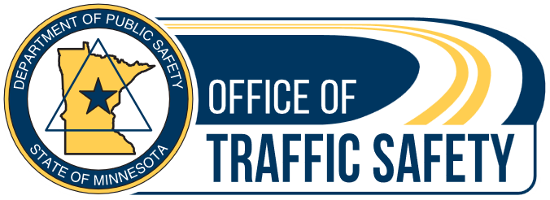

April 2026 distracted driving extra enforcement campaign social media posts
Below are several sample social media posts. These are for traffic safety partners during the distracted driving enforcement campaign. To use the photos in this document, simply right click and select “save as photo.” Remember, individualized posts and images specific to your community are always preferred over premade graphics.
If your law enforcement officers are making stops, have them write a brief description and take a photo. Photo ideas include a squad car on the side of the road, flashing lights, any evidence that a driver was using their phone or otherwise distracted.
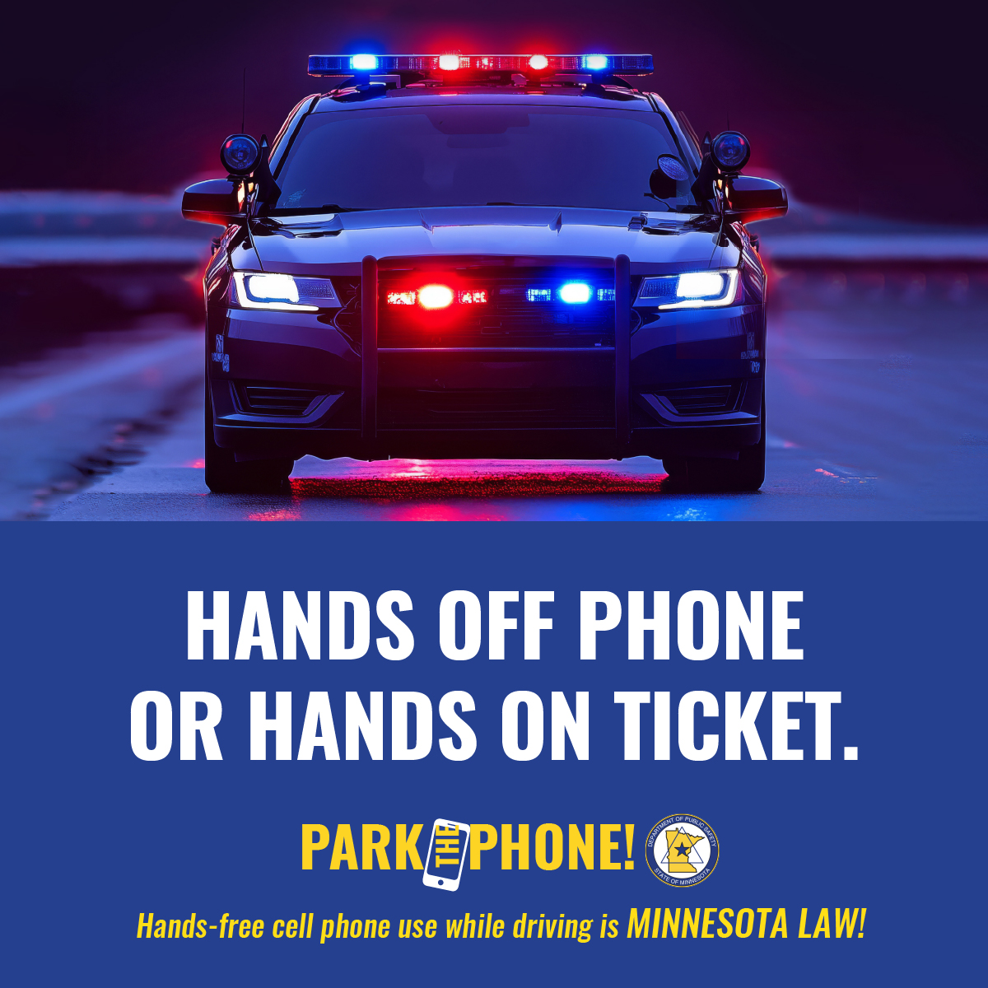
You may also download a variety of social media graphics from the Office of Traffic safety Dropbox.
Suggested text: The law is simple: If you have a phone in your hand, you will get a ticket. Save yourself the cash and protect others — pay attention.
The Minnesota Department of Public Safety’s Office of Traffic Safety is funding extra distracted driving enforcement in April. Keep yourself and others safe on the road by parking the phone.
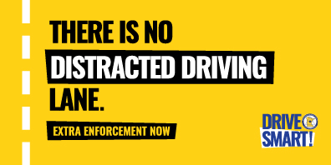

Suggested text: Can you imagine a lane where every driver is distracted? Of course, not — it would be full of crashes.
Everyone knows they should focus on the road, yet many drivers think they are the exception. You’re not.Buckle up, park the phone and set all the distractions aside.

Suggested text: Are your hands on the wheel while driving? Fantastic! On the phone? No! Eating a messy sub sandwich with sauces dripping off the sides? Not the time. Doing your makeup? Not behind the wheel.
The rule is simple when driving – just drive.
Extra enforcement is out now. Keep your hands on the wheel and avoid a ticket or worse, a crash.
