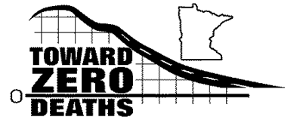

2021
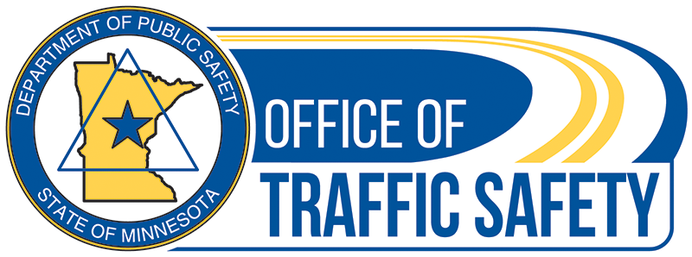
March, 2021
Minnesota Toward Zero Deaths
Fatal & Serious Injury Crash Review Committee Guide

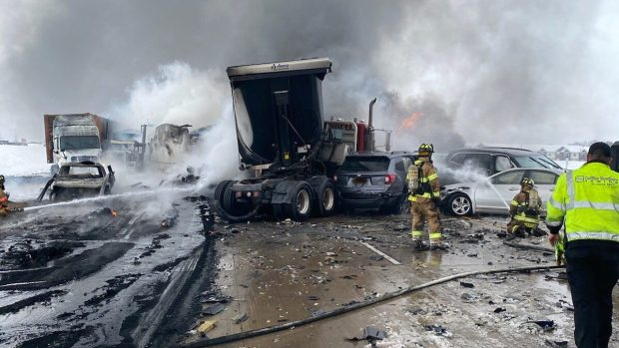

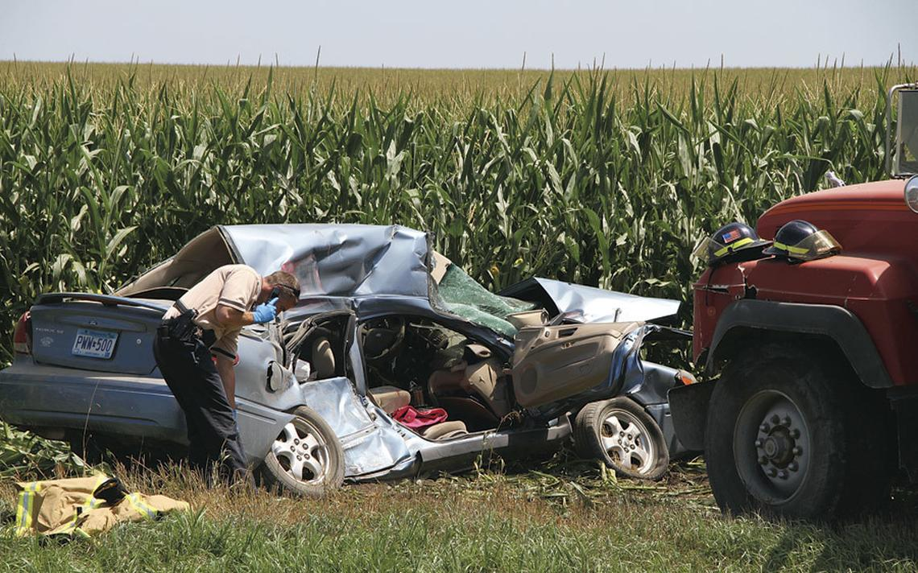

Fatal & Serious Injury Crash Review Committee Overview
Each Toward Zero Deaths (TZD) Safe Roads Coalition must establish a Fatality & Serious Injury Crash Review Committee (FSIRC) to review all fatal crashes and when possible, serious injury crashes in the area served.
[A serious injury usually requires hospitalization, is life altering or life changing.]
The purpose of the FSIRC is to:
- Identify patterns that contributed to recent crashes, the resulting fatalities and serious injuries.
- Determine specific actions that can be initiated to help prevent similar crashes and outcomes.
- Follow through with action items.
- Inform stakeholders as appropriate.
Action items may involve:
- Initiating specific community awareness initiatives.
- Informing engineering, enforcement, EMS, and other stakeholders about the committee meeting, patterns identified, what the committee is going to do to raise community awareness of the patterns, and share other ideas discussed. (see example letter)
Actions must consider respect for the family and friends of the person(s) killed or injured.
Considering the number and types of recent crashes and other resources, the process to review fatal crashes may differ from those to review serious injury crashes. The priority is on reviewing fatal crashes.
FSIRC Meetings
FSIRC meetings may be held in-person or virtually using a secured platform.
Meeting participants are prohibited from copying, photographing, or recording documents or information reviewed. This includes, but is not limited to names, dates of birth, addresses, or similarly protected data as classified by Minnesota Statutes Chapter 13, The Minnesota data Practices Act, that could be used to identify any individual involved in an incident that is reviewed.
Best practices for virtual meeting security.
- Limit reuse of access codes.
- Use one-time PINs or meeting identifier codes, and consider multi-factor authentication (MFA).
- Use a "waiting room" and don't allow the meeting to begin until the host joins.
- Enable notification when attendees join by playing a tone or announcing names. If this is not an option, make sure the meeting host asks new attendees to identify themselves.
- If available, use a dashboard to monitor attendees.
- Don't record the meeting.
- If it's a web meeting (with video):
  - Disable features you don't need (like chat or file sharing).
  - Before anyone shares their screen, remind them not to share other sensitive information during the meeting inadvertently.
It’s recommended that the quarterly FSIRC meetings are scheduled for the entire year. If no fatal or serious injury crashes occur, or the incidents cannot be reviewed due to pending litigation or investigations, a scheduled meeting may be cancelled.
Committee Participants
The Fatality & Serious Injury Review Committee should not include members of the media, schools, or other individuals that are not essential to the FSIRC discussions.
At a minimum, the FSIRC should include representatives from:
- Local and State Law Enforcement
- County and State District Traffic Engineers
- Emergency Medical Services
- TZD Safe Roads Coordinator
- Office of Traffic Safety Law Enforcement Liaison
- TZD Regional Coordinator
Ideally, in addition to the representatives listed above, the FSIRC should make efforts to include:
- Law enforcement officers that were at the scene of the crashes
- EMS personnel that were at the scene of the crashes
- Law enforcement officers responsible for investigating the crashes
- A representative from the County Attorney’s Office
Regardless of if meetings are held in-person or virtually, each participant must complete a confidentiality agreement. The confidentiality agreement template is provided in this document. The meeting organizer must maintain completed participant agreements for a minimum of 7 years.
To properly impact the community, it’s recommended that the FSIRC act on its actions as soon as possible after each meeting.
Cases involving pending criminal charges or cases that have not been reviewed by the County Attorney’s office should not be addressed until the case is closed or charges are declined. Contact should be made with the lead investigating officers, and if appropriate the County Attorney’s Office, to ensure details of the crashes can be discussed without impeding or threatening any pending criminal prosecutions or misdemeanor level prosecutions handled by a City Attorney or local prosecutor.
The FSIRC should review each fatal crash and when possible, serious injury crashes to identify contributing factors which may include:
- Age, gender and role of persons involved: drivers, passengers, pedestrians, etc.
- Number and types of vehicles involved: car, light truck, SUV, commercial vehicle, motorcycle, etc.
- Crash location: specific roadway, intersection, other location.
- Time of day, day of the week, weather conditions, etc.
- Human factors: alcohol, speed, distractions, etc.
- Factors that contributed to the cause of death or injury: non-seat belt use, no helmet worn, delayed response time, etc.
- Roadway environmental factors: roadway types, surface types, curve, grade, construction, animal, etc.
- Vehicle factors: tire failure, air-bag deployment failure, etc.
- Any other contributing factors.
Obtaining Crash Information
TZD Safe Roads Coalitions commonly learn of fatal or serious injury crashes from contacts with law enforcement and emergency medical services personnel. It’s important for FSIRC members to know as many of the crash details as possible. However there is no need to obtain information such as names, addresses, dates of birth, vehicle identification or license plate numbers, or any other information that may be considered private.
A typical fatal crash investigation will take three to six months to complete. Non-public/investigative information will not be available to the committee. Ideally, officers and EMS staff that were at the crash scenes will attend the FSIRC meetings. When this isn’t possible, officers and EMS staff who attend should obtain information from others who were at the crash scenes.
The Minnesota State Patrol (MSP) conducts investigations for all fatal crashes that occur on state highways. Each State Patrol district handles crash information differently. The State Patrol has a uniform process for determining what information can be released based on investigation and criminal charging status. A District Lieutenant or District Investigator is the appropriate point of contact. FSIRC members should work with their State Patrol representatives to obtain MSP crash information that is legally available to share with the public. Troopers should address any problems or concerns regarding the FSIRC obtaining MSP crash information with their District Commanders.
State Patrol Incidents (Crashes) can be viewed at: https://app.dps.mn.gov/mspmedia/DisplayAllIncidents.asp
In addition to the MSP, fatal and serious injury crashes that occur on a county or municipal road may be investigated by the Sheriff’s Office or Police Department. Each entity may handle crash information differently. TZD Safe Roads Coordinators should work with their local Law Enforcement representatives to obtain local crash information that is legally available to share with the public.
Ideally, the FSIRC will have access to information found in the investigating agencies crash reconstruction report. These reports can take several months to complete. It’s recommended that the FSIRC discuss the fatal or serious injury crashes using whatever public information they can obtain, rather than delaying discussion until the reconstruction report is completed.
If there is an ongoing criminal investigation or pending charges related to a fatal or serious injury crash, it’s likely the prosecutor will prohibit the release of information for the FSIRC to discuss the incident. These incidents should be noted and reviewed when the information becomes available.
Crash Factors
Many factors combine to produce circumstances that may lead to a motor vehicle crash. There is rarely a single cause of such an event. Experts and studies have identified three categories of factors that contribute to crashes:
- Human: Human factors involve the actions taken by or the condition of the driver, including speeding, being affected by alcohol or drugs, lack of seat belt use, inattention, decision errors, violating traffic laws, and age.
- Roadway Environment: Roadway environment factors include the design of the roadway, roadside hazards, and roadway conditions.
- Vehicle: Vehicle factors include any failures in the vehicle or its design.
Human factors contribute to crashes most often, followed by roadway environment and vehicle factors.
Human factors associated with non-drivers may contribute to crashes. For example, a pedestrian may be distracted or impaired by alcohol or drugs, or a bicyclist may cross an intersection against a traffic light.
A vehicle occupant who neglects to wear a seat belt may not contribute directly to causing a crash, but is a likely factor that contributed to the resulting fatality or serious injury.
Post-crash factors that may influence survival/fatality outcomes include:
- Emergency response time
- Extrication time
- Transport time to a hospital or trauma center
Crash victims have a much smaller chance of survival if they are not attended to in an emergency room within one hour from the time of the crash. This is known as “The Golden Hour.”
Getting crash victims to the correct level trauma center is important. Level 1 or Level 2 trauma centers are best suited to handle major trauma victims.
Committee Action
FSIRC members may be able to act on specific action items, such as submitting a newspaper article, informing law enforcement, engineering, or emergency medical services stakeholders about the committee’s findings and action items. Circumstances where an appropriate action item doesn’t exist may occur, however this should rarely happen. It’s important to remember that all action items must consider respect for the family and friends of the person(s) killed or injured. At each meeting, it should be determined who is responsible for following through with each action item, and report back to the committee as appropriate.
Initiatives to enhance public awareness of issues relative to fatal or serious injury crashes, or crash trends identified by the FSIRC, must be carefully worded and not refer to a specific crash or individual. This is where looking at both fatal and serious injury crashes may be beneficial in educating the community about recent contributing factors, rather than focusing on a single crash.
It’s recommended that the committee inform all stakeholder leaders of the committee’s findings, action items, and important points of discussion. Stakeholders may include: emergency medical service providers, engineering departments, and law enforcement agencies. The TZD regional coordinator should also be informed. Please see the “Sample Letter to Stakeholder Leaders”.
The committee’s priority is to use the facts of the incidents reviewed to determine what can be done to prevent the same type of actions, behaviors, and outcomes from happening in the future. Potential educational opportunities should be discussed and appropriately initiated.
Committee Meeting Reports
Conducting quarterly FSIRC meetings is a required TZD Safe Roads grant activity.
FSIRC meetings should not be held if crashes cannot be discussed due to no crashes occurring, pending charges or active investigations. If a FSIRC meeting is not held in a given quarter, the coalition coordinator must explain the reason(s) in the quarterly progress report.
A meeting summary that includes participant names, the number of fatal crashes reviewed, the number of serious injury crashes reviewed, the contributing factors identified, the action items, and the persons responsible for completing the actions, must be submitted with the TZD Safe Roads Quarterly Progress Report to the Office of Traffic Safety. The meeting summary does not have to list individual crashes reviewed. Meeting summaries must be updated to document progress with action items and other follow through, and submitted with progress reports as appropriate.
At the end of the grant period, each TZD Safe Roads grantee must provide a written summary of the FSIRC findings and action items that occurred during the grant year. The report must be submitted along with the TZD Safe Roads Final Progress Report.

Fatal and Serious Injury Committee Confidentiality Agreement
This agreement dated __________________, 20___ , by and between [Coalition Name], and __________ (“Meeting Participant”).
It is the policy of [Coalition Name] that Fatal and Serious Injury Committee meeting participants will not display, share, or disclose, protected data as classified by Minnesota Statutes Chapter 13, The Minnesota data Practices Act, through their participation in the [Coalition Name] Fatal and Serious Injury Committee meeting held on [Date] to any person, including relatives, friends, and associates. This agreement is not intended to prevent disclosure where disclosure is required by law.
Meeting participants must demonstrate professionalism, good judgment, and care to prevent unauthorized or inadvertent displays or disclosures of protected data as classified by Minnesota Statutes Chapter 13, The Minnesota data Practices Act.
Meeting participants are prohibited from copying, photographing, or recording documents or information reviewed. This includes, but is not limited to names, dates of birth, addresses, or any other , or similarly protected data as classified by Minnesota Statutes Chapter 13, The Minnesota data Practices Act that could be used to identify any individual involved in an incident that is reviewed.
Certification
I have read [Coalition Name]’s Statement of Confidentiality presented above. I agree to abide by the requirements of the agreement and inform the committee meeting organizer immediately if I believe any violation (unintentional or otherwise) of the agreement has occurred. I understand that violation of this agreement may lead to legal action.
Printed Name: __________________________
Signature: _____________________________ Date: __________

Sample Letter to Stakeholder Leaders
March 9, 2021
Mr. Thomas Olson
Good County Engineer
(address)
Dear Mr. Olson,
The Good County Toward Zero Deaths Fatal and Serious Injury Crash Review Committee met on February 4, 2021, to review two fatal crashes and one serious injury crash that recently occurred in the county.
Our review identified the contributing factors, and the resulting fatalities and injuries of these crashes as:
- Road departure, crossing center median
- Driver inexperience
- Drowsy or distracted driving
- Poor tire condition for winter driving
- Use of cruise control on icy roads
As a result of these findings, with the objective of preventing similar crashes and outcomes, the Committee members will implement the following actions:
- Submit articles to local newspapers and radio stations to educate the public on distracted driving risks and laws, driving at safe speeds for conditions, not using cruise control during inclement weather, and the effects of drowsy driving.
- Post articles on the County TZD Web Site and develop a radio PSA to raise awareness of, and suggest participation in, crash avoidance skills training programs offered at Dakota County Technical College and the Minnesota Highway Safety Research Center in St. Cloud
- Provide information for local driver educators and law enforcement to use to educate parents on the importance of teaching their teens how to drive in winter conditions, and equipping their vehicles with good winter tires, during the Point of Impact Parent Awareness Classes.
Here are some other ideas that the Committee members discussed that we would like to share with you:
- Installing cable median barriers to reduce the severity of cross-over crashes.
- Installing rumble strips & safety edges may reduce the likelihood and severity of run-off the road and cross-over crashes.
Note: The above information is provided for discussion purposes only and does not constitute a formal or implied request for action.
Please feel free to contact me if there are any questions or concerns.
Sincerely,
Sally Johnson, Good County TZD Safe Roads Coalition Coordinator
E-Mail: sally.johnson@good.co.mn.us
Phone: (555) 432-1234
Copy: Michael Potter, County Sheriff; Jane Johnson, City Police Chief;
Pamela Theisen, Regional EMS Committee Chair; Holly Youngs, TZD Regional Coordinator

The following are samples of forms that may be used by Fatality & Serious Injury Review Committees.
The forms may be edited to meet your needs.

Single Crash Review Worksheet Example
Date of Review | February 4, 2021
Crash Type | Fatal: X Serious Injury: X
Reviewers | Jan Bengal, Public Health; Dean Anderson, State Patrol; Dan Ellingson, City PD; Ryan Booth, MnDOT; Capt. Matt Johnson, Sheriff’s Office; Gary Donaldson, County Highway; Jim King , Ambulance Service
Date & Time of Crash | September 13, 2020 6:30 p.m.
Primary Responding Agency | County Sheriff’s Office
City/Township | Rosebud Twp.
Location | Hwy 7 & Hwy 77
Road Surface | Asphalt, Dry
Weather | Cloudy
Collision Factors | Intersection with traffic light. Right-angle.
Other Factors | Traffic light function checked by MnDOT and found to be functioning properly.
Notes | Witnesses claim driver #2 had a red light and entered the intersection while braking hard. Skid marks confirm this.
DRIVER 1 Age/Sex | 45 year old Male
Physical Conditions | Normal, no physical impairment
Seat Belt | Yes
Ejection | No
Injury Severity | B
Contributing Factors | Driver claimed to have had a green light and didn’t see the other vehicle in time.
Vehicle 1 Type | SUV
Vehicle 1 PASSENGERS | One 8 year old child in back seat, behind driver.
Contributing Factors | None
Seat Belt | Yes
Ejection | No
Injury Severity | B
DRIVER 2 Age/Sex | 38 year old Male
Physical Conditions | Normal, no physical impairment
Seat Belt | Yes
Ejection | No
Injury Severity | No
Contributing Factors | Driver claimed to have had a green light and applied brakes in an attempt to avoid hitting the other vehicle. He stated he was having a conversation with his passenger, but was not distracted.
Vehicle 2 Type | Semi Tractor-Trailer
Vehicle 2 PASSENGERS | Front seat 46-yr old female
Contributing Factors | Lap belt was worn with the shoulder belt placed behind the right shoulder. Severe head and neck injuries occurred as a result of hitting the dash board.
Seat Belt | Yes
Ejection | No
Injury Severity | Fatal
Conclusion | Vehicle 1 struck on the rear passenger side by Vehicle 2. Proper seat belt use likely contributed to limiting injury severity to level B. Improper seat belt use likely contributed to the fatality. Distraction by the driver of Vehicle 2, and a lack of defensive observation by the driver of Vehicle 1, may have contributed to the crash.
Action Items | An article will be submitted to local newspapers, county newsletter, radio stations, and posted on social media, stressing that the county is experiencing fatal crashes at rural intersections. Attention will be given to avoiding distractions, driving defensively, judging distances and times correctly, and wearing seat belts properly.

Crash Review Worksheet: Example 2
TYPE: ☐ FATAL ☐ SERIOUS INJURY
Date:_________________ Time:___________________ Weather Conditions: ________________________
Road Conditions:___________________________________________________________________________
Location:_________________________________________________________________________________
Responding Agencies:_______________________________________________________________________
Vehicle A:
Make: _________________________ Model:____________________________ Vehicle Year:_____________
Driver A:
Age:_____ Sex: _____ Chemical Use: _____________
Medical Condition: _____________________ Health Status: __________________________________
Lap Belt Use: _____ Shoulder Belt Use: _____ Air Bag:_____ Ejected: _____
Front Passenger A:
Age:_____ Sex: _____ Chemical Use: _____________
Medical Condition: _____________________ Health Status: __________________________________
Lap Belt Use: _____ Shoulder Belt Use: _____ Air Bag:_____ Ejected: _____
Rear Passenger A1:
Age:_____ Sex: _____ Chemical Use: _____________
Medical Condition: _____________________ Health Status: __________________________________
Lap Belt Use: _____ Shoulder Belt Use: _____ Air Bag:_____ Ejected: _____
Rear Passenger A2:
Age:_____ Sex: _____ Chemical Use: _____________
Medical Condition: _____________________ Health Status: __________________________________
Lap Belt Use: _____ Shoulder Belt Use: _____ Air Bag:_____ Ejected: _____
Vehicle B:
Make: _________________________ Model:____________________________ Vehicle Year:_____________
Driver B:
Age:_____ Sex: _____ Chemical Use: _____________
Medical Condition: _____________________ Health Status: __________________________________
Lap Belt Use: _____ Shoulder Belt Use: _____ Air Bag:_____ Ejected: _____
Front Passenger B:
Age:_____ Sex: _____ Chemical Use: _____________
Medical Condition: _____________________ Health Status: __________________________________
Lap Belt Use: _____ Shoulder Belt Use: _____ Air Bag:_____ Ejected: _____
Rear Passenger B1:
Age:_____ Sex: _____ Chemical Use: _____________
Medical Condition: _____________________ Health Status: __________________________________
Lap Belt Use: _____ Shoulder Belt Use: _____ Air Bag:_____ Ejected: _____
Rear Passenger B2:
Age:_____ Sex: _____ Chemical Use: _____________
Medical Condition: _____________________ Health Status: __________________________________
Lap Belt Use: _____ Shoulder Belt Use: _____ Air Bag:_____ Ejected: _____
Contributing Factors:
__________________________________________________________________________________________________________________________________________________________________________________________________________________________________________________________________________________________________________________________________________________________________________________________________________________________________________________________________________________________________________________________________________________________________________________________________________________________________________________________________________________________________________________________________________________________________________________________________________________________________________________________________________________________
EDUCATION, Notes and Action Plans:
______________________________________________________________________________________________________________________________________________________________________________________________________________________________________________________________________________________________________________________________________________________________________________________________________________________________________________________________________________________________________________________________
Person(s) Responsible for Implementing EDUCATION Action Plans:
___________________________________ ___________________________________
___________________________________ ___________________________________

EMERGENCY MEDICAL SERVICES, Notes and Action Plans:
____________________________________________________________________________________________________________________________________________________________________________________________________________________________________________________________________________________________________________________________________________________
Person(s) Responsible for Implementing EMS Action Plans:
___________________________________ ___________________________________
___________________________________ ___________________________________
LAW ENFORCEMENT Notes and Action Plans:
____________________________________________________________________________________________________________________________________________________________________________________________________________________________________________________________________________________________________________________________________________________
Person(s) Responsible for Implementing LAW ENFORCEMENT Action Plans:
___________________________________ ___________________________________
___________________________________ ___________________________________

ENGINEERING Notes and Action Plans:
____________________________________________________________________________________________________________________________________________________________________________________________________________________________________________________________________________________________________________________________________________________
Person(s) Responsible for Implementing ENGINEERING Action Plans:
___________________________________ ___________________________________
___________________________________ ___________________________________
OTHER Notes and Action Plans:
____________________________________________________________________________________________________________________________________________________________________________________________________________________________________________________________________________________________________________________________________________________
Person(s) Responsible for Implementing OTHER Action Plans:
___________________________________ ___________________________________
___________________________________ ___________________________________

The following pages provide two examples of
Quarterly FSIRC Reports
and the
Final Report Form
that TZD Safe Roads Grantees must submit to the Office of Traffic Safety.

QUARTERLY REPORT EXAMPLE 1
Meeting Date: February 4, 2021
Names & Titles of Attendees: Sally Johnson, Coalition Coordinator; Dep. Ann Henry, Sheriff’s Office; Sgt. Mike Schneider, City P.D; Mary Holmes, Ambulance Service; Bridget Booth, County Engineer
Summary of Crashes Reviewed:
The committee reviewed 3 fatal and 5 serious injury crashes, resulting in 5 deaths and 8 serious injuries, which occurred in Blue Lake County in June, July and August, 2020.
- Two fatal and three serious injury crashes involved younger male drivers under age 30.
- Four of the five deaths and six of the eight serious injuries were attributed to no seat belt use.
- One fatality was a pedestrian.
- Three crashes were attributed to driver impairment (alcohol).
- Speed was a contributing factor in three crashes.
- Three crashes occurred during dark (nighttime) conditions.
- One crash occurred during rainy weather.
- Two were single-vehicle run-off-the-road crashes. One on a county road curve, the other at a T-intersection on a city street.
- Two crashes occurred on rural gravel roads.
- Emergency response at one crash was delayed due to an unknown construction-related road closure.
Summary of Primary Contributing Factors:
- Lack of seat belt use
- Younger male drivers
- Alcohol
- Speed
- Nighttime
Action Items:
- The TZD Safe Roads Coalition will place additional emphasis on the importance of seat belt use for every vehicle occupant during all activities and outreach efforts. Additional effort to reach younger males will be made by working with companies that employ, and sports venues frequented by, young males. Specifically: ABC Lumber, AAA Metal Fabrication, Speed-Track Raceway.
Action Item 1 to be completed by: All coalition members.
- Letters will be sent to County Sheriff Sam Peterson, City Police Chief Bill Grams, EMS Manager Mary McMillan, and Tom Larson TZD Regional Coordinator, to inform them of the committee’s findings, action items, and important points of discussion.
Note: The information provided to local stakeholders is for discussion purposes only and does not constitute a formal or implied request for action.

QUARTERLY REPORT EXAMPLE 2
Meeting Date: February 4, 2021
Names & Titles of Attendees: Sally Johnson, Coalition Coordinator; Dep. Ann Henry, Sheriff’s Office; Sgt. Mike Schneider, City P.D; Mary Holmes, Ambulance Service; Bridget Booth, County Engineer
CRASH 1: A 23-year-old male, wearing lap and shoulder belts, had not slept for over 48 hours. Crash occurred at 11:30 p.m. after the driver lost control, rolled several times, and crossed the center median on a state highway before being t-boned by a vehicle travelling the opposite direction. The driver died at the scene. The driver was not ejected. Chemical impairment was not a factor. Cruise control was set at 74 mph. The roads had icy spots with blowing snow. First responders arrived 14 minutes after the crash.
Crash 1 Action Plans:
- The TZD Safe Roads Coalition will educate the public on driving at safe speeds for conditions, not using cruise control during inclement weather, and the effects of drowsy driving. This will be done by submitting articles to local newspapers and radio stations.
- Parents will be educated on the importance of teaching their novice teen drivers how to drive in winter conditions. The Coalition Coordinator will ask driver educators to do this during their Point of Impact Parent Awareness Classes.
Other discussion: Installing cable median barriers may reduce the severity of this type of crash.
CRASH 2: A 16-year-old female, wearing lap and shoulder belts, crashed head-on into a school bus at 3:30 p.m. She was not texting and not ejected. Chemical impairment was not a factor. Road conditions included blowing snow and icy spots. She applied the brakes and slid 50 feet before impact. Tires on her vehicle had very little tread. The driver was newly licensed and died at the scene.
Crash 2 Action Plans:
1. Educate young drivers and parents on the importance of proper vehicle maintenance, especially tires. The Coalition Coordinator will ask driver educators to do this during their Point of Impact Parent Awareness Classes.
2. Parents will be educated on the importance of teaching their novice teen drivers how to drive in winter conditions. The Safe Roads Coalition Coordinator will ask driver educators to do this during their Point of Impact Parent Awareness Classes.
CRASH 3: A 26 year old female, wearing lap and shoulder belts, was checking a website on her phone when the right side tires left the paved portion of the roadway. She over corrected, crossed the center median, and struck an oncoming vehicle. The crash occurred at 4:30 p.m. There are no rumble strips on the edge of the road as the road is too narrow. The driver was not ejected and chemical impairment was not a factor. The driver was transported to a level 1 trauma center with life threatening injuries and survived. The road conditions were good to fair.
Crash 3 Action Plans:
- Continue educating the public on distracted driving risks & laws with a focus on laws that prohibit texting and accessing the internet while being a part of traffic. The Safe Roads Coalition will submit articles to local newspapers and radio stations.
- Educate drivers on how to safely manage and recover from right-side run-off the road situations. This will be done by posting articles on the County TZD Web Site, developing a radio PSA message, and suggesting participation in crash avoidance skills training programs offered at Dakota County Technical College and the Minnesota Highway Safety Research Center in St. Cloud.
Letters will be sent to County Sheriff Sam Peterson, City Police Chief Bill Grams, EMS Manager Mary McMillan, and Tom Larson TZD Regional Coordinator, to inform them of the committee’s findings, action items, and important points of discussion.
Note: Information provided to local stakeholder leaders is for discussion purposes only and does not constitute a formal or implied request for action.

Fatal & Serious Injury Review Committee
Office of Traffic Safety
FINAL REPORT FORM
October 1, 2020 – September 30, 2021
Grantee:

Number of meetings held
Number of Fatal Crashes Reviewed
Number of Fatalities
Number of Serious Injury Crashes Reviewed
Number of Serious Injuries

Identified Trends | Frequency
Seat Belt
Speed
Distraction
Inexperience
Equipment
Weather
Alcohol
Other Substances
Other: (please list below)

ACTION ITEMS
Meeting # | Actions | Completed | Not Completed
1
2
3
4

STAKEHOLDER LEADERS INFORMED OF COMMITTEE FINDINGS, ACTIONS, DISCUSSION POINTS
Meeting # | Stakeholder Leaders | Completed | Not Completed
1
2
3
4

Notes, Comments:

