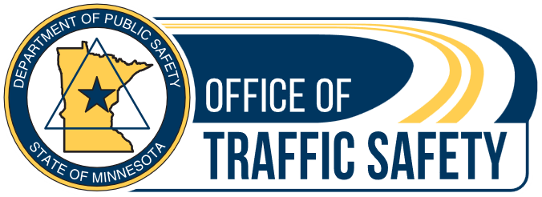

Seat belt social media for partners
Below are several sample social media posts for the Click it or Ticket seat belt extra enforcement and awareness campaign. The text below represents examples and suggestions. Partners are encouraged to create their own social media tailored for their audience.

Individualized posts and photos specific to your community are always preferred over premade graphics. Users may download pictures on the Office of Traffic Safety Dropbox.
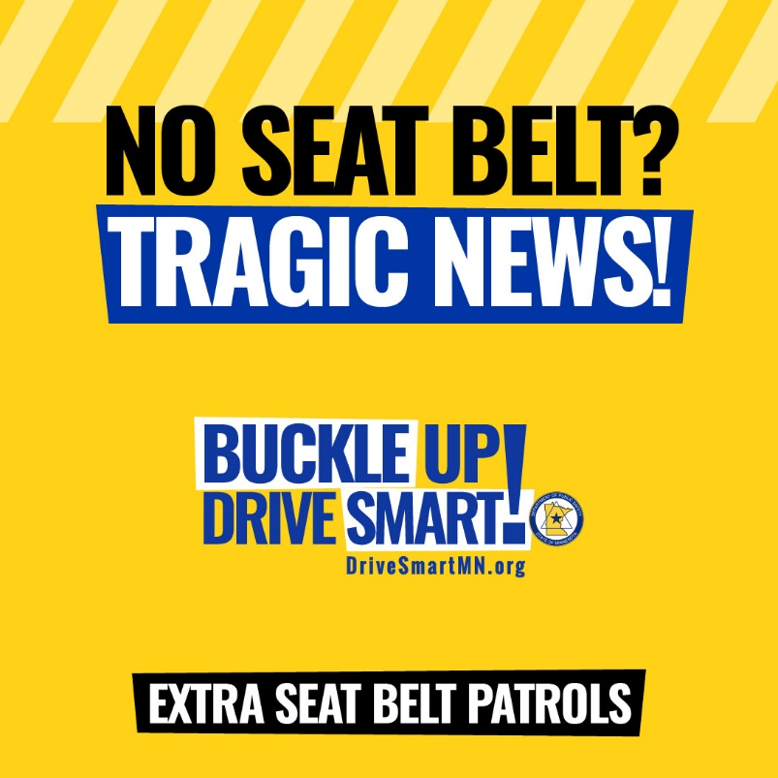
Suggested text: Getting a ticket is never fun, but it’s not about the ticket. For Minnesota law enforcement, it’s about saving lives.
Every traffic safety officer has seen tragedies that could have been prevented by wearing a seat belt.
Extra enforcement is on Minnesota roads. Don’t make the news because of a crash. Instead, wear your seat belt. Click it or ticket.
Suggested text: Not wearing a seat belt? That’s a tragedy waiting to happen. [Your department] has extra law enforcement on the road to prevent unbelted people from making the next crash headline.

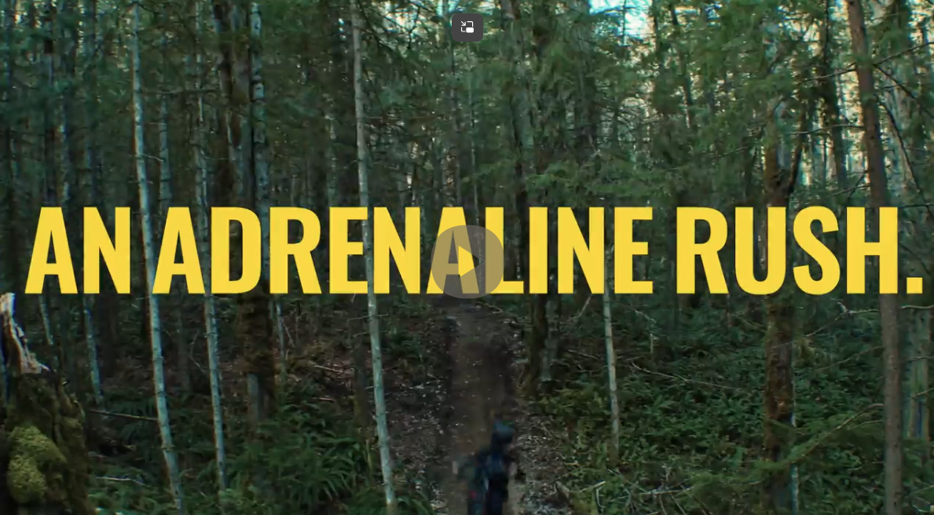
Suggested text
Going out for some extreme sports? Great — have fun. But don’t turn driving into an adrenaline rush by taking deadly risks.
Wear a seat belt and follow the speed limit. Keep yourself and others safe on the road.
Buckle up! Drive smart!

Video in Dropbox link.

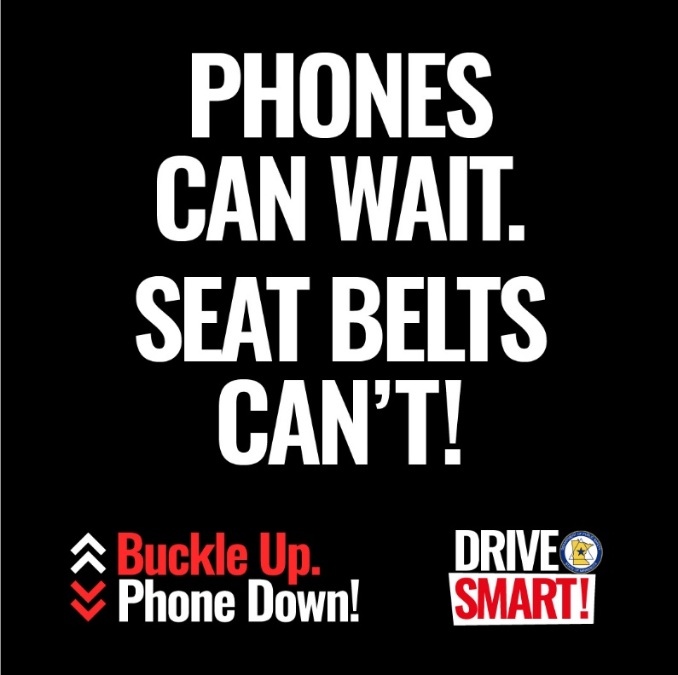
Suggested text
It’s actually fine to put things off. When it comes to your phone and driving, it’s the right thing to do.
What can’t wait? Your seat belt. Wear it every ride, every time you get in your vehicle. Drive safe. Drive smart!
Ring, ring. What’s that? Your phone —and it can wait. Your seat belt can’t. Wear it every time you drive.

