Speeding extra enforcement social media for partners
Below are several sample social media posts for the summer extra enforcement campaign. You can find all of the graphics below and more on the Office of Traffic Safety Dropbox. The text below represents examples and suggestions. Partners are encouraged to create their own social tailored for their audience.

Individualized posts and photos specific to your community are always preferred over premade graphics. For example:
- When law enforcement officers are making stops, have them write a brief description and take a photo of the vehicle and road where the speeding happened.
- Show a street known for deadly crashes and call for drivers to slow down.
- Take a photo of an officer using radar to detect speeding drivers.
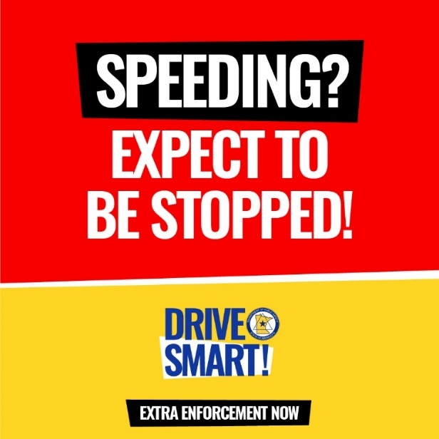
Suggested text:
- Speeding? Extra enforcement is on Minnesota roads. Slow down or get pulled over.

- You know what really slows you down? A speeding ticket or worse yet, a crash. [Agency Name] officers are on the lookout for dangerous drivers. Slow down and safely get to your destination.

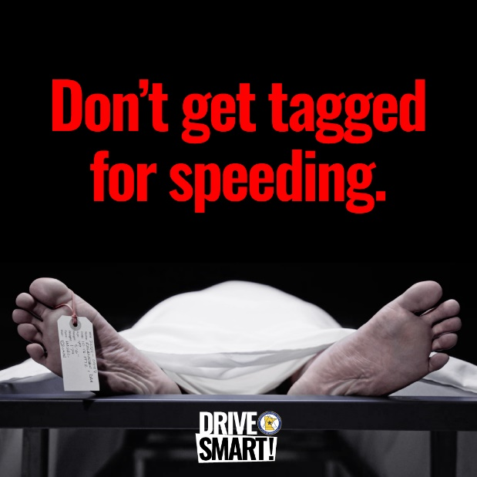
Suggested text:
Speeding won’t get you there any faster, but it might end your life sooner than you think in a crash. Slow down and safely make it to your destination. Extra enforcement is on Minnesota roads.

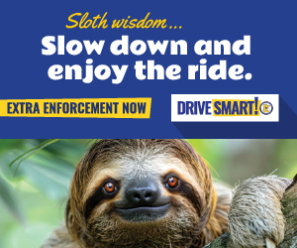

Suggested text:
- Even the sloth knows speed is overrated. Extra enforcement is now on Minnesota roads. Officers will be on the lookout for speeders, so slow down or get pulled over.

- Last year from Memorial Day to Labor Day, our officers stopped [Local stops data] people for speeding. Make this summer a safe one — slow down or get pulled over.

