LIFE SAFETY & FIRE INSPECTION CHECKLIST
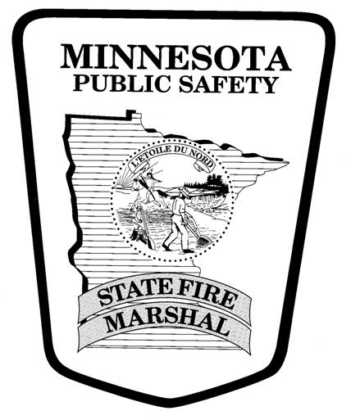
College Classroom & Lecture Buildings
Y = Meets Requirements; N= Does Not Meet Requirements
Y N Y N

EXTERIOR:
   Fire Lanes marked/unobstructed (MSFC 503.3, 503.4)
   Address visible (MSFC 505.1)
   Fire hydrants/water supply accessible (MSFC 507)
   Combustible accumulations/storage acceptable
(MSFC 304.2, MSFC 315.4)
   F.D. key box present/maintained (MSFC 506)
   F.D. connections visible/maintained (MSFC 912)
   Gas meter/piping protected against impact
(MSFC 312, 603.9)
   Dumpsters are outside and 5 ft. or more from
combustible walls, openings or combustible roof eave
lines. (MSFC 304.3.3)

EXIT FEATURES/MEANS OF EGRESS:
   Adequate number of exits
(MSFC 1004.2, 1006, 1016, 1104.25)
   Exits, aisles, & corridors free of obstructions
(MSFC 1031.3)
   Exit doors open from inside (MSFC 1010.1.9)
   Exit signs present and operational (MSFC 1013, 1104.3)
   Emergency lighting present, operational & tested
(MSFC 1008, 1104.5)
   Exit corridors rated (MSFC 1020.1, 1104.17)
   No locks, chains, keys or special knowledge required to
open exit doors (MSFC 1010.1.9.4)
   Panic hardware on exit doors if capacity of room is 50 or
more people for assembly use (MSFC 1010.1.10)

CONSTRUCTION FEATURES:
   Fire rated construction present/maintained
(MSFC 703.1)
   Incidental use areas separated/sprinklered
(MSFC 1105.3)
   Rated/required fire doors operational (MSFC 704.2)
   Vertical openings protected (MSFC 1103.4)

STORAGE:
   Storage neat and orderly (MSFC 315.3)
   Storage of combustible materials kept to a minimum (MSFC 304.2)
   Combustible storage prohibited in electrical equipment
rooms, restrictions apply in boiler/mechanical rooms
(MSFC 315.3.3)
   Storage maintained [2’ below ceiling un-sprinklered,
18” sprinklered] (MSFC 315.3.1)
   Rubbish/waste subject to spontaneous ignition shall be disposed of daily and in listed container (MSFC 304.3.1)
   Fuel-powered equipment shall be stored outdoors or in
fire rated room (MSFC 313.1)

FLAMMABLE/COMBUSTIBLE LIQUIDS:
   Safety containers if used (MSFC 5005.1.10, 5705.2.4)
   Adequate ventilation (MSFC 5705.3.7.5.1)
   No basement storage unless sprinklered
(MSFC 5704.3.5.1)
   No sources of ignition (MSFC 5704.2.4)
   Quantities >10 gals in cabinet (MSFC 5704.3.4.4)
   Not stored/kept near exits (MSFC 5704.3.3.3)

UTILITY/MECHANICAL/HVAC:
   Heating equipment serviced annually to ensure proper
operation (MSFC 603.5.2)
   Approved piping, connections & appliances used
(MSFC 603.1.2)
   Combustion air supply/venting present (MSFC 603.1)
   Adequate clearance between combustibles and appliances (MSFC 305.1, 603.5.3)
   Commercial hood ducts/filters are clean
(MSFC 607.3.3)
   Spray finishing to be conducted in separate booth or room
with adequate ventilation (MSFC 2404.2)

HAZARDOUS MATERIALS:
  Compressed gas cylinders secured (MSFC 5303.5)
  Rooms/areas properly labeled (MSFC 5003.5)
  Acceptable quantities (MSFC 5003.1.1)
  Separation of incompatible materials (MSFC 5003.9.8)
  Safety Data Sheets available for inspection (MSFC 5003.4)

ELECTRICAL:
   No electrical hazards (MSFC 604.1, 604.6)
   Appliances/fixtures in good condition (MSFC 604.7)
   Power taps are correct design & properly used
(MSFC 604.4)
   Extension cords not substituted for fixed wiring
(MSFC 604.5)
   Access/clearance to electrical panels (MSFC 604.3)
   Electrical Rooms labeled (MSFC 604.3.1)

FIRE SAFETY PRECAUTIONS:
   Proper clearance between combustible materials and
heaters (MSFC 305.1)
   No open flames (lighters, matches, etc.) in classrooms/
lecture halls/offices unless a permit is obtained
(MSFC 308.3)
   Keep combustible rubbish to a minimum
(MSFC 304.1, 304.2)
   No hot work (welding, grinding) near combustible materials unless shielded (MSFC 3504.1.1)
   Maintain fire watch 30 minutes after hot work (welding, grinding) is finished (MSFC 3504.2.1)
   Fire safety and evacuation plans created and maintained
(MSFC 404)

FIRE PROTECTION SYSTEMS:
   Extinguishers, pull stations, sprinkler controls are readily
accessible (MSFC 901.6, 903.3.1, 906.5, 509)
   All systems tested/inspected at least annually
(MSFC 901.6.1, 904.12.5, 907.8)
   Coverage is adequate and properly installed
(MSFC 903.3.1, 905.2, 907, Chapter 11)
   Control panel/annunciator panel in normal condition
[no trouble or alarm conditions] (MSFC 901.6, 901.7)
   Commercial Kitchen Hood System fuel shutoff present (MSFC 904.12.2)

LIFE SAFETY & FIRE INSPECTION RECOMMENDATIONS
College Classroom & Lecture Buildings

NOTE: The information contained below are recommendations to ensure life and fire safety in the event of an emergency and not actual Minnesota State Fire Code (MSFC) requirements.

- Ensure employees know how to evacuate from work areas and perform any assigned duties in an emergency.

- Employees should know the location of the nearest means to activate the fire alarm system and extinguisher.

- In the event of a fire, occupants should only fight the fire IF:

  - Fire is not spreading rapidly
  - Fire is not blocking means of escape
  - Occupants are trained to use equipment needed to fight fire

If none of the above are possible, leave the area IMMEDIATELY

- Post evacuation routes in each classroom/lecture hall/auditorium located near exit doors

- If chemicals or hazardous materials are required, order and store the minimum amount required for teaching, instruction or use.

- Survey chemicals or hazardous materials at least annually and properly discard any that are expired or show signs of decomposition.

- Regularly clean lint traps on dryers and filters on vents, fans, air conditioners or other mechanical equipment

- Clean up spills of flammable liquids or other hazardous materials quickly and safely

