
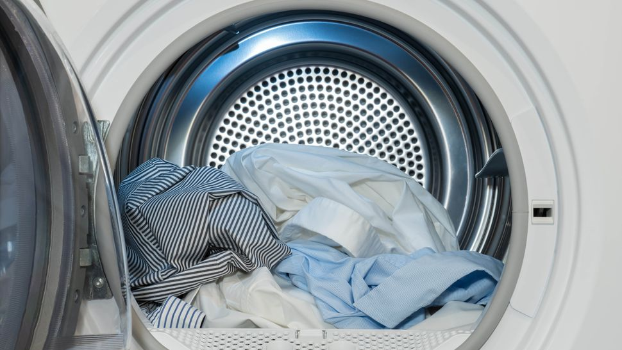
Did you know?

The leading cause of home
clothes dryer fires is failure
to clean them.

Inspect and clean the dryer vents at least once a year.

To prevent electrical hazards, the dryer must be connected to a safe grounding system.

Check the outdoor vent flap to make sure it is not covered by snow.

Keep the area around your dryer clear of things that can burn, like boxes, cleaning supplies and clothing, etc.
- Have your dryer installed and serviced by a
professional.
- Do not use the dryer without a lint filter.
- Make sure you clean the lint filter before or after
each load of laundry. Also remove any lint that has collected around the drum.
- Rigid or flexible metal venting material should be
used to sustain proper air flow and drying time.
- Make sure the air exhaust vent pipe is not restricted
and the outdoor vent flap will open when the dryer
is operating.
- Follow the manufacturer’s operating instructions
and don’t overload your dryer.
- Turn the dryer off if you leave home or when you
go to bed.
Clothes Dryer Safety
YOUR FIRE DEPARTMENT’S WEBSITE

Your fire department street address Telephone: XXX-XXX-XXXX Fax: XXX-XXX-XXXX

