INSPECTION CHECKLIST
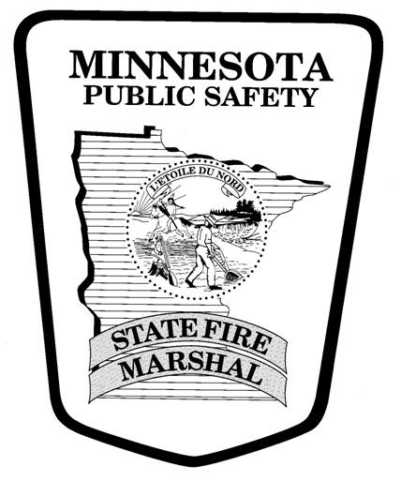
Fireworks (Public Display)
Y = Meets Requirements; N= Does Not Meet Requirements; N/A = Not Applicable
2020 Minnesota State Fire Code (MSFC), 2018 Edition NFPA 1123
Y N N/A

GENERAL:

□ □ □ A permit is required for public displays (Minn. Stat. § 624.22 & MSFC 5608.1.1)
□ □ □ The pyrotechnic operator must be certified by the MN State Fire Marshal (Minn. Stat. § 624.22 &
MSFC 5608.1.1)
□ □ □ Diagram/site plan required showing location of buildings, highways, overhead obstructions, and audience/crowd
distances (MSFC 5608.2.1)
□ □ □ Public assemblage plan can be required – including standby firefighters (MSFC 403.12 & 5608.2)

Y N N/A

FIREWORKS STORAGE AT DISPLAY SITE:

□ □ □ Fireworks shall not be unattended (MSFC 5608.5.1)
□ □ □ Fireworks shall be kept dry (MSFC 5608.5.2)
□ □ □ Shells to be inspected. Damaged, leaking, wet, or torn shells shall not be used (MSFC 5608.5.3)
□ □ □ Aerial shells to be checked for proper fit into mortars (MSFC 5608.5.3)
□ □ □ Ready boxes to be used for storage of fireworks and located at least 25 feet from mortars (MSFC 5608.5.5)
□ □ □ Smoking and open flames are prohibited within 50 ft. of area where fireworks or pyrotechnic materials are
present. (NFPA 1123 8.1.6.1)
□ □ □ NO SMOKING OR OPEN FLAME signs must be conspicuously posted in the area (MSFC 310.3)

Y N N/A

FIREWORKS DISPLAY SITE:

□ □ □ Minimum required radius of display site shall be 70 ft. per inch of internal mortar diameter of the largest aerial
shell to be fired [Ex. A 6” mortar = 420’] (NFPA 1123 5.1.3)
□ □ □ Discharge site arranged so that the trajectory of aerial shells shall not be within 25 feet of overhead objects or
obstructions. (NFPA 1123 5.1.4.7)
□ □ □ The AHJ (fire official) can order that a display be stopped if weather conditions or poor crowd control become a
concern (NFPA 1123 8.1.4.1 and 8.1.4.2)
□ □ □ Aerial shells greater than 6 inches in diameter shall be preloaded into mortars prior to beginning of display with
some exceptions (NFPA 1123 8.2.9.1)
□ □ □ Aerial shells greater than 6 inches in diameter shall be fired with electrical ignition or other means of remote
ignition with some exceptions (NFPA 1123 8.2.9.2.1 and 8.2.9.2.2)
□ □ □ Only the operator, authorized assistants and inspectors representing the AHJ are permitted to be in the display
site while display is in progress (NFPA 1123 8.1.3.2)
□ □ □ Operators and assistants shall only use flashlights, electrical lighting or other nonincendive illumination such as
chemical luminescent devices for illuminating the firing and ready box area (NFPA 1123 8.1.5)
□ □ □ The radius for ground pieces of low hazard potential shall be at least 75 feet (NFPA 1123 5.1.3.5.1)
□ □ □ The radius for ground pieces of high hazard potential shall be at least 125 feet (NFPA 1123 5.1.3.5.2)
□ □ □ Post display inspection and accounting for unexploded devices is required (MSFC 5608.9)

