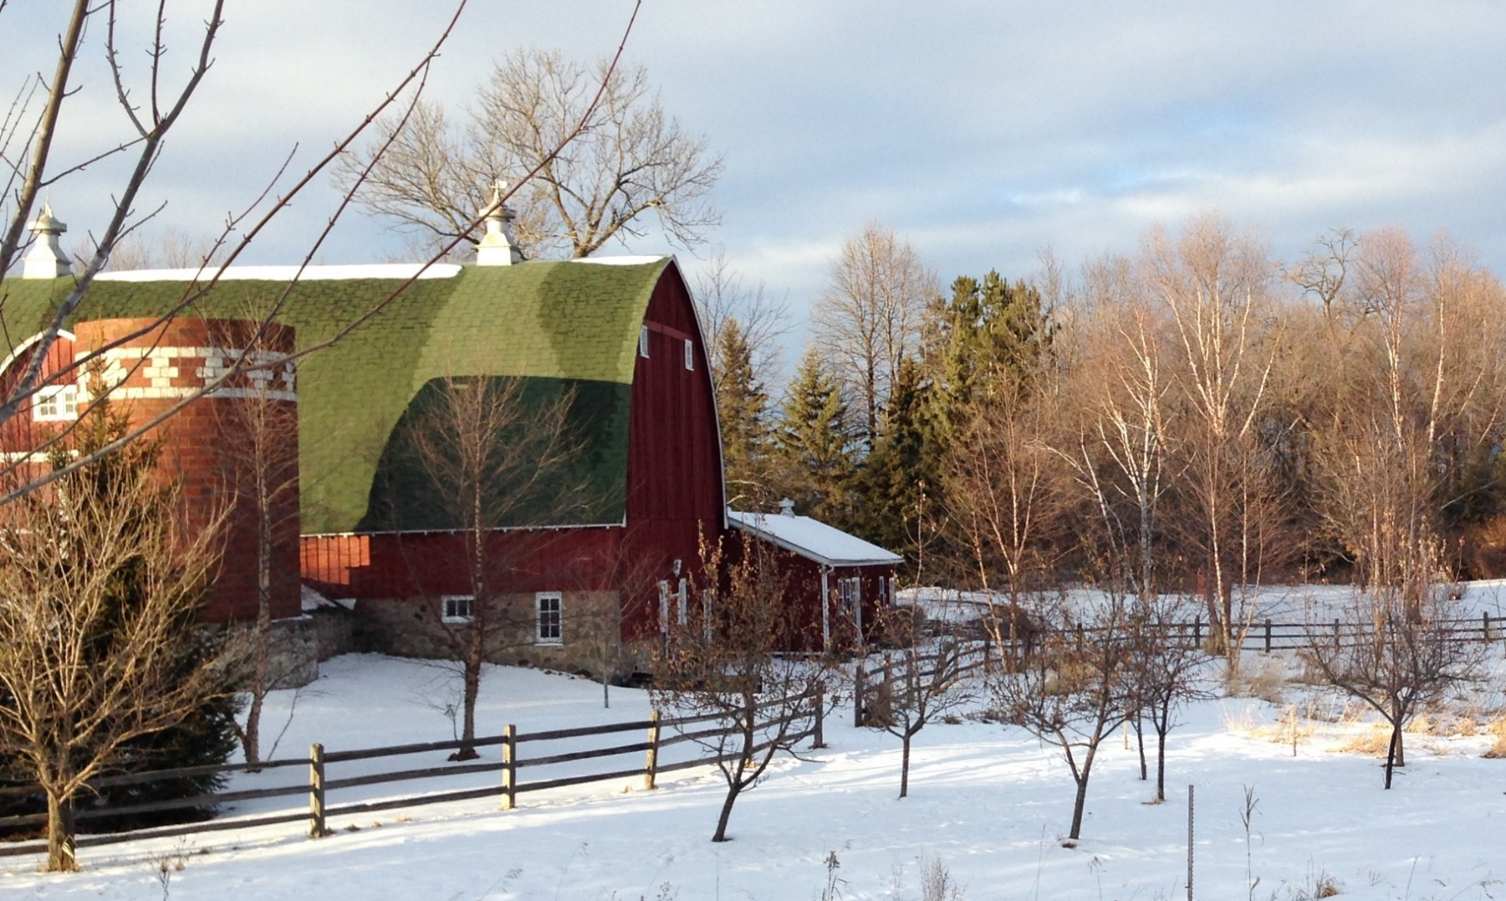

- Keep heat lamps and space heaters at least 3 feet from anything that can burn.

- Inspect heating equipment annually.

- Use extension cords on a limited and temporary basis.

- Clear dust and debris from lights and outlets.

- The barn is a smoke-free zone.

- When possible, store hay, straw and feed away from the main barn.

PROTECT YOUR ANIMALS YOURYOURLIVELIVESTOCK
Did you know?
Over the past decade, two people and countless animals died in 625 livestock production and storage facilities costing over $56 million in damage.

Barns and agricultural buildings used for other things have additional code requirements.
Check with your local fire department for considerations unique to your farm.
YOUR DEPARTMENT WEBSITE

Your department address Telephone: XXX-XXX-XXXX Fax: XXX-XXX-XXXX

