
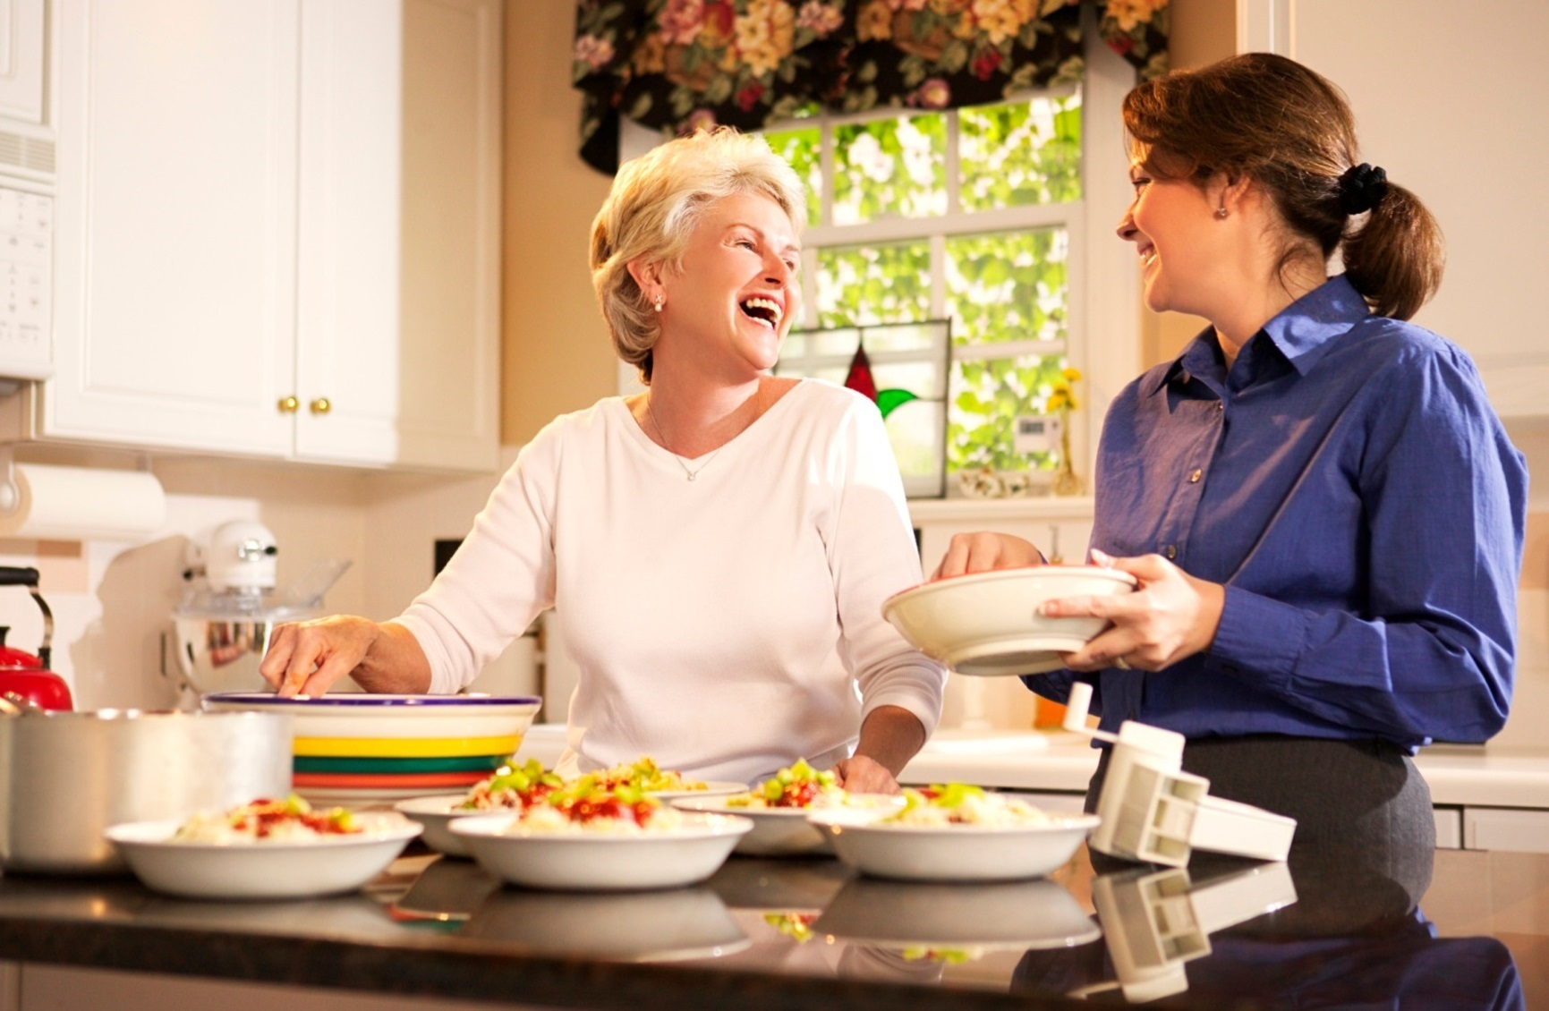
YOUR DEPARTMENT WEBSITE

Your department street address Telephone: XXX-XXX-XXXX Fax: XXX-XXX-XXXX

PREVENT COOKING FIRES

- Stay in the kitchen when cooking.

- If you leave the room, turn off the stove and move the pan from the burner.

- Keep things that can burn — oven mitts, towels, and wooden spoons — three feet from the stove.

- If a fire starts, slide a tight-fitting lid on the pan and turn off the heat.

- Avoid loose-fitting clothing that can easily catch fire.
Did you know?
Last year in Minnesota the leading cause of structure fires was cooking.

Cooking fires caused nearly $6 million in damage last year in Minnesota.

The top two factors last year in cooking fires were unattended equipment and combustibles too close to a heat source.

