Certifying a new FSC brand style
To begin, log into your account at the State Fire Marshal division’s eApplication Public Portal.
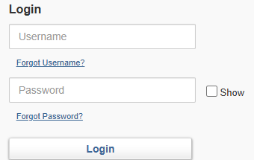
(Note: This process will require you to already have a user account affiliated with your manufacturer.)
- Once logged in, go to the “all applications” tab and select “view all company applications”.
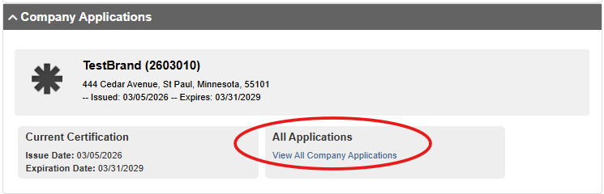
- Click “apply now” next to the “new fire standard compliant cigarette brand style application”.
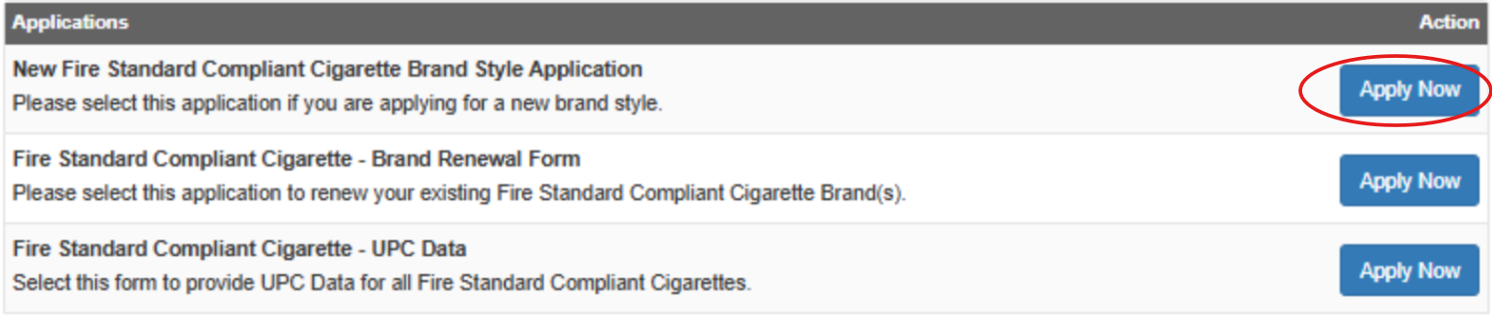
- Under “actions to take”, select “add record to the service” and click the green plus: next to the “brand style” text box.
- Select your brand from the dropdown menu and enter the name of your new brand style in the model text box.
- Enter the appropriate pack UPC number that goes with your new brand and fill in the rest of the information.
- Once the form is complete, click “save” and “continue”.
- On the next page, enter the name of the lab tech who did your testing and answer questions about the testing results.
- Upload your documentation from the testing lab (pdfs are best, but the system supports a variety of formats), then click “save, and “continue”.
- Upload your package artwork.
- Sign and date by entering the password associated with your account and click “submit”.
- Once you have submitted your form, you will be redirected to the checkout page. Select the “pay now” button and complete the checkout process.
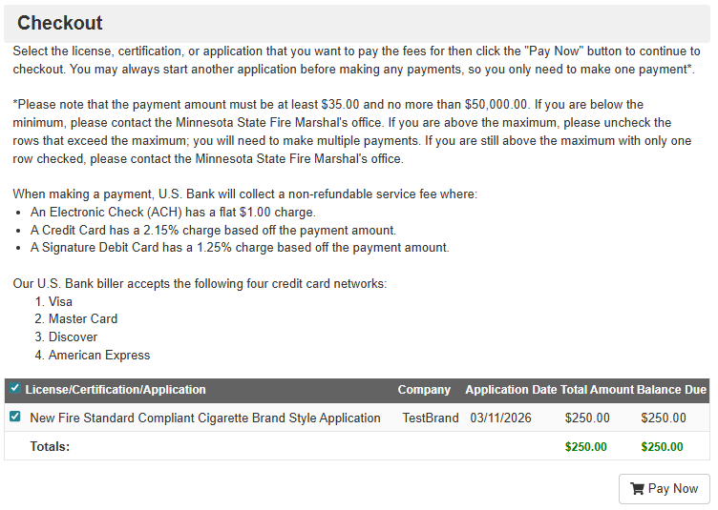
(Tip: If you have multiple brand styles to certify, you may skip the individual payment process and pay for multiple certifications at once by choosing the “checkout” option on your account’s landing page once you’ve entered in each of your certifications.)

