Creating a new user account
To begin, go to the State Fire Marshal division’s eApplication Public Portal.
- Scroll to the bottom of the page and select “create account” button.
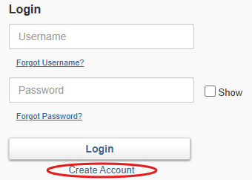
(Note: When filling out the application, all account demographic fields marked with red asterisks must be completed.)
- When you have filled in all your information correctly, click “save”.
- After submitting your user account information, you will receive an email to set your password. You should then be able to log into your account.

Setting your account to FSC
Once you have created your new user account in the licensing portal, you must submit a user account request to ensure your account is associated with the FSC program. (Our licensing site serves several groups including sprinkler fitters and explosives handlers.)
- Under the “applications” tab, select “view all user applications”.
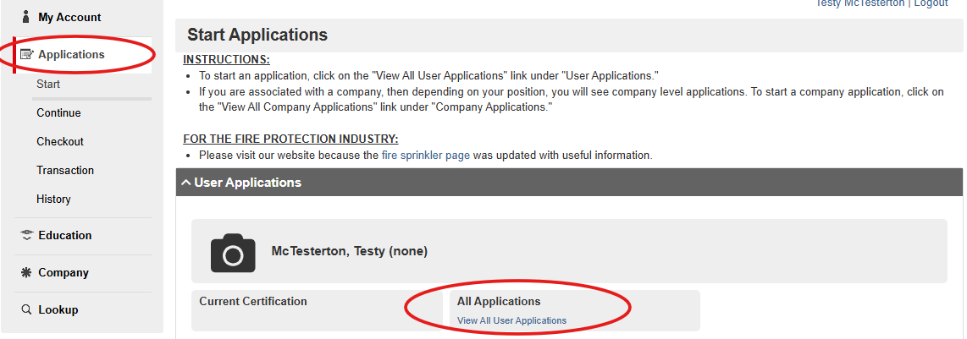
- Under the user account request, click “apply now”, then select “fire standard compliance cigarette program.
- Sign and date, then click “submit”.

Associating your new user account with a manufacturer
Next, you'll need to submit a Fire Standard Compliance cigarette manufacturer affiliation request. This application formally requests access to the account of a specific manufacturer.
- Under the “applications” tab, select “view all user applications”.
- Click “apply now” next to the “fire standard compliant cigarette manufacturer affiliation request”. 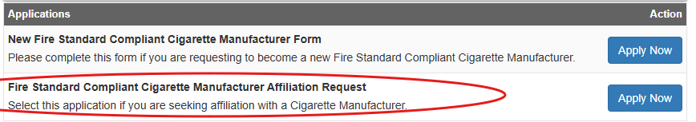
- Select the manufacturer you're requesting to affiliate with in the dropdown menu.
- Find the correct brand and select today's date.
- Enter the password associated with your account and click “submit”.

Completion of these steps will trigger an approval request email to the primary contact on-file for that manufacturer (if applicable). They must approve your affiliation for you to perform certifications for their products. You will be notified when this approval is complete.

