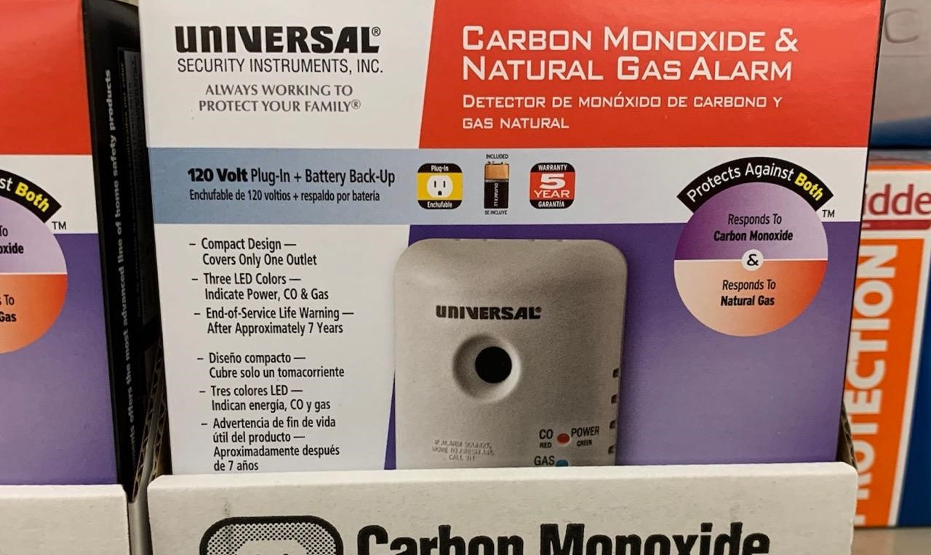


- Gas explosions can happen where liquid propane, natural gas, oil or bio-fuels are present.
- Explosive gas alarms alert people to the presence of dangerous levels of gas — some of which emit no obvious odor.
- Follow instructions carefully for the installation and use of gas appliances and equipment.
- Hire qualified technicians to work on gas equipment at your home or on your property.
- Cap the gas line after you remove a gas appliance from your home or property.
Did you know?
Minnesota law does not require that explosive gas alarms be placed in homes.

There have been 13 deaths in Minnesota over the past five years due to gas-related explosions.

Explosive gas alarms can be purchased at home improvement stores for as little as $17 for a basic model.

GAS EXPLOSIONS
YOUR WEBSITE

Your Department Address Telephone: XXX-XXX-XXXX Fax: XXX-XXX-XXXX

