
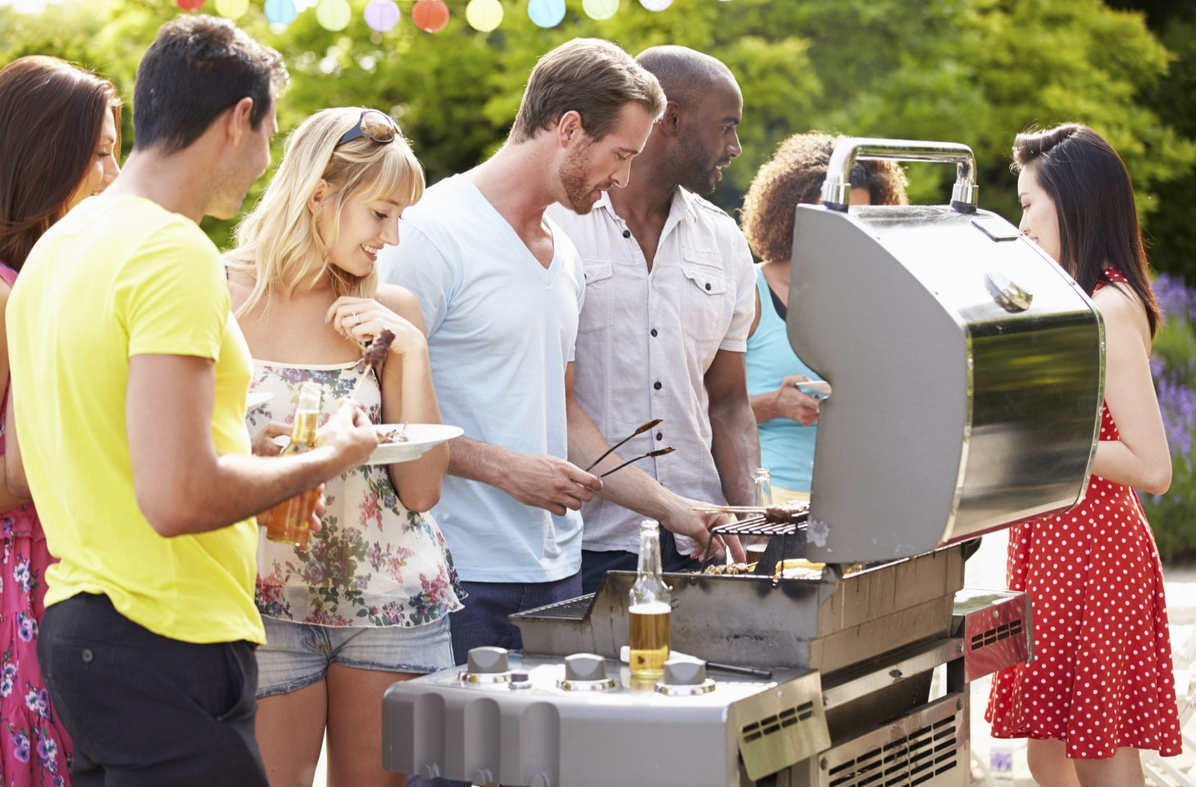
- Never use a grill indoors and don’t leave it unattended.

- When lighting a grill, keep the top open. If it does not light in the first several attempts, wait five minutes before trying again.

- Check the grill’s tubes and hoses before using a grill that has not been used in a while.

- Keep your grill clean.

- When grilling, place the grill away from your home, deck railings and out from under eaves.
Did you know?
July is the peak month for
U.S. home fires.

Most grill fires start because something that could burn was too close to the grill.

Most home fires involving grills are started by gas grills, not charcoal grills.

You should check
the gas tank hose
on propane grills
for leaks before using them for
the first time.

GRILLING SAFETY
YOUR FIRE DEPARTMENT’S WEBSITE

Your fire department street address Telephone: XXX-XXX-XXXX Fax: XXX-XXX-XXXX

