
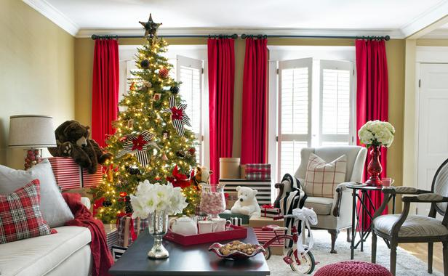
- Use flameless candles when decorating for the holidays.

- Make sure exit paths and exits are clear of holiday decorations and clutter.

- Cooking for a holiday gathering? Never leave food cooking on the stove unattended.

- Keep a timer with you when baking in the oven so you don’t lose track of time; check on items in the oven frequently.
WINTER HOLIDAY SAFETY
Did you know?
Two of every five home decoration fires are started by candles.
The three leading causes of Minnesota fires are all holiday staples: Cooking, heating and open flames.

Nearly half of holiday decoration fires happen because decorations are placed too close to a heat source.

YOUR DEPARTMENT WEBSITE

Your Department Street Address Telephone: XXX-XXX-XXXX Fax: XXX-XXX-XXXX

