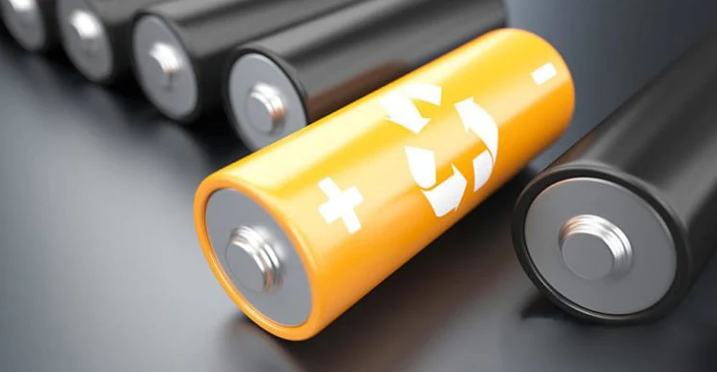
- Purchase devices that are listed by a qualified testing laboratory.
- Always follow the manufacturer’s instructions.
- Only use the battery that is designed for the device.
- Only use the charging cord that came with the device.
- Do not charge device under your pillow, your bed, or on a couch.
- Do not keep charging the device after it is fully charged
- Keep batteries at room temperature when possible.
- Do not charge them at temperatures below 32°F (0°C) or above 105°F (40°C).
- Store batteries away from anything that can catch fire
- https://www.epa.gov/recycle/used-lithium-ion-battiers

LITHIUM-ION BATTERY SAFETY!

Did you know?

Lithium-ion batteries supply power to many kinds of devices including smart phones, laptops, e-scooters and e-bikes, e-cigarettes, smoke alarms, toys, skateboards and even cars. If not used correctly, or if damaged, these batteries can catch on fire or explode.

DO NOT BRING MOBLITY
DEVICES INTO ELEVATORS!

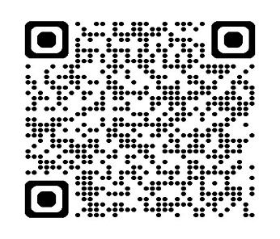
YOUR DEPARTMENT WEBSITE
Your department address Telephone: XXX-XXX-XXXX


