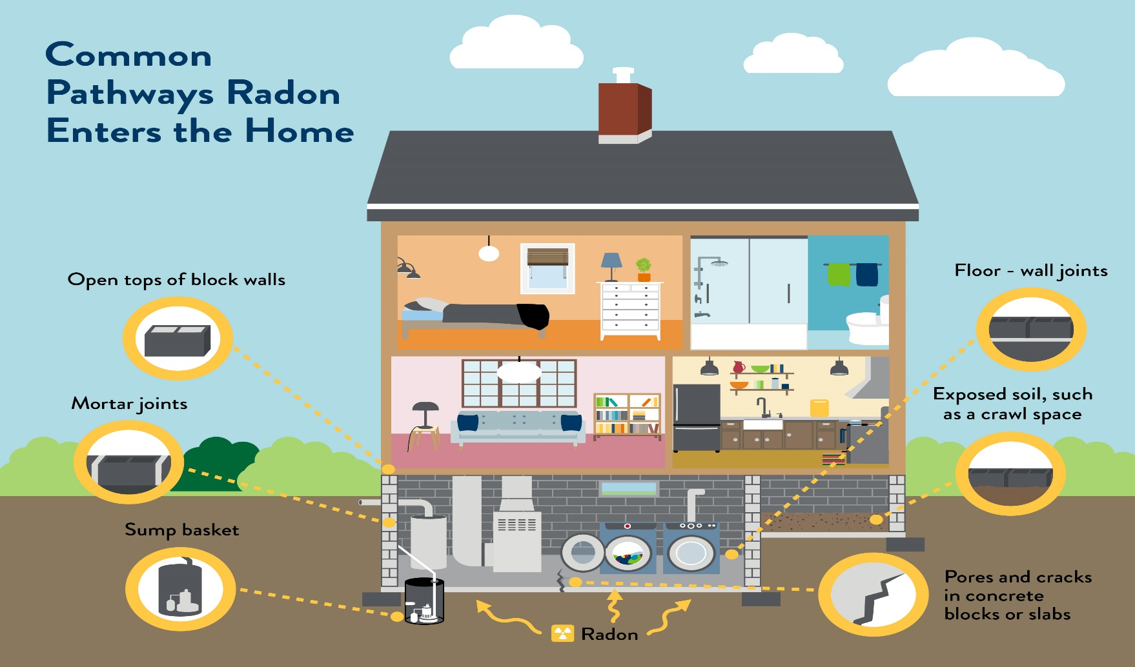
- Radon gas from the soil can build-up in homes.
- When your home is at 4 pCi/L or more a radon mitigation system should be installed to reduce radon.
- The only way to know if your home has high radon is to test.
- You can test for radon by purchasing a test kit at mn.radon.com.
- Keep your family safe and test for radon.
- Indoor Air Unit mn.gov/radon


Did you know?
Radon causes lung cancer.
It’s the #1 cause of lung cancer for non-smokers.
Testing for radon is easy and inexpensive.
2 out of 5 Minnesota homes have radon.

RADON
YOUR DEPARTMENT WEBSITE

Your department address Telephone: XXX-XXX-XXXX Fax: XXX-XXX-XXXX

