
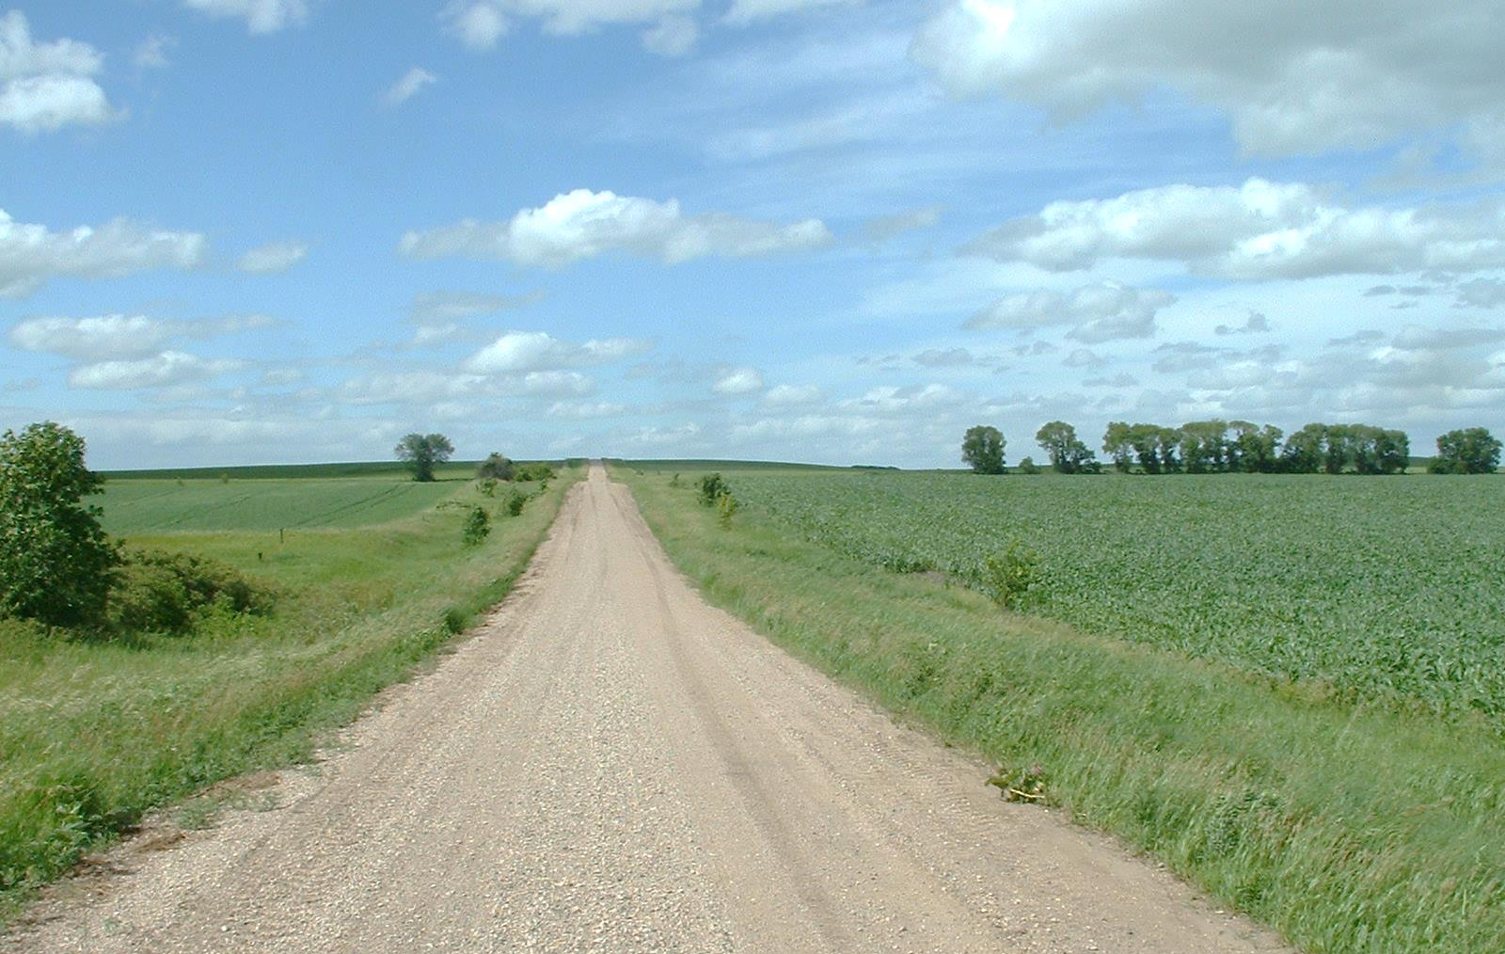
- Be sure your address is visible to emergency vehicles.

- Learn first aid. Knowing a few basics will help you get started before first responders arrive.

- Be vigilant around outdoor fires.

- Store your firewood away from your home. If stored too close, it will make the flames spread quickly if there is a fire.

- Make sure your home is accessible for emergency vehicles.
Did you know?
There is one structure fire every three minutes in rural Minnesota.

In 2013, fire caused more than $148 million in property damage in rural Minnesota.

Sixty-five percent of Minnesota’s fire loss happened in rural parts of the state.

RURAL AREA FIRE TIPS
YOUR DEPARTMENT WEBSITE

Your department address Telephone: XXX-XXX-XXXX Fax: XXX-XXX-XXXX

