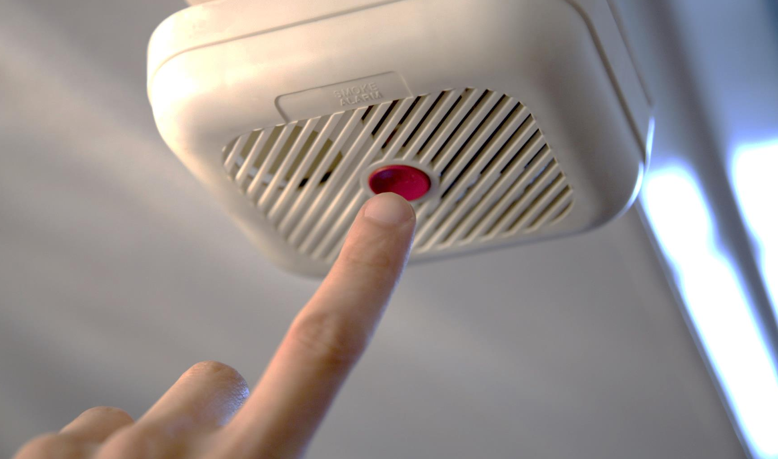
- Install smoke alarms in every bedroom, outside each sleeping area and on every level of the home, including the basement.

- Interconnect your home’s smoke alarms. This way, when one sounds, they all sound.

- Teach children the sound of the smoke alarm and to exit the home/building when it sounds.

- Place alarms on the ceiling. If alarms are placed on the wall they must be no more than 12 inches below the ceiling.

Did you know?
Smoke alarms should be tested monthly.

Smoke alarm batteries should be changed at least once a year.

All smoke alarms should be replaced every 10 years.

Working smoke alarms cut in half your risk of dying in a residential fire.

SMOKE ALARMS
WHAT YOU NEED TO KNOW ABOUT:
sfm.dps.mn.gov
445 Minnesota St., Suite 145, St. Paul, MN 55101 Telephone: 651-201-7200 Fax: 651-215-0525


