
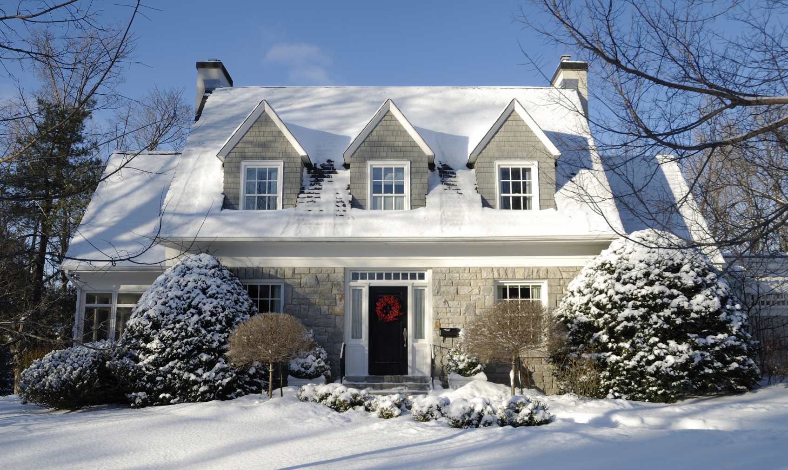

FREEZE OUT WINTER FIRES
- Keep all doors and windows that could be used for an escape route clear of snow and ice.

- Keep all vents — fireplace, dryer, furnace and oven — clear of snow, ice and debris.

- Never use a blow torch to thaw frozen pipes.

- Use flashlights, not candles, if you lose power.

- Keep anything that can burn at least three feet from heat sources; do not use your oven to heat your home.
Did you know?
Most home fires occur in the winter and peak in January.

Each year in the United States there is more than $2 billion in property loss due to winter home fires.

Last year in Minnesota, 39 percent of fire deaths occurred
in October, November and December.
YOUR DEPARTMENT WEBSITE

Your department street address Telephone: XXX-XXX-XXXX Fax: XXX-XXX-XXXX

