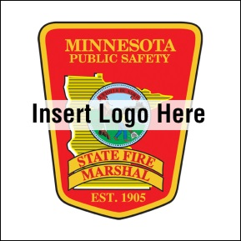
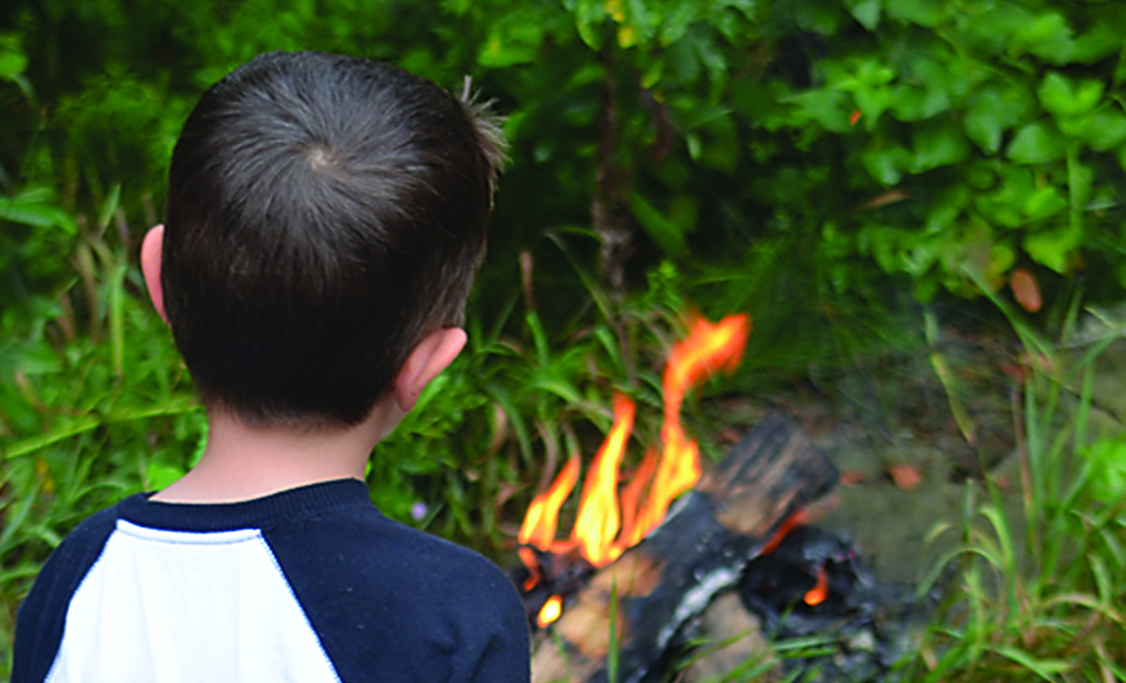
- Be a good role model. Use fire safely and talk to your kids about the dangers of fire.

- Keep fire tools secured and locked up.

- Look for signs of fire misuse including unexplained scorch marks or melted areas in clothes, furniture, toys, paper and outside areas.

- Talk to your child if you notice signs of fire misuse or contact your local fire department for help. If this is an emergency, call 911 immediately!

YOUTH FIRESETTING PREVENTION
Did you know?
Children between ages 10 and 17 account for about 50 percent of arson arrests.

In 2013, children started 300 fires in Minnesota.

Even if a child starts a small fire, it is a big deal. Fires can cause property damage, injury and death.

Help is available to stop this behavior.
sfm.dps.mn.gov
445 Minnesota St., Suite 145, St. Paul, MN 55101 Telephone: 651-201-7200 Fax: 651-215-0525

